**TRƯỜNG ĐẠI HỌC TÀI NGUYÊN VÀ MÔI TRƯỜNG TP.HCM**

**KHOA CÔNG NGHỆ THÔNG TIN**



**TỔNG HỢP LAB LẬP TRÌNH DI ĐỘNG**

Sinh viên thực hiện: **Phạm Hồng Duy**

Mã số sinh viên: 1150070008

Lớp**: 11_ĐH_TTMT**

Khoá**: 2022 - 2026**

**MỤC LỤC**

LAB-1 3

**Máy tính** 3

**Camera** 7

**Tạo xúc xắc** 11

**Màu nền khác nhau** 16

**Splash có Custom ProgressBar (overlay)** 21

**Bấm vào icon chuyển về cuộc gọi** 26

**Tạo màn hình chính MainActivity** 32

LAB 3 37

**Máy đổi tiền** 37

**Đổi độ dài** 37

**Custom Controls** 54

**List trong Android** 72

LAB 2 85

**Truyện cười** 85

**Bài Con Thỏ+Bài tập** 91

**Đăng nhập** 95

**Ứng dụng Learning** 97

**Emoji vui nhộn** 100

**Con voi** 104

LAB 4 108

**Truyện cười** 108

**12 cung hoàng đạo** 109

LAB 5 134

# **LAB-1**

## **Máy tính**

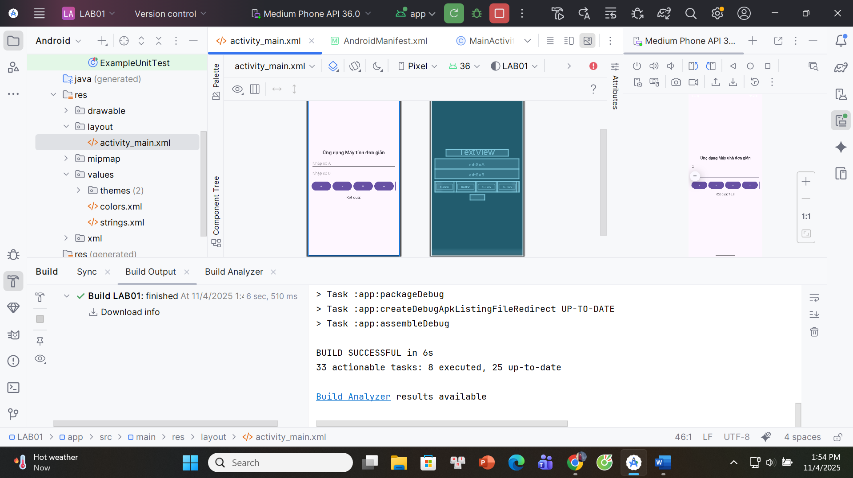**BƯỚC 1-Android Mainfest**  
 *<?*xml version="1.0" encoding="utf-8"*?>*<manifest xmlns:android="http://schemas.android.com/apk/res/android">  
  
 <application  
 android:allowBackup="true"  
 android:label="@string/app_name"  
 android:supportsRtl="true"  
 android:theme="@style/Theme.Material3.DayNight.NoActionBar">  
  
 *<!-- BÀI 4: MainActivity là màn mở đầu -->* <activity  
 android:name=".MainActivity"  
 android:exported="true">  
 <intent-filter>  
 <action android:name="android.intent.action.MAIN"/>  
 <category android:name="android.intent.category.LAUNCHER"/>  
 </intent-filter>  
 </activity>  
  
 </application>  
</manifest>

**BƯỚC 2-MainActivity**  
package com.example.lab01;  
  
import android.content.Intent;  
import android.os.Bundle;  
import android.widget.Toast;  
  
import androidx.appcompat.app.AppCompatActivity;  
  
public class MainActivity extends AppCompatActivity {  
 @Override protected void onCreate(Bundle savedInstanceState) {  
 super.onCreate(savedInstanceState);  
 setContentView(R.layout.activity_main);  
  
 findViewById(R.id.btnBai1).setOnClickListener(v ->  
 startIfExists("com.example.lab01.M000ActSplash"));  
  
 findViewById(R.id.btnBai2).setOnClickListener(v ->  
 startIfExists("com.example.lab01.M000ActSplashWithLoading"));  
  
 findViewById(R.id.btnBai3).setOnClickListener(v ->  
 startIfExists("com.example.lab01.M001ActProfile"));  
  
 findViewById(R.id.btnExit).setOnClickListener(v -> finish());  
 }  
  
 private void startIfExists(String className) {  
 try {  
 Class<?> c = Class.*forName*(className);  
 startActivity(new Intent(this, c));  
 } catch (ClassNotFoundException e) {  
 Toast.makeText(this, getString(R.string.chua_cai), Toast.*LENGTH_SHORT*).show();  
 }  
 }  
}

**BƯỚC 3-Activity_main.xml**

<?xml version="1.0" encoding="utf-8"?>  
<LinearLayout xmlns:android="http://schemas.android.com/apk/res/android"  
 android:layout_width="match_parent"  
 android:layout_height="match_parent"  
 android:orientation="vertical"  
 android:padding="24dp"  
 android:gravity="center">  
  
 <Button  
 android:id="@+id/btnBai1"  
 android:layout_width="match_parent"  
 android:layout_height="wrap_content"  
 android:text="@string/b1"/>  
  
 <Button  
 android:id="@+id/btnBai2"  
 android:layout_width="match_parent"  
 android:layout_height="wrap_content"  
 android:text="@string/b2"  
 android:layout_marginTop="12dp"/>  
  
 <Button  
 android:id="@+id/btnBai3"  
 android:layout_width="match_parent"  
 android:layout_height="wrap_content"  
 android:text="@string/b3"  
 android:layout_marginTop="12dp"/>  
  
 <Button  
 android:id="@+id/btnExit"  
 android:layout_width="match_parent"  
 android:layout_height="wrap_content"  
 android:text="@string/exit"  
 android:layout_marginTop="12dp"/>  
</LinearLayout>

## **Camera**

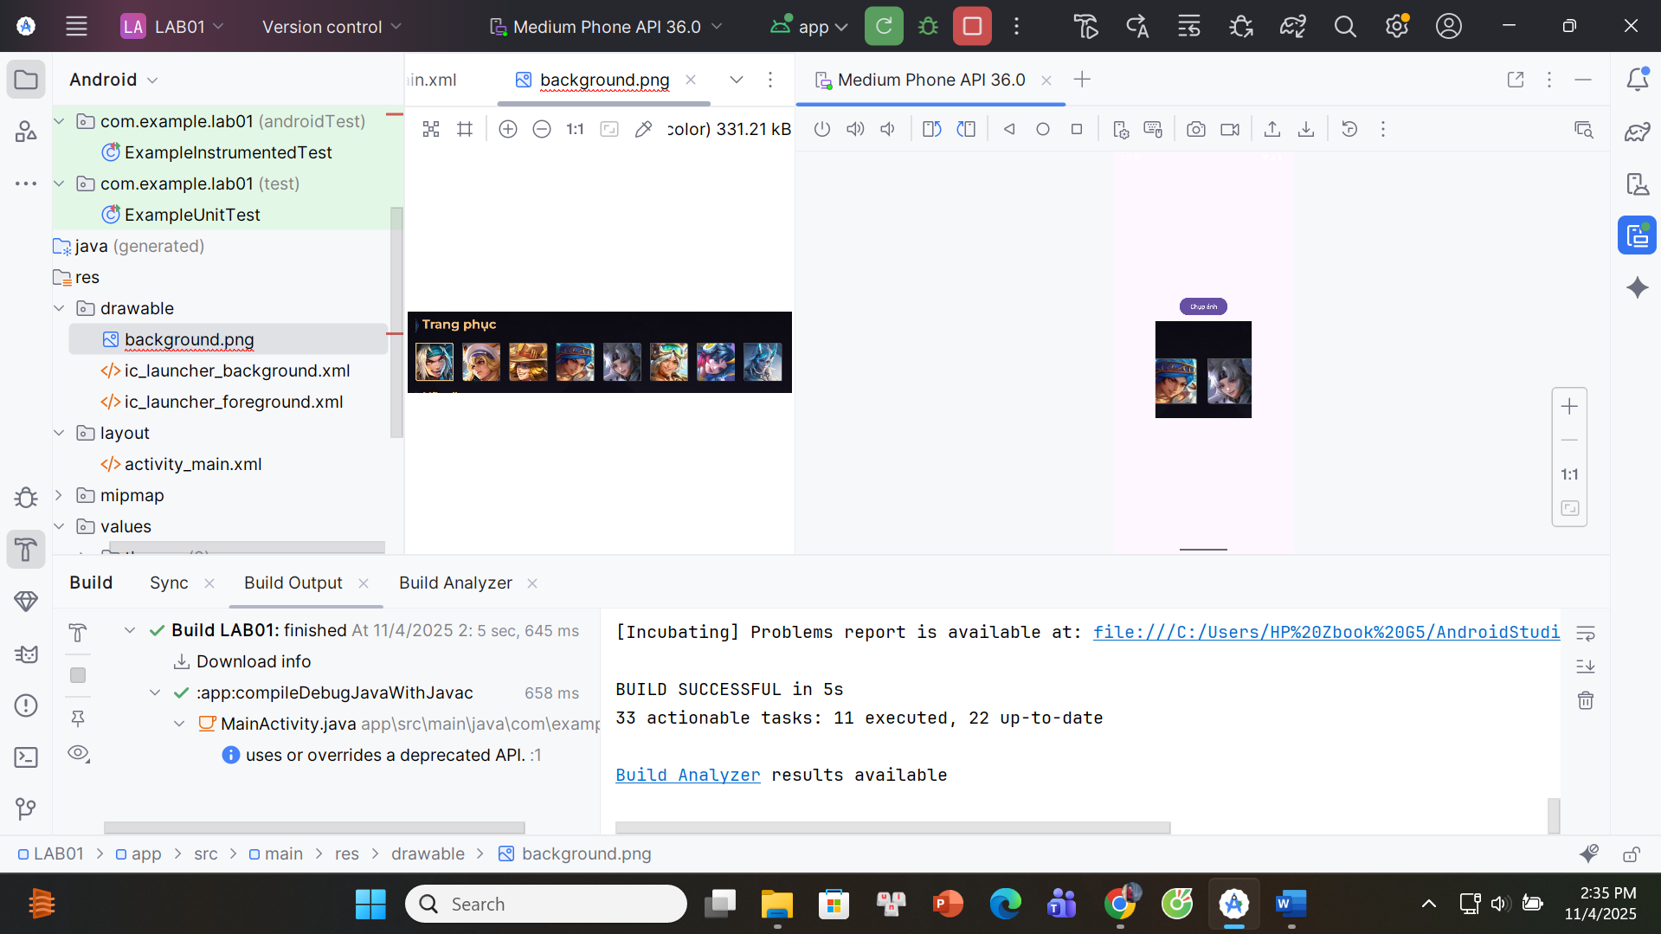

**BƯỚC 1-Activity_main.xml**

<?xml version="1.0" encoding="utf-8"?>  
<ScrollView xmlns:android="http://schemas.android.com/apk/res/android"  
 android:layout_width="match_parent" android:layout_height="match_parent"  
 android:fillViewport="true">  
  
 <LinearLayout  
 android:orientation="vertical" android:layout_width="match_parent"  
 android:layout_height="wrap_content" android:padding="16dp" android:gravity="center">  
  
 <!-- (Có thể giữ phần máy tính của bạn ở trên) -->  
  
 <!-- Nút chụp ảnh -->  
 <Button  
 android:id="@+id/btnOpenCamera"  
 android:layout_width="wrap_content"  
 android:layout_height="wrap_content"  
 android:text="Chụp ảnh"  
 android:layout_marginTop="16dp"/>  
  
 <!-- Ảnh hiển thị -->  
 <ImageView  
 android:id="@+id/imgPreview"  
 android:layout_width="220dp"  
 android:layout_height="220dp"  
 android:layout_marginTop="10dp"  
 android:scaleType="centerCrop"  
 android:src="@drawable/background"/>  
 <!-- tuỳ chọn: thêm placeholder_camera.png vào res/drawable -->  
  
 </LinearLayout>  
</ScrollView>

**BƯỚC 2-AndroidMainfest**

*<?*xml version="1.0" encoding="utf-8"*?>*<manifest package="com.example.lab01"  
 xmlns:android="http://schemas.android.com/apk/res/android"><uses-permission android:name="android.permission.CAMERA"/>  
 <application  
 android:allowBackup="true"  
 android:icon="@mipmap/ic_launcher"  
 android:label="@string/app_name"  
 android:supportsRtl="true"  
 android:theme="@style/Theme.Material3.DayNight.NoActionBar"><activity  
 android:name=".MainActivity"  
 android:exported="true">  
 <intent-filter>  
 <action android:name="android.intent.action.MAIN"/>  
 <category android:name="android.intent.category.LAUNCHER"/>  
 </intent-filter>  
 </activity>  
 </application>  
</manifest>

**BƯỚC 3-MAINACTIVITY**

package com.example.lab01;  
import androidx.appcompat.app.AppCompatActivity;  
import android.content.Intent;  
import android.graphics.Bitmap;  
import android.os.Bundle;  
import android.view.View;  
import android.widget.*;  
public class MainActivity extends AppCompatActivity {Button btnOpenCamera;  
 ImageView imgPreview;private static final int *REQ_CAMERA* = 100; *// mở camera* private static final int *REQ_PERM_CAMERA* = 200; *// xin quyền CAMERA (runtime)* @Override  
 protected void onCreate(Bundle savedInstanceState) {  
 super.onCreate(savedInstanceState);  
 setContentView(R.layout.*activity_main*);  
 initControl();  
 addEvents();  
 }private void initControl() {  
 btnOpenCamera = findViewById(R.id.*btnOpenCamera*);  
 imgPreview = findViewById(R.id.*imgPreview*);}private void addEvents() {btnOpenCamera.setOnClickListener(new View.OnClickListener() {  
 @Override public void onClick(View v) {  
 if (checkSelfPermission(android.Manifest.permission.*CAMERA*)  
android.content.pm.PackageManager.*PERMISSION_GRANTED*) {Intent intent = new Intent(android.provider.MediaStore.*ACTION_IMAGE_CAPTURE*);  
 startActivityForResult(intent, *REQ_CAMERA*);  
 } else {requestPermissions(new String[]{android.Manifest.permission.*CAMERA*}, *REQ_PERM_CAMERA*);  
 }  
 }  
 });  
 }@Override  
 public void onRequestPermissionsResult(int requestCode, String[] permissions, int[] grantResults) {  
 super.onRequestPermissionsResult(requestCode, permissions, grantResults);  
 if (requestCode == *REQ_PERM_CAMERA*) {  
 if (grantResults.length > 0  
 && grantResults[0] == android.content.pm.PackageManager.*PERMISSION_GRANTED*) {  
 *// Vừa được cấp quyền -> mở camera luôn* Intent intent = new Intent(android.provider.MediaStore.*ACTION_IMAGE_CAPTURE*);  
 startActivityForResult(intent, *REQ_CAMERA*);  
 } else {  
 Toast.*makeText*(this, "Bạn đã từ chối quyền Camera", Toast.*LENGTH_SHORT*).show();  
 }  
 }  
 }@Override  
 protected void onActivityResult(int requestCode, int resultCode, Intent data) {  
 super.onActivityResult(requestCode, resultCode, data);  
 if (requestCode == *REQ_CAMERA* && resultCode == *RESULT_OK* && data != null) {  
 Bundle extras = data.getExtras();  
 Bitmap bitmap = (Bitmap) extras.get("data"); *// ảnh cỡ nhỏ (thumbnail)* if (bitmap != null) {  
 imgPreview.setImageBitmap(bitmap);  
 }  
 }  
 }  
}

## **Tạo xúc xắc**

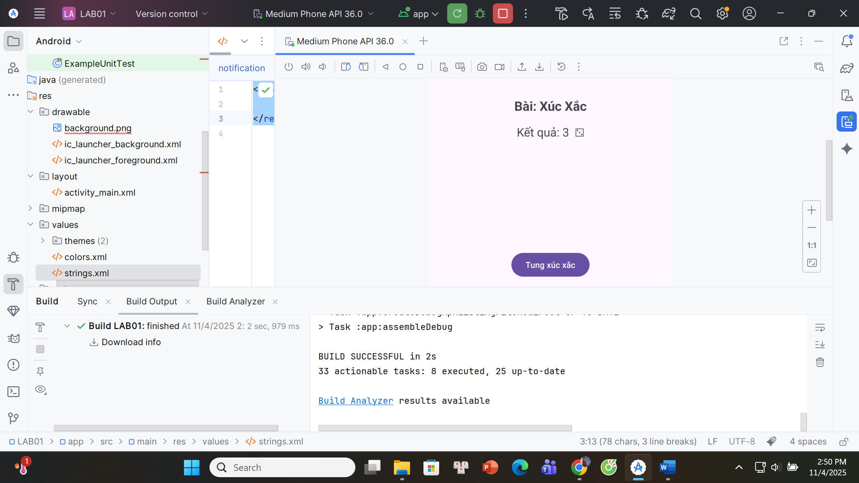

**BƯỚC 1-ANDROID MANIFEST**

<?xml version="1.0" encoding="utf-8"?>

<manifest package="com.example.lab01"

xmlns:android="http://schemas.android.com/apk/res/android">

<application

android:allowBackup="true"

android:icon="@mipmap/ic_launcher"

android:label="@string/app_name"

android:supportsRtl="true"

android:theme="@style/Theme.Material3.DayNight.NoActionBar">

<activity

android:name=".MainActivity"

android:exported="true">

<intent-filter>

<action android:name="android.intent.action.MAIN"/>

<category android:name="android.intent.category.LAUNCHER"/>

</intent-filter>

</activity>

</application>

</manifest>

**BƯỚC 2-STRINGS_xml**

<resources>  
 <string name="app_name">LAB01 - Xúc Xắc</string>  
</resources>

BƯỚC 3-ACTIVITY_MAIN.xml

<?xml version="1.0" encoding="utf-8"?>

<LinearLayout xmlns:android="http://schemas.android.com/apk/res/android"

android:orientation="vertical" android:gravity="center"

android:padding="24dp"

android:layout_width="match_parent" android:layout_height="match_parent">

<TextView

android:id="@+id/tvTitle"

android:text="Bài: Xúc Xắc"

android:textStyle="bold"

android:textSize="22sp"

android:layout_marginBottom="16dp"

android:layout_width="wrap_content" android:layout_height="wrap_content"/>

<TextView

android:id="@+id/tvResult"

android:text="Kết quả: -"

android:textSize="20sp"

android:layout_marginBottom="12dp"

android:layout_width="wrap_content" android:layout_height="wrap_content"/>

<ImageView

android:id="@+id/imgDice"

android:layout_width="160dp"

android:layout_height="160dp"

android:scaleType="centerInside"

android:contentDescription="Hình xúc xắc"

android:layout_marginBottom="16dp"/>

<Button

android:id="@+id/btnRoll"

android:text="Tung xúc xắc"

android:layout_width="wrap_content" android:layout_height="wrap_content"/>

</LinearLayout>

**BƯỚC 3-MAINACTIVITY**

package com.example.lab01;

import androidx.appcompat.app.AppCompatActivity;

import android.os.Bundle;

import android.widget.Button;

import android.widget.ImageView;

import android.widget.TextView;

import java.util.Random;

public class MainActivity extends AppCompatActivity {

TextView tvResult;

ImageView imgDice;

Button btnRoll;

Random rng = new Random();

boolean useDiceImages = false;

@Override

protected void onCreate(Bundle savedInstanceState) {

super.onCreate(savedInstanceState);

setContentView(R.layout.activity_main);

initControl();

addEvents();

}

private void initControl() {

tvResult = findViewById(R.id.tvResult);

imgDice = findViewById(R.id.imgDice);

btnRoll = findViewById(R.id.btnRoll);

}

private void addEvents() {

btnRoll.setOnClickListener(v -> rollDice());

}

private void rollDice() {

int x = 1 + rng.nextInt(6); // 1..6

String[] unicode = {"⚀","⚁","⚂","⚃","⚄","⚅"};

tvResult.setText("Kết quả: " + x + " " + unicode[x-1]);

if (useDiceImages) {

int resId = getDiceResId(x);

if (resId != 0) imgDice.setImageResource(resId);

}

}

// Map 1..6 -> R.drawable.dice_1..dice_6 (nếu có)

private int getDiceResId(int x) {

switch (x) {

case 1: return getResourceIdSafe("dice_1");

case 2: return getResourceIdSafe("dice_2");

case 3: return getResourceIdSafe("dice_3");

case 4: return getResourceIdSafe("dice_4");

case 5: return getResourceIdSafe("dice_5");

case 6: return getResourceIdSafe("dice_6");

}

return 0;

}

private int getResourceIdSafe(String name) {

int id = getResources().getIdentifier(name, "drawable", getPackageName());

return id == 0 ? 0 : id;

}

}

## **Màu nền khác nhau**

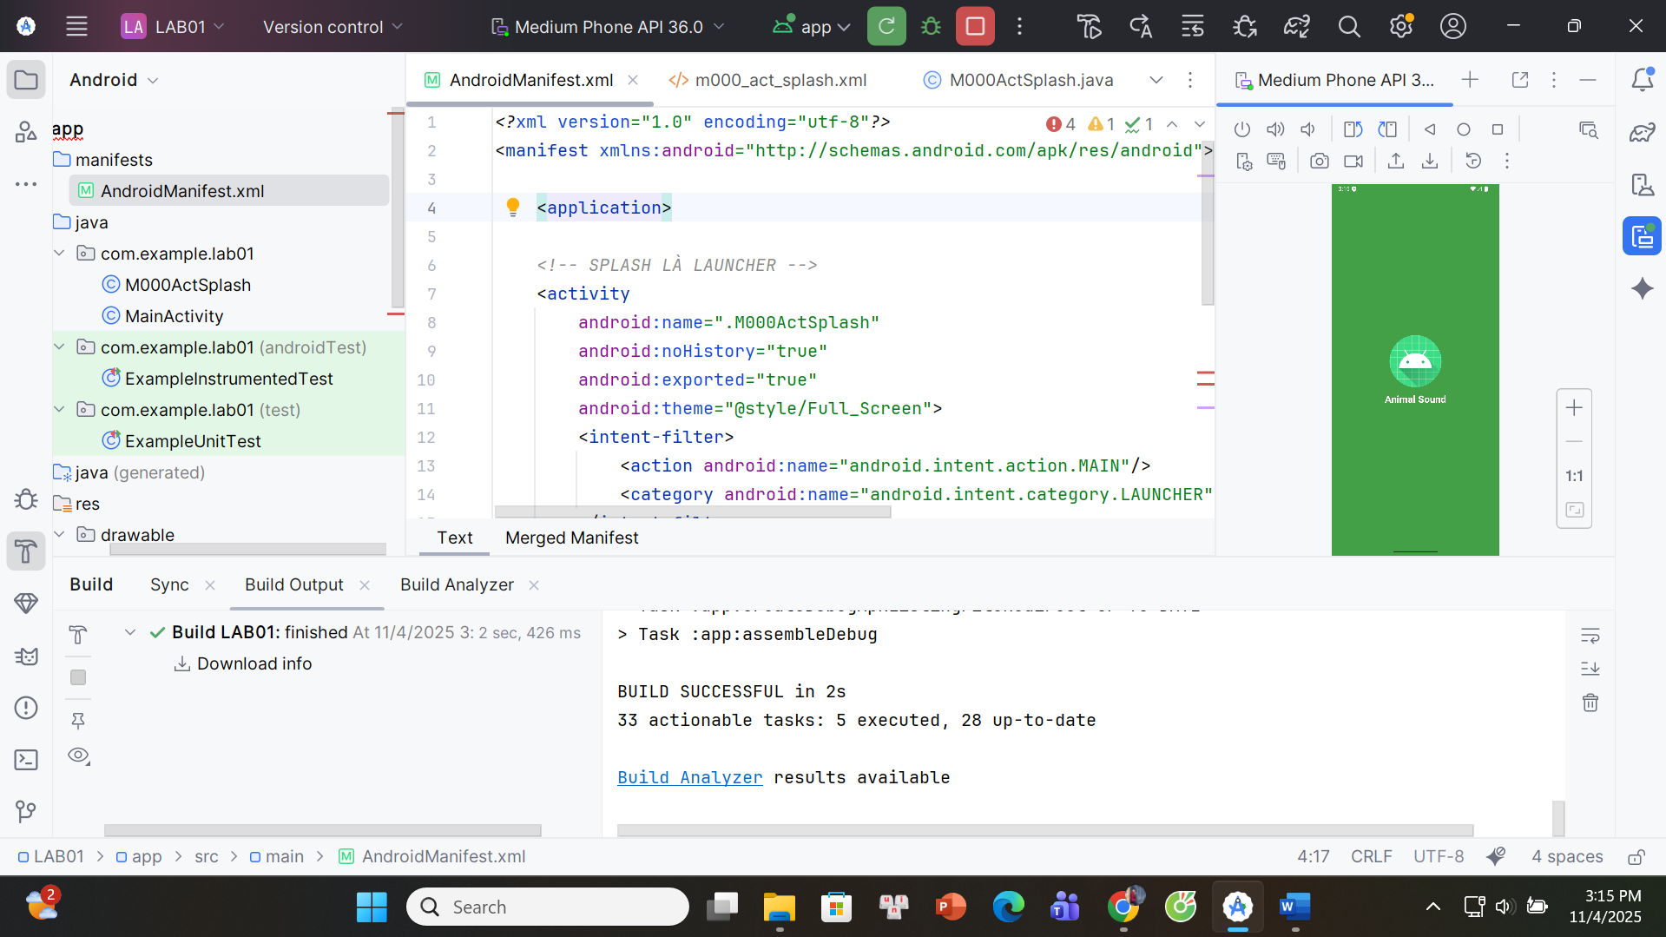

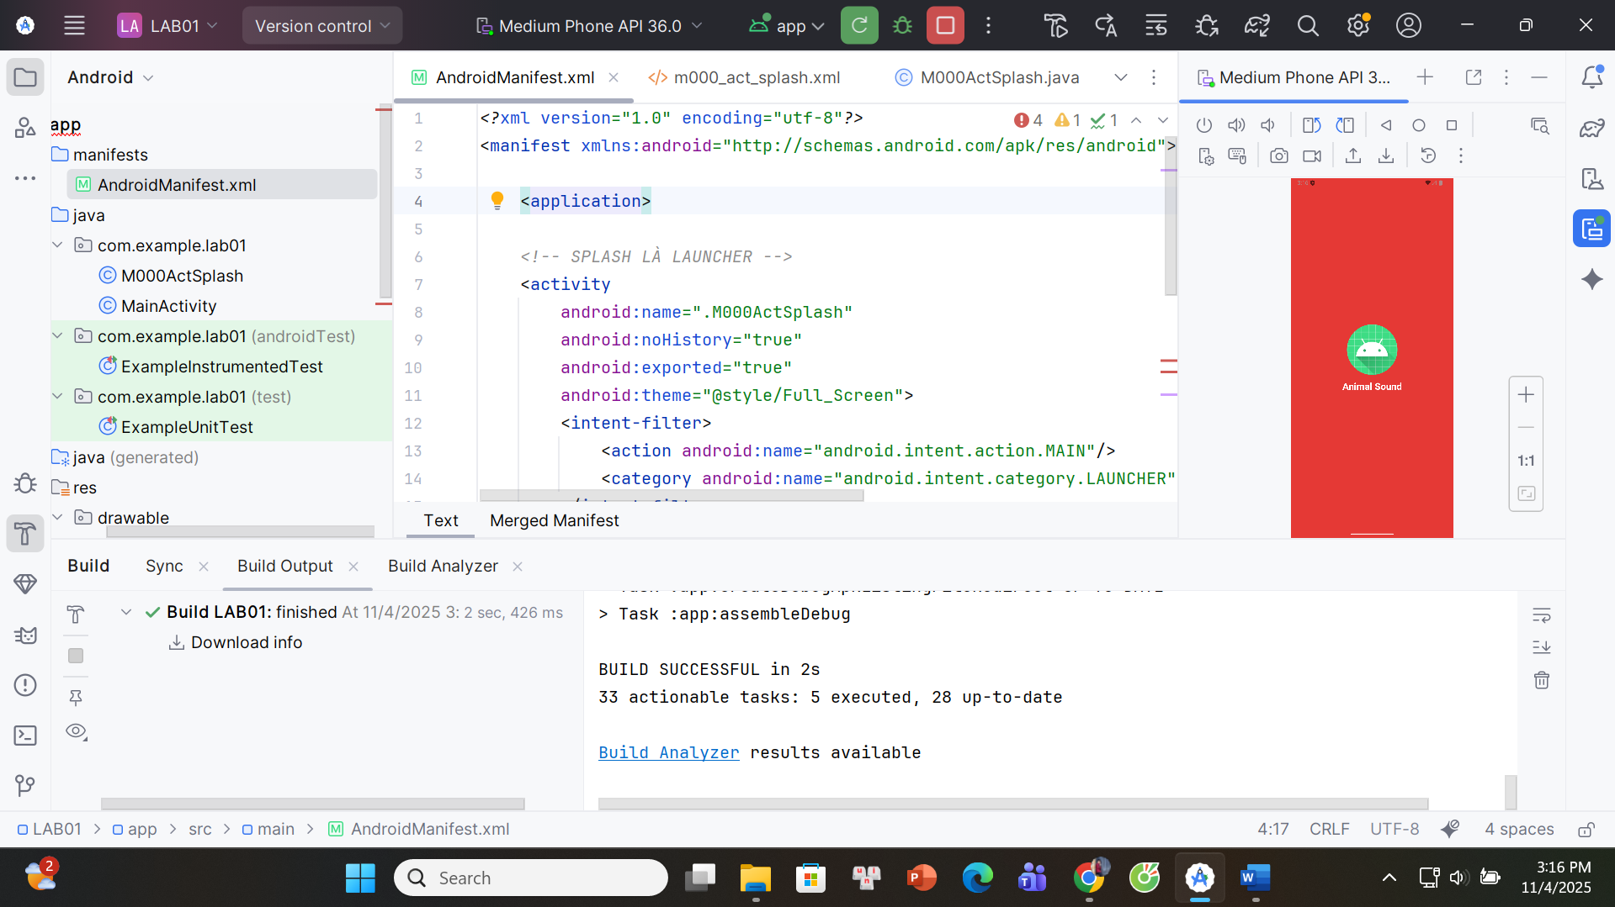

**BƯỚC 1-COLORS.xml**

<resources>

<color name="white">#FFFFFFFF</color>

<color name="rand_1">#1E88E5</color>

<color name="rand_2">#8E24AA</color>

<color name="rand_3">#43A047</color>

<color name="rand_4">#FB8C00</color>

<color name="rand_5">#E53935</color>

</resources>  
**BƯỚC 2-THEME.xml**

<resources>

<style name="Theme.LAB01" parent="Theme.Material3.DayNight.NoActionBar"/>

<style name="Full_Screen" parent="Theme.MaterialComponents.DayNight.NoActionBar"/>

</resources>

**BƯỚC 3-TẠO m000_act_splash.xml**

<?xml version="1.0" encoding="utf-8"?>

<LinearLayout xmlns:android="http://schemas.android.com/apk/res/android"

android:id="@+id/rootSplash"

android:layout_width="match_parent"

android:layout_height="match_parent"

android:gravity="center"

android:orientation="vertical"

android:padding="24dp">

<ImageView

android:id="@+id/imgAnimal"

android:layout_width="128dp"

android:layout_height="128dp"

android:src="@mipmap/ic_launcher"/>

<TextView

android:layout_width="wrap_content"

android:layout_height="wrap_content"

android:text="@string/app_name"

android:textColor="@android:color/white"

android:textSize="24sp"

android:textStyle="bold"

android:layout_marginTop="12dp"/>

</LinearLayout>

**BƯỚC 4-TẠO M000ActSplash**

package com.example.lab01;

import android.graphics.drawable.ColorDrawable;

import android.os.Bundle;

import android.os.Handler;

import android.widget.ImageView;

import android.widget.LinearLayout;

import androidx.annotation.ColorInt;

import androidx.appcompat.app.AppCompatActivity;

import java.util.Random;

public class M000ActSplash extends AppCompatActivity {

private final int[] colorIds = new int[]{

R.color.rand_1, R.color.rand_2, R.color.rand_3, R.color.rand_4, R.color.rand_5

};

private final int[] iconIds = new int[]{

R.drawable.ic_penguin, // nếu chưa có, tạm để dòng dưới

R.mipmap.ic_launcher

};

@Override protected void onCreate(Bundle savedInstanceState) {

super.onCreate(savedInstanceState);

setContentView(R.layout.m000_act_splash);

LinearLayout root = findViewById(R.id.rootSplash);

ImageView img = findViewById(R.id.imgAnimal);

Random rd = new Random();

@ColorInt int color = getResources().getColor(colorIds[rd.nextInt(colorIds.length)]);

int ic = iconIds[rd.nextInt(iconIds.length)];

root.setBackground(new ColorDrawable(color));

img.setImageResource(ic);

// demo: tự thoát sau 1.5s (hoặc chuyển màn khác nếu muốn)

new Handler().postDelayed(this::finish, 1500);

}

}

**BƯỚC 5-ANDROID MANIFEST**

*<?*xml version="1.0" encoding="utf-8"*?>*<manifest xmlns:android="http://schemas.android.com/apk/res/android">  
 <application><activity  
 android:name=".M000ActSplash"  
 android:noHistory="true"  
 android:exported="true"  
 android:theme="@style/Full_Screen">  
 <intent-filter>  
 <action android:name="android.intent.action.MAIN"/>  
 <category android:name="android.intent.category.LAUNCHER"/>  
 </intent-filter>  
 </activity><activity android:name=".MainActivity" />  
 <activity android:name=".M000ActSplashWithLoading" android:noHistory="true" android:theme="@style/Full_Screen"/>  
 <activity android:name=".M001ActProfile"/>  
</application>  
 </manifest>

## **Splash có Custom ProgressBar (overlay)**

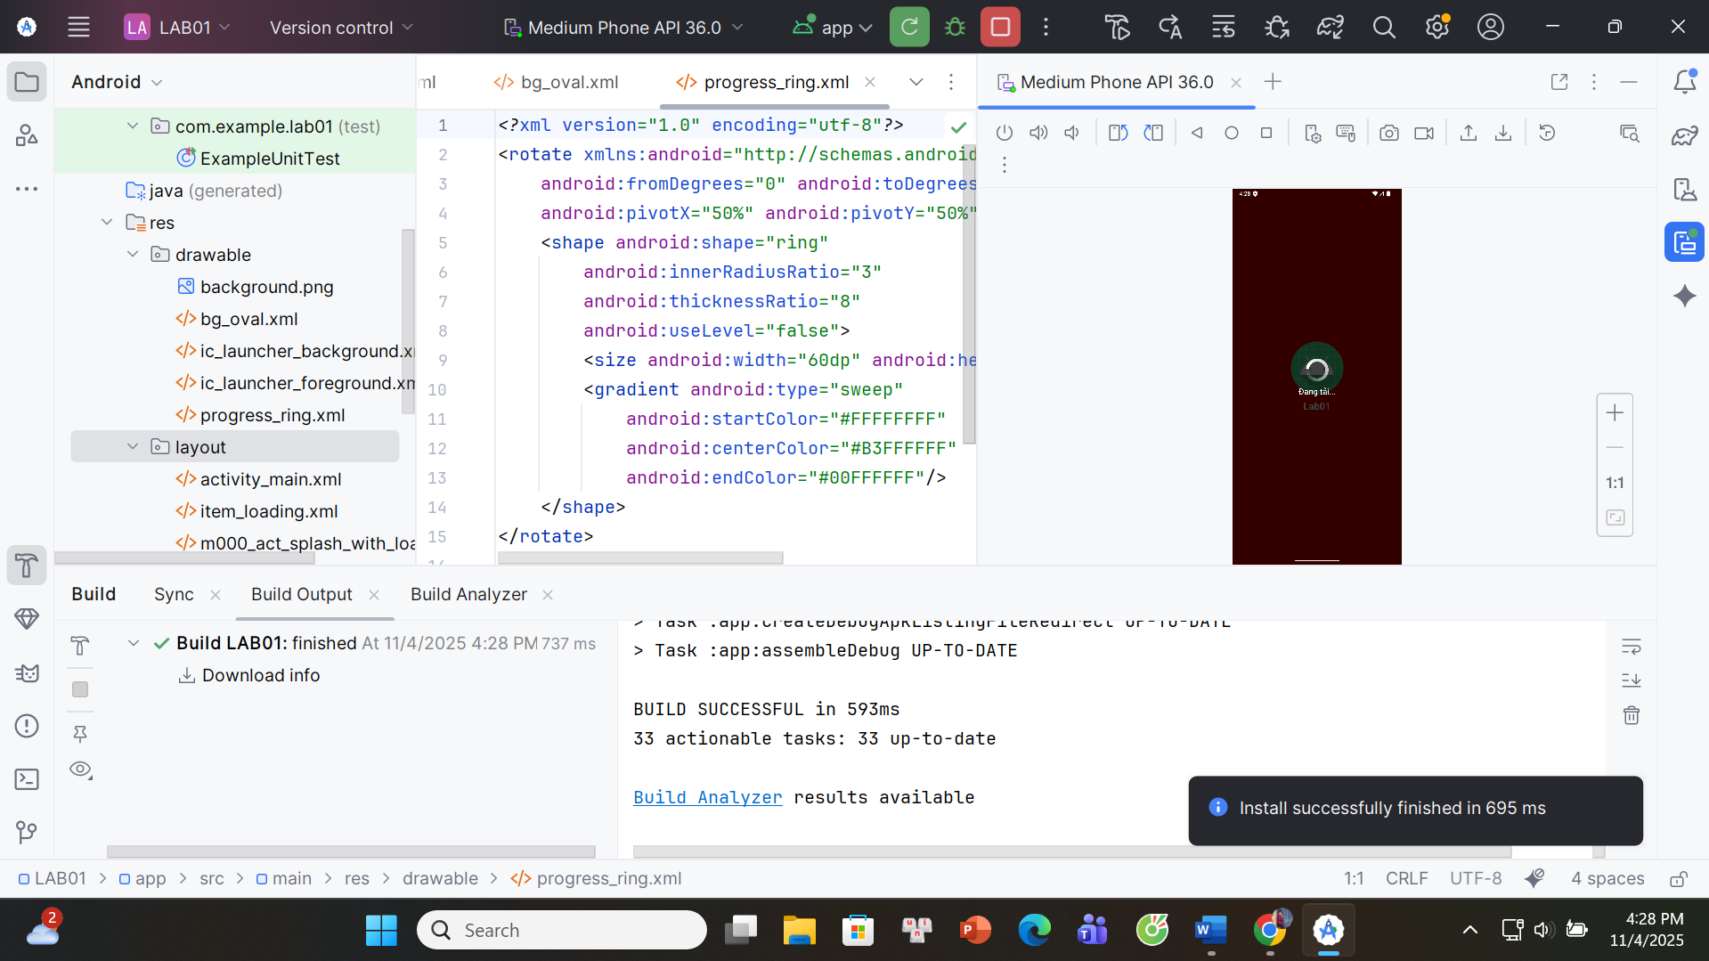

**BƯỚC 1-ANDROID MANIFEST**

<?xml version="1.0" encoding="utf-8"?>

<manifest xmlns:android="http://schemas.android.com/apk/res/android">

<application

android:allowBackup="true"

android:label="@string/app_name"

android:supportsRtl="true"

android:theme="@style/Theme.Material3.DayNight.NoActionBar">

<activity

android:name=".M000ActSplashWithLoading"

android:noHistory="true"

android:exported="true"

android:theme="@style/Theme.Material3.DayNight.NoActionBar">

<intent-filter>

<action android:name="android.intent.action.MAIN"/>

<category android:name="android.intent.category.LAUNCHER"/>

</intent-filter>

</activity>

</application>

</manifest>

**BƯỚC 2-STRINGS.xml**

<?xml version="1.0" encoding="utf-8"?>

<resources>

<string name="app_name">Lab01</string>

<string name="txt_loading">Đang tải...</string>

</resources>

**BƯỚC 3-Tạo progress_ring**

<?xml version="1.0" encoding="utf-8"?>

<rotate xmlns:android="http://schemas.android.com/apk/res/android"

android:fromDegrees="0" android:toDegrees="360"

android:pivotX="50%" android:pivotY="50%">

<shape android:shape="ring"

android:innerRadiusRatio="3"

android:thicknessRatio="8"

android:useLevel="false">

<size android:width="60dp" android:height="60dp"/>

<gradient android:type="sweep"

android:startColor="#FFFFFFFF"

android:centerColor="#B3FFFFFF"

android:endColor="#00FFFFFF"/>

</shape>

</rotate>

**BƯỚC 4-Tạo m000_act_splash_with_loading**

<?xml version="1.0" encoding="utf-8"?>

<FrameLayout xmlns:android="http://schemas.android.com/apk/res/android"

android:layout_width="match_parent" android:layout_height="match_parent">

<!-- Nội dung Splash -->

<LinearLayout

android:id="@+id/rootSplash2"

android:layout_width="match_parent" android:layout_height="match_parent"

android:gravity="center" android:orientation="vertical" android:padding="24dp">

<ImageView

android:id="@+id/imgAnimal2"

android:layout_width="128dp" android:layout_height="128dp"

android:src="@mipmap/ic_launcher"/>

<TextView

android:layout_width="wrap_content" android:layout_height="wrap_content"

android:text="@string/app_name" android:textColor="@android:color/white"

android:textSize="24sp" android:textStyle="bold" android:layout_marginTop="12dp"/>

</LinearLayout>

<include

android:id="@+id/loadingOverlay"

layout="@layout/item_loading"/>

</FrameLayout>

**BƯỚC 5-Tạo M000ActSplashWithLoading**

package com.example.lab01;

import android.graphics.drawable.ColorDrawable;

import android.os.Bundle;

import android.os.Handler;

import android.view.View;

import android.widget.ImageView;

import android.widget.LinearLayout;

import androidx.appcompat.app.AppCompatActivity;

import androidx.core.content.ContextCompat;

import java.util.Random;

public class M000ActSplashWithLoading extends AppCompatActivity {

@Override protected void onCreate(Bundle b) {

super.onCreate(b);

setContentView(R.layout.m000_act_splash_with_loading);

LinearLayout root = findViewById(R.id.rootSplash2);

ImageView img = findViewById(R.id.imgAnimal2);

View overlay = findViewById(R.id.loadingOverlay);

// Random nền (dùng màu hệ thống cho gọn)

int[] colors = new int[]{

android.R.color.holo_blue_dark,

android.R.color.holo_purple,

android.R.color.holo_green_dark,

android.R.color.holo_orange_dark,

android.R.color.holo_red_dark

};

int bg = ContextCompat.getColor(this, colors[new Random().nextInt(colors.length)]);

root.setBackground(new ColorDrawable(bg));

// Icon (có thể thay bằng @drawable/ic_penguin nếu đã thêm)

img.setImageResource(R.mipmap.ic_launcher);

// Hiện overlay 2 giây rồi ẩn

overlay.setVisibility(View.VISIBLE);

new Handler().postDelayed(() -> overlay.setVisibility(View.GONE), 2000);

}

*}*

## **Bấm vào icon chuyển về cuộc gọi**

**BƯỚC 1-STRINGS.xml**

<resources>

<string name="app_name">Profile</string>

<string name="txt_name">Ali Connors</string>

<string name="txt_phone1">(650) 555-1234</string>

<string name="txt_phone2">(323) 555-6789</string>

<string name="txt_title_mobile">Mobile</string>

<string name="txt_email">aliconnors@example.com</string>

</resources>

**BƯỚC 2-TẠO m001_act_profile**

<?xml version="1.0" encoding="utf-8"?>

<LinearLayout xmlns:android="http://schemas.android.com/apk/res/android"

android:layout_width="match_parent" android:layout_height="match_parent"

android:orientation="vertical" android:background="#FAFAFA">

<!-- Header -->

<FrameLayout

android:layout_width="match_parent" android:layout_height="260dp">

<!-- Ảnh nền: tạm dùng ic_launcher, có ảnh thì đổi -->

<ImageView

android:id="@+id/imgBg"

android:layout_width="match_parent" android:layout_height="match_parent"

android:scaleType="centerCrop" android:src="@mipmap/ic_launcher"/>

<TextView

android:id="@+id/tvName"

android:layout_width="wrap_content" android:layout_height="wrap_content"

android:text="@string/txt_name" android:textColor="@android:color/white"

android:textSize="30sp" android:textStyle="bold"

android:layout_gravity="bottom|start" android:layout_margin="24dp"/>

<ImageView

android:id="@+id/btnFav"

android:layout_width="68dp" android:layout_height="68dp"

android:layout_gravity="bottom|end" android:layout_margin="16dp"

android:background="@drawable/bg_oval" android:padding="16dp"

android:src="@mipmap/ic_launcher" android:tint="@android:color/white"/>

</FrameLayout>

<!-- Phone block -->

<LinearLayout

android:layout_width="match_parent" android:layout_height="wrap_content"

android:orientation="horizontal" android:padding="20dp">

<ImageView

android:id="@+id/icPhone"

android:layout_width="60dp" android:layout_height="60dp"

android:padding="10dp" android:src="@mipmap/ic_launcher"

android:tint="#424FB7"/>

<LinearLayout

android:layout_width="0dp" android:layout_height="wrap_content"

android:layout_weight="1" android:orientation="vertical"

android:layout_marginStart="16dp">

<TextView

android:layout_width="wrap_content" android:layout_height="wrap_content"

android:text="@string/txt_phone1" android:textSize="18sp" android:textColor="#535353"/>

<TextView

android:layout_width="wrap_content" android:layout_height="wrap_content"

android:text="@string/txt_title_mobile" android:textSize="14sp" android:textColor="#979797"/>

<View

android:layout_width="match_parent" android:layout_height="0.5dp"

android:background="#979797" android:layout_marginTop="16dp"/>

<TextView

android:layout_width="wrap_content" android:layout_height="wrap_content"

android:text="@string/txt_phone2" android:textSize="18sp"

android:textColor="#535353" android:layout_marginTop="16dp"/>

<TextView

android:layout_width="wrap_content" android:layout_height="wrap_content"

android:text="@string/txt_title_mobile" android:textSize="14sp" android:textColor="#979797"/>

</LinearLayout>

</LinearLayout>

<!-- Email block -->

<LinearLayout

android:layout_width="match_parent" android:layout_height="wrap_content"

android:orientation="horizontal" android:padding="20dp">

<ImageView

android:id="@+id/icEmail"

android:layout_width="60dp" android:layout_height="60dp"

android:padding="10dp" android:src="@mipmap/ic_launcher"

android:tint="#424FB7"/>

<TextView

android:layout_width="wrap_content" android:layout_height="wrap_content"

android:text="@string/txt_email" android:textSize="18sp"

android:textColor="#535353" android:layout_marginStart="16dp"/>

</LinearLayout>

</LinearLayout>

**BƯỚC 3-TẠO bg_oval**

<?xml version="1.0" encoding="utf-8"?>

<shape xmlns:android="http://schemas.android.com/apk/res/android" android:shape="oval">

<solid android:color="#FF4181"/>

</shape>

**BƯỚC 4-ANDROID MANIFEST**

*<?*xml version="1.0" encoding="utf-8"*?>*<manifest xmlns:android="http://schemas.android.com/apk/res/android">  
 <application  
 android:allowBackup="true"  
 android:label="@string/app_name"  
 android:supportsRtl="true"  
 android:theme="@style/Theme.Material3.DayNight.NoActionBar"><activity  
 android:name=".M001ActProfile"  
 android:exported="true">  
 <intent-filter>  
 <action android:name="android.intent.action.MAIN"/>  
 <category android:name="android.intent.category.LAUNCHER"/>  
 </intent-filter>  
 </activity>  
 </application>  
</manifest>

**BƯỚC 5-TẠO M001ActProfile.java**

package com.example.lab01;

import android.content.Intent;

import android.net.Uri;

import android.os.Bundle;

import android.widget.ImageView;

import androidx.appcompat.app.AppCompatActivity;

public class M001ActProfile extends AppCompatActivity {

@Override protected void onCreate(Bundle b) {

super.onCreate(b);

setContentView(R.layout.m001_act_profile);

ImageView icPhone = findViewById(R.id.icPhone);

ImageView icEmail = findViewById(R.id.icEmail);

// Bấm icon điện thoại -> mở trình quay số (không cần permission)

icPhone.setOnClickListener(v ->

startActivity(new Intent(Intent.ACTION_DIAL, Uri.parse("tel:(650)555-1234")))

);

// Bấm icon email -> mở app email

icEmail.setOnClickListener(v -> {

Intent i = new Intent(Intent.ACTION_SENDTO, Uri.parse("mailto:aliconnors@example.com"));

i.putExtra(Intent.EXTRA_SUBJECT, "Liên hệ nhanh");

i.putExtra(Intent.EXTRA_TEXT, "Chào Ali, ...");

startActivity(i);

});

}

}

## **Tạo màn hình chính MainActivity**

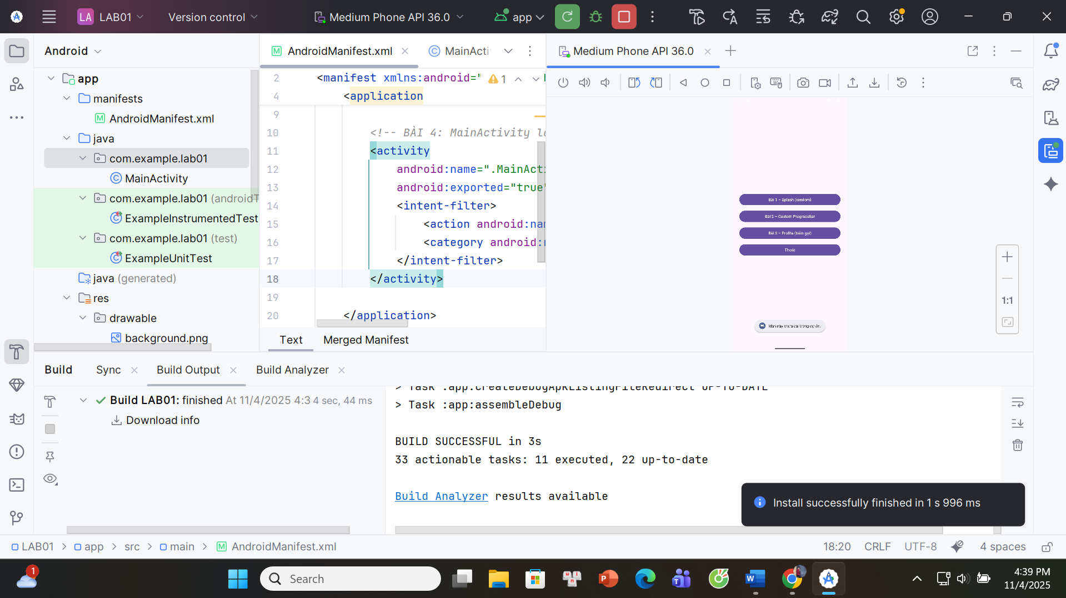

**BƯỚC 1-ANDROID MANIFEST**

<?xml version="1.0" encoding="utf-8"?>

<manifest xmlns:android="http://schemas.android.com/apk/res/android">

<application

android:allowBackup="true"

android:label="@string/app_name"

android:supportsRtl="true"

android:theme="@style/Theme.Material3.DayNight.NoActionBar">

<activity

android:name=".MainActivity"

android:exported="true">

<intent-filter>

<action android:name="android.intent.action.MAIN"/>

<category android:name="android.intent.category.LAUNCHER"/>

</intent-filter>

</activity>

</application>

</manifest>

**BƯỚC 2-Strings.xml**

<?xml version="1.0" encoding="utf-8"?>

<resources>

<string name="app_name">LAB01</string>

<string name="b1">Bài 1 – Splash (random)</string>

<string name="b2">Bài 2 – Custom ProgressBar</string>

<string name="b3">Bài 3 – Profile (bấm gọi)</string>

<string name="exit">Thoát</string>

<string name="chua_cai">Màn này chưa cài trong dự án.</string>

</resources>

**BƯỚC 3-ACTIVITY_MAIN.xml**

<?xml version="1.0" encoding="utf-8"?>

<LinearLayout xmlns:android="http://schemas.android.com/apk/res/android"

android:layout_width="match_parent"

android:layout_height="match_parent"

android:orientation="vertical"

android:padding="24dp"

android:gravity="center">

<Button

android:id="@+id/btnBai1"

android:layout_width="match_parent"

android:layout_height="wrap_content"

android:text="@string/b1"/>

<Button

android:id="@+id/btnBai2"

android:layout_width="match_parent"

android:layout_height="wrap_content"

android:text="@string/b2"

android:layout_marginTop="12dp"/>

<Button

android:id="@+id/btnBai3"

android:layout_width="match_parent"

android:layout_height="wrap_content"

android:text="@string/b3"

android:layout_marginTop="12dp"/>

<Button

android:id="@+id/btnExit"

android:layout_width="match_parent"

android:layout_height="wrap_content"

android:text="@string/exit"

android:layout_marginTop="12dp"/>

</LinearLayout>

**BƯỚC 4-MAIN ACTIVITY.java**

package com.example.lab01;

import android.content.Intent;

import android.os.Bundle;

import android.widget.Toast;

import androidx.appcompat.app.AppCompatActivity;

public class MainActivity extends AppCompatActivity {

@Override protected void onCreate(Bundle savedInstanceState) {

super.onCreate(savedInstanceState);

setContentView(R.layout.activity_main);

findViewById(R.id.btnBai1).setOnClickListener(v ->

startIfExists("com.example.lab01.M000ActSplash"));

findViewById(R.id.btnBai2).setOnClickListener(v ->

startIfExists("com.example.lab01.M000ActSplashWithLoading"));

findViewById(R.id.btnBai3).setOnClickListener(v ->

startIfExists("com.example.lab01.M001ActProfile"));

findViewById(R.id.btnExit).setOnClickListener(v -> finish());

}

private void startIfExists(String className) {

try {

Class<?> c = Class.forName(className);

startActivity(new Intent(this, c));

} catch (ClassNotFoundException e) {

Toast.makeText(this, getString(R.string.chua_cai), Toast.LENGTH_SHORT).show();

}

}

}

# **LAB 2**

## **Truyện cười**

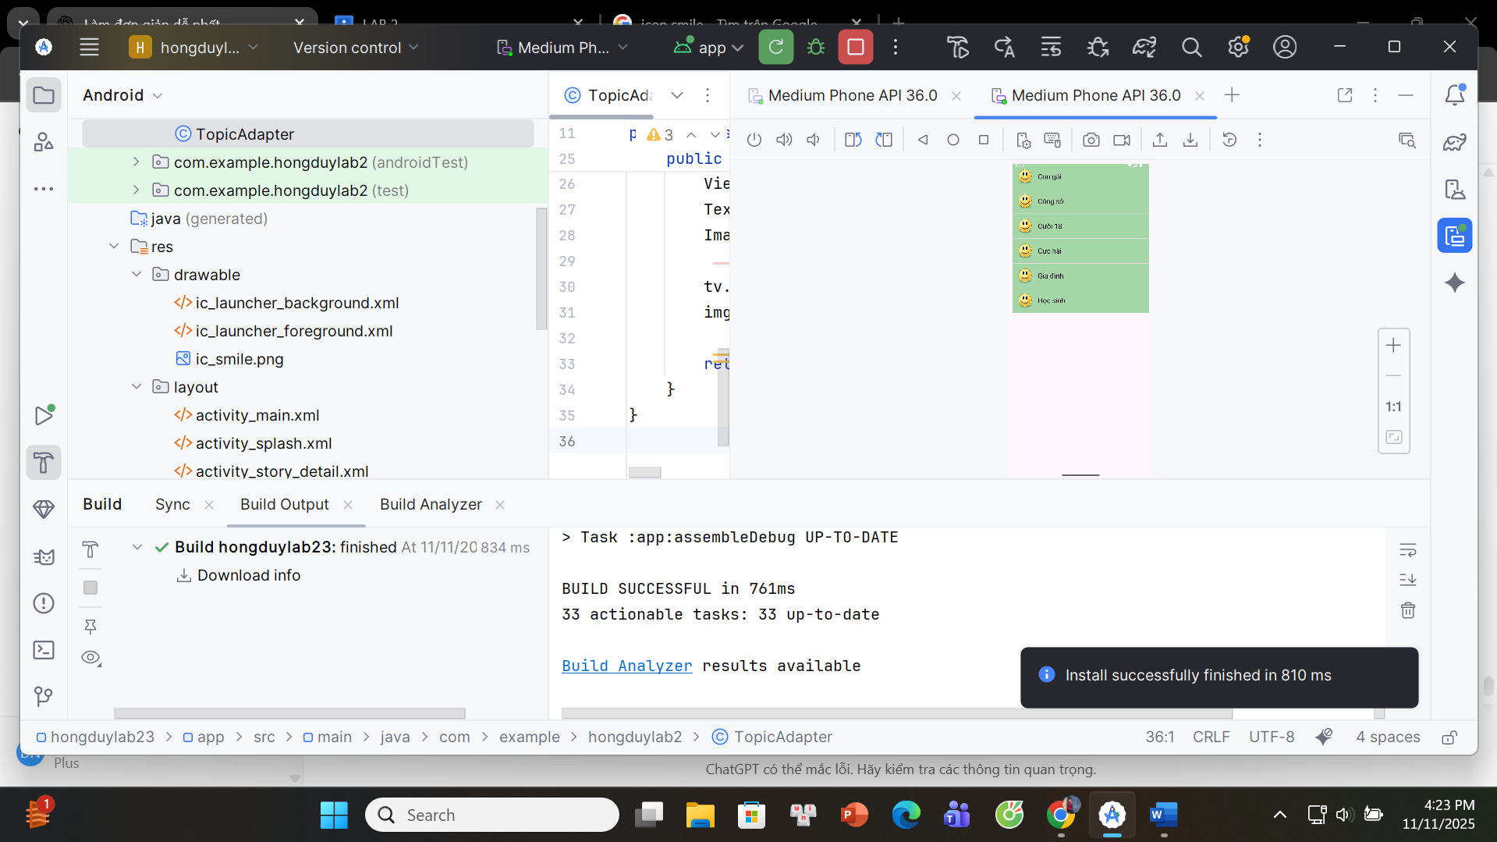

**AndroidManifest.xml**

<manifest xmlns:android="http://schemas.android.com/apk/res/android"  
 package="com.example.hongduylab2">  
 <application  
 android:theme="@style/Theme.Material3.Light.NoActionBar">  
 <activity android:name=".StoryDetailActivity" android:exported="false"/>  
 <activity android:name=".StoryListActivity" android:exported="false"/>  
 <activity android:name=".MainActivity" android:exported="false"/>  
 <activity android:name=".SplashActivity" android:exported="true">  
 <intent-filter>  
 <action android:name="android.intent.action.MAIN"/>  
 <category android:name="android.intent.category.LAUNCHER"/>  
 </intent-filter>  
 </activity>  
 </application>  
</manifest>

topic_item.xml (item_topic.xml)

<LinearLayout xmlns:android="http://schemas.android.com/apk/res/android"  
 android:layout_width="match_parent"  
 android:layout_height="70dp"  
 android:orientation="horizontal"  
 android:gravity="center_vertical"  
 android:padding="10dp"  
 android:background="#A5D6A7"  
 android:layout_marginBottom="6dp">  
 <ImageView  
 android:id="@+id/imgTopic"  
 android:layout_width="50dp"  
 android:layout_height="50dp"  
 android:src="@drawable/ic_smile" />  
 <TextView  
 android:id="@+id/tvTopic"  
 android:textSize="20sp"  
 android:textColor="#000000"  
 android:layout_marginStart="12dp"  
 android:layout_width="wrap_content"  
 android:layout_height="wrap_content" />  
</LinearLayout>

**SplashActivity.java**

package com.example.hongduylab2;  
import android.content.Intent;  
import android.os.Bundle;  
import android.os.Handler;  
import androidx.appcompat.app.AppCompatActivity;  
  
public class SplashActivity extends AppCompatActivity {  
  
 @Override  
 protected void onCreate(Bundle savedInstanceState) {  
 super.onCreate(savedInstanceState);  
 setContentView(R.layout.activity_splash);  
  
 new Handler().postDelayed(() -> {  
 startActivity(new Intent(SplashActivity.this, MainActivity.class));  
 finish();  
 }, 1500);  
 }  
}

**MainActivity.java**

package com.example.hongduylab2;  
import androidx.appcompat.app.AppCompatActivity;  
import android.os.Bundle;  
import android.widget.ListView;  
import android.content.Intent;  
public class MainActivity extends AppCompatActivity {  
 String[] topics = {"Con gái", "Công sở", "Cười 18", "Cực hài", "Gia đình", "Học sinh"};  
 int icon = R.drawable.ic_smile;  
  
 @Override  
 protected void onCreate(Bundle savedInstanceState) {  
 super.onCreate(savedInstanceState);  
 setContentView(R.layout.activity_main);  
  
 ListView list = findViewById(R.id.listTopic);  
 TopicAdapter adapter = new TopicAdapter(this, topics, icon);  
 list.setAdapter(adapter);  
  
 list.setOnItemClickListener((adapterView, view, i, l) -> {  
 Intent intent = new Intent(MainActivity.this, StoryListActivity.class);  
 intent.putExtra("topic", topics[i]);  
 startActivity(intent);  
 });  
 }  
**}**

**TopicAdapter.java**

package com.example.hongduylab2;  
import android.content.Context;  
import android.view.LayoutInflater;  
import android.view.View;  
import android.view.ViewGroup;  
import android.widget.ArrayAdapter;  
import android.widget.ImageView;  
import android.widget.TextView;  
public class TopicAdapter extends ArrayAdapter<String> {  
 Context context;  
 String[] titles;  
 int icon;  
  
 public TopicAdapter(Context ctx, String[] titles, int icon) {  
 super(ctx, R.layout.item_topic, titles);  
 this.context = ctx;  
 this.titles = titles;  
 this.icon = icon;  
 }  
  
 @Override  
 public View getView(int position, View convertView, ViewGroup parent) {  
 View row = LayoutInflater.from(context).inflate(R.layout.item_topic, parent, false);  
 TextView tv = row.findViewById(R.id.tvTopic);  
 ImageView img = row.findViewById(R.id.imgTopic);  
 tv.setText(titles[position]);  
 img.setImageResource(icon);  
 return row;  
 }  
}

**StoryListActivity.java**

package com.example.hongduylab2;  
import androidx.appcompat.app.AppCompatActivity;  
import android.os.Bundle;  
import android.widget.ArrayAdapter;  
import android.widget.ListView;  
import android.content.Intent;  
public class StoryListActivity extends AppCompatActivity {  
 String[] stories = {"Việc học", "Cười 1 phút", "Chưa chi đã đau"};  
 @Override  
 protected void onCreate(Bundle savedInstanceState) {  
 super.onCreate(savedInstanceState);  
 setContentView(R.layout.activity_story_list);  
  
 ListView list = findViewById(R.id.listStory);  
 list.setAdapter(new ArrayAdapter<>(this, android.R.layout.simple_list_item_1, stories));  
  
 list.setOnItemClickListener((parent, view, position, id) -> {  
 Intent intent = new Intent(StoryListActivity.this, StoryDetailActivity.class);  
 intent.putExtra("name", stories[position]);  
 startActivity(intent);  
 });  
 }  
}

**StoryDetailActivity.java**

package com.example.hongduylab2;  
import androidx.appcompat.app.AppCompatActivity;  
import android.os.Bundle;  
import android.widget.TextView;  
  
public class StoryDetailActivity extends AppCompatActivity {  
  
 @Override  
 protected void onCreate(Bundle savedInstanceState) {  
 super.onCreate(savedInstanceState);  
 setContentView(R.layout.activity_story_detail);  
  
 TextView tv = findViewById(R.id.tvDetail);  
 String name = getIntent().getStringExtra("name");  
 setTitle(name);  
  
 if (name.equals("Việc học")) {  
 tv.setText("Lúc bé thì tưởng học là chơi, lớn lên mới biết học là học...");  
 } else if (name.equals("Cười 1 phút")) {  
 tv.setText("Một phút để cười là một phút không phí...");  
 } else {  
 tv.setText("Chưa chi đã đau là tình trạng...");  
 }  
 }  
}

## **Bài Con Thỏ+Bài tập**

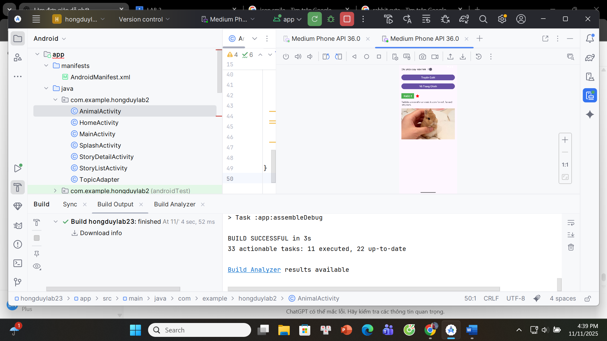

**AnimalActivity.java**

package com.example.hongduylab2;  
import androidx.appcompat.app.AppCompatActivity;  
import android.os.Bundle;  
import android.widget.Button;  
import android.widget.Switch;  
import android.content.Intent;  
import android.content.pm.ActivityInfo;  
import android.widget.ImageView;  
import android.widget.TextView;  
public class AnimalActivity extends AppCompatActivity {  
 @Override  
 protected void onCreate(Bundle savedInstanceState) {  
 super.onCreate(savedInstanceState);  
 setContentView(R.layout.activity_animal);  
  
 TextView tvName = findViewById(R.id.tvName);  
 TextView tvDescription = findViewById(R.id.tvDescription);  
 ImageView imgAnimal = findViewById(R.id.imgAnimal);  
 ImageView imgHeart = findViewById(R.id.imgHeart);  
 Switch swRotate = findViewById(R.id.swRotate);  
 Button btnToTruyen = findViewById(R.id.btnToTruyen);  
 Button btnToHome = findViewById(R.id.btnToHome);  
 tvName.setText("Rabbit");  
 tvDescription.setText("Rabbits are small mammals known for their long ears and soft fur. They are friendly animals and can be found worldwide.");  
 imgAnimal.setImageResource(R.drawable.rabbit);  
 swRotate.setOnCheckedChangeListener((buttonView, isChecked) -> {  
 if (isChecked) {  
 setRequestedOrientation(ActivityInfo.SCREEN_ORIENTATION_UNSPECIFIED);  
 } else {  
 setRequestedOrientation(ActivityInfo.SCREEN_ORIENTATION_PORTRAIT);  
 }  
 });  
 btnToTruyen.setOnClickListener(v ->  
 startActivity(new Intent(AnimalActivity.this, MainActivity.class)));  
 btnToHome.setOnClickListener(v ->  
 startActivity(new Intent(AnimalActivity.this, HomeActivity.class)));  
 }  
}

**activity_animal.xml**

<ScrollView xmlns:android="http://schemas.android.com/apk/res/android"  
 android:layout_width="match_parent"  
 android:layout_height="match_parent"  
 android:padding="16dp">  
 <LinearLayout  
 android:orientation="vertical"  
 android:layout_width="match_parent"  
 android:layout_height="wrap_content">  
 <Switch  
 android:id="@+id/swRotate"  
 android:layout_width="wrap_content"  
 android:layout_height="wrap_content"  
 android:text="Cho phép xoay màn hình"  
 android:textSize="16sp"  
 android:checked="true"  
 android:layout_marginBottom="20dp"/>  
 <Button  
 android:id="@+id/btnToTruyen"  
 android:layout_width="match_parent"  
 android:layout_height="wrap_content"  
 android:text="Truyện Cười"  
 android:textSize="18sp"  
 android:layout_marginBottom="10dp"/>  
 <Button  
 android:id="@+id/btnToHome"  
 android:layout_width="match_parent"  
 android:layout_height="wrap_content"  
 android:text="Về Trang Chính"  
 android:textSize="18sp"  
 android:layout_marginBottom="25dp"/>  
 <LinearLayout  
 android:layout_width="wrap_content"  
 android:layout_height="wrap_content"  
 android:gravity="center_vertical"  
 android:orientation="horizontal">  
 <TextView  
 android:id="@+id/tvName"  
 android:layout_width="wrap_content"  
 android:layout_height="wrap_content"  
 android:background="#4CAF50"  
 android:textColor="#FFFFFF"  
 android:textSize="20sp"  
 android:paddingHorizontal="16dp"  
 android:paddingVertical="6dp"  
 android:text="Rabbit"/>  
 <ImageView  
 android:id="@+id/imgHeart"  
 android:layout_width="28dp"  
 android:layout_height="28dp"  
 android:layout_marginStart="10dp"  
 android:src="@android:drawable/btn_star_big_on"  
 android:tint="#FF0000"/>  
 </LinearLayout>  
 <TextView  
 android:id="@+id/tvDescription"  
 android:layout_width="match_parent"  
 android:layout_height="wrap_content"  
 android:textSize="16sp"  
 android:layout_marginTop="12dp"  
 android:text="Rabbits are small mammals known for soft fur and long ears."/>  
  
 <ImageView  
 android:id="@+id/imgAnimal"  
 android:layout_width="match_parent"  
 android:layout_height="220dp"  
 android:layout_marginTop="16dp"  
 android:scaleType="centerCrop"  
 android:src="@drawable/rabbit"/>  
 </LinearLayout>  
</ScrollView>

## **Đăng nhập**

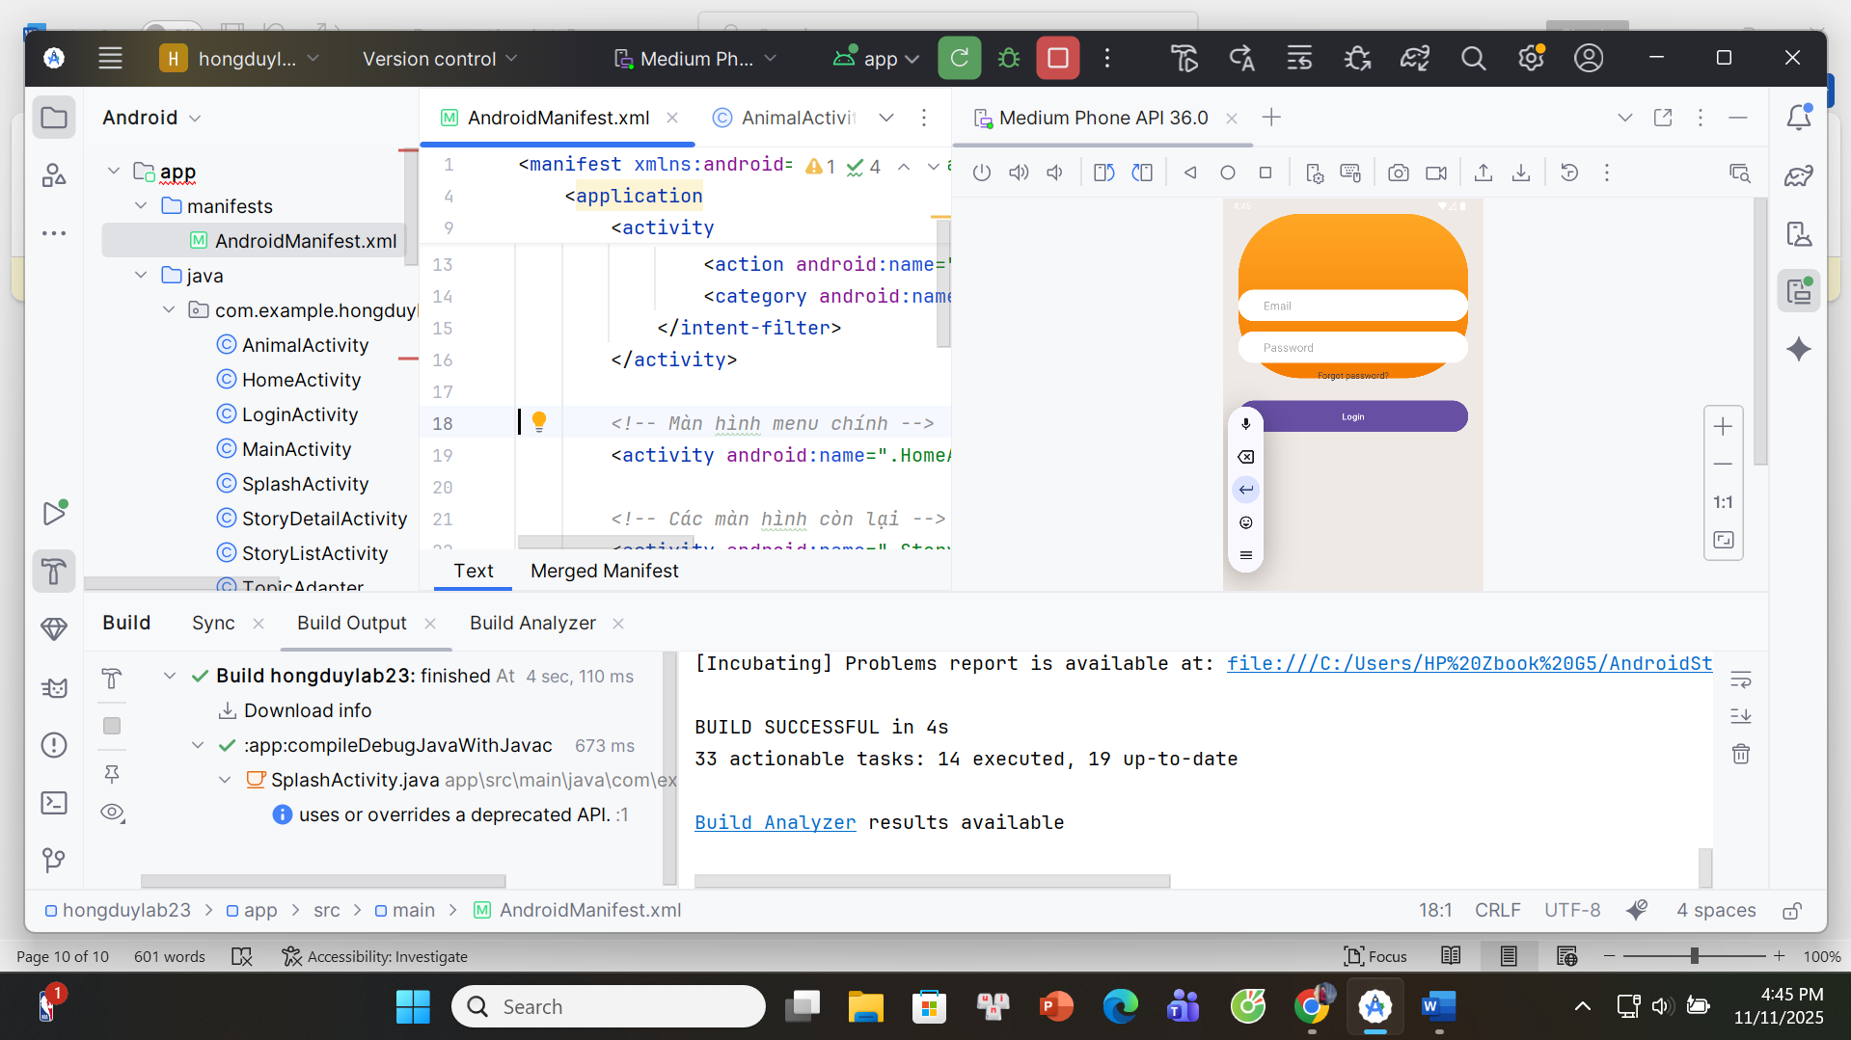

**LoginActivity.java**

package com.example.hongduylab2;  
import androidx.appcompat.app.AppCompatActivity;  
import android.content.Intent;  
import android.os.Bundle;  
import android.widget.Button;  
import android.widget.EditText;  
public class LoginActivity extends AppCompatActivity {  
 @Override  
 protected void onCreate(Bundle savedInstanceState) {  
 super.onCreate(savedInstanceState);  
 setContentView(R.layout.activity_login);  
 EditText edtEmail = findViewById(R.id.edtEmail);  
 EditText edtPassword = findViewById(R.id.edtPassword);  
 Button btnLogin = findViewById(R.id.btnLogin);  
  
 btnLogin.setOnClickListener(v ->   
 startActivity(new Intent(LoginActivity.this, HomeActivity.class)));  
 }  
}

**activity_login.xml**

<LinearLayout xmlns:android="http://schemas.android.com/apk/res/android"  
 android:orientation="vertical"  
 android:layout_width="match_parent"  
 android:layout_height="match_parent"  
 android:background="#EFE9E5"  
 android:padding="24dp">  
 <View  
 android:layout_width="match_parent"  
 android:layout_height="260dp"  
 android:background="@drawable/bg_top_curve" />  
 <EditText  
 android:id="@+id/edtEmail"  
 android:layout_width="match_parent"  
 android:layout_height="50dp"  
 android:layout_marginTop="-140dp"  
 android:hint="Email"  
 android:paddingLeft="40dp"  
 android:background="@drawable/bg_input"/>  
 <EditText  
 android:id="@+id/edtPassword"  
 android:layout_width="match_parent"  
 android:layout_height="50dp"  
 android:layout_marginTop="16dp"  
 android:hint="Password"  
 android:paddingLeft="40dp"  
 android:background="@drawable/bg_input"/>  
  
 <Button  
 android:id="@+id/btnLogin"  
 android:layout_width="match_parent"  
 android:layout_height="50dp"  
 android:text="Login"  
 android:background="@drawable/bg_button"  
 android:layout_marginTop="30dp"/>  
</LinearLayout>

## **Ứng dụng Learning**

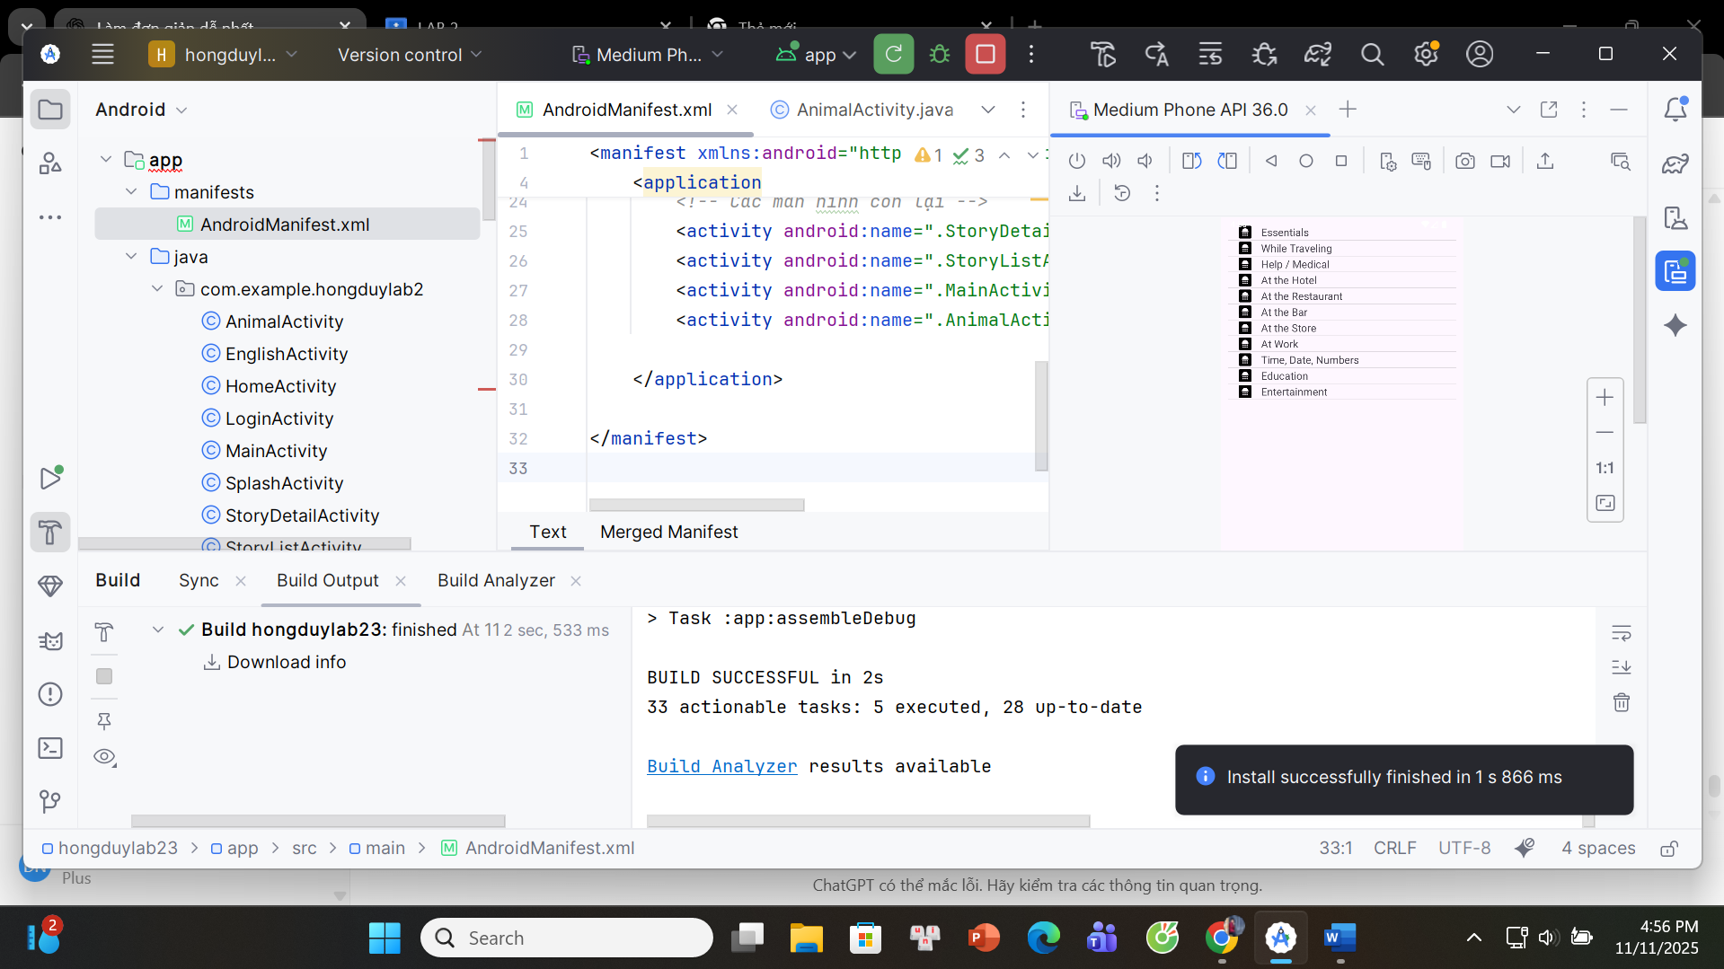

**EnglishActivity.java**

package com.example.hongduylab2;  
import androidx.appcompat.app.AppCompatActivity;  
import android.os.Bundle;  
import android.widget.ListView;  
public class EnglishActivity extends AppCompatActivity {  
 String[] topics = {  
 "Essentials",  
 "While Traveling",  
 "Help / Medical",  
 "At the Hotel",  
 "At the Restaurant",  
 "At the Bar",  
 "At the Store",  
 "At Work",  
 "Time, Date, Numbers",  
 "Education",  
 "Entertainment"  
 };  
 int[] icons = {  
 R.drawable.ic_essentials,  
 R.drawable.ic_travel,  
 R.drawable.ic_medical,  
 R.drawable.ic_hotel,  
 R.drawable.ic_restaurant,  
 R.drawable.ic_bar,  
 R.drawable.ic_store,  
 R.drawable.ic_work,  
 R.drawable.ic_time,  
 R.drawable.ic_education,  
 R.drawable.ic_entertainment  
 };  
 @Override  
 protected void onCreate(Bundle savedInstanceState) {  
 super.onCreate(savedInstanceState);  
 setContentView(R.layout.activity_english);  
 ListView listView = findViewById(R.id.listVocab);  
 VocabAdapter adapter = new VocabAdapter(this, topics, icons);  
 listView.setAdapter(adapter);  
 }  
}

**VocabAdapter.java**

package com.example.hongduylab2;  
import android.content.Context;  
import android.view.View;  
import android.view.ViewGroup;  
import android.widget.BaseAdapter;  
import android.widget.ImageView;  
import android.widget.TextView;  
public class VocabAdapter extends BaseAdapter {  
 Context context;  
 String[] title;  
 int[] icons;  
 public VocabAdapter(Context context, String[] title, int[] icons) {  
 this.context = context;  
 this.title = title;  
 this.icons = icons;  
 }  
 @Override  
 public int getCount() { return title.length; }  
 @Override  
 public Object getItem(int i) { return title[i]; }  
 @Override  
 public long getItemId(int i) { return i; }  
 @Override  
 public View getView(int i, View view, ViewGroup parent) {  
 if(view == null)  
 view = View.inflate(context, R.layout.item_vocab, null);  
  
 ImageView img = view.findViewById(R.id.imgIcon);  
 TextView tv = view.findViewById(R.id.tvTitle);  
 img.setImageResource(icons[i]);  
 tv.setText(title[i]);  
 return view;  
 }  
}

**activity_english.xml**

<ListView xmlns:android="http://schemas.android.com/apk/res/android"  
 android:id="@+id/listVocab"  
 android:layout_width="match_parent"  
 android:layout_height="match_parent"  
 android:padding="12dp"/>

**item_vocab.xml**

<LinearLayout xmlns:android="http://schemas.android.com/apk/res/android"  
 android:layout_width="match_parent"  
 android:layout_height="60dp"  
 android:gravity="center_vertical"  
 android:paddingHorizontal="16dp">  
 <ImageView  
 android:id="@+id/imgIcon"  
 android:layout_width="26dp"  
 android:layout_height="26dp"  
 android:tint="#444"/>  
 <TextView  
 android:id="@+id/tvTitle"  
 android:layout_width="wrap_content"  
 android:layout_height="wrap_content"  
 android:layout_marginStart="14dp"  
 android:textSize="18sp"/>  
</LinearLayout>

## **Emoji vui nhộn**

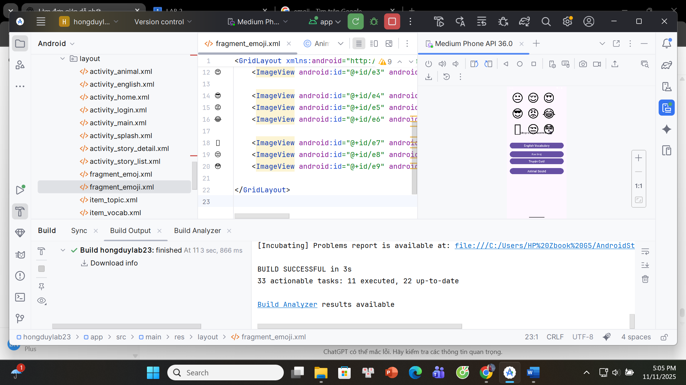

**fragment_emoji.xml**

<GridLayout xmlns:android="http://schemas.android.com/apk/res/android"  
 android:layout_width="match_parent"  
 android:layout_height="match_parent"  
 android:padding="20dp"  
 android:rowCount="3"  
 android:columnCount="3"  
 android:alignmentMode="alignMargins"  
 android:useDefaultMargins="true"  
 android:background="@color/white">  
  
 <ImageView android:id="@+id/e1" android:layout_width="100dp" android:layout_height="100dp" android:src="@drawable/emoji_1" />  
 <ImageView android:id="@+id/e2" android:layout_width="100dp" android:layout_height="100dp" android:src="@drawable/emoji_2" />  
 <ImageView android:id="@+id/e3" android:layout_width="100dp" android:layout_height="100dp" android:src="@drawable/emoji_3" />  
  
 <ImageView android:id="@+id/e4" android:layout_width="100dp" android:layout_height="100dp" android:src="@drawable/emoji_4" />  
 <ImageView android:id="@+id/e5" android:layout_width="100dp" android:layout_height="100dp" android:src="@drawable/emoji_5" />  
 <ImageView android:id="@+id/e6" android:layout_width="100dp" android:layout_height="100dp" android:src="@drawable/emoji_6" />  
  
 <ImageView android:id="@+id/e7" android:layout_width="100dp" android:layout_height="100dp" android:src="@drawable/emoji_7" />  
 <ImageView android:id="@+id/e8" android:layout_width="100dp" android:layout_height="100dp" android:src="@drawable/emoji_8" />  
 <ImageView android:id="@+id/e9" android:layout_width="100dp" android:layout_height="100dp" android:src="@drawable/emoji_9" />  
  
</GridLayout>

**EmojiFragment.java**

package com.example.hongduylab2;  
  
import android.os.Bundle;  
import android.os.Handler;  
import android.view.LayoutInflater;  
import android.view.View;  
import android.view.ViewGroup;  
import android.widget.ImageView;  
import android.widget.Toast;  
import androidx.fragment.app.Fragment;  
  
public class EmojiFragment extends Fragment {  
  
 @Override  
 public View onCreateView(LayoutInflater inflater, ViewGroup container,  
 Bundle savedInstanceState) {  
  
 View view = inflater.inflate(R.layout.fragment_emoji, container, false);  
  
 int[] emojiIDs = { R.id.e1, R.id.e2, R.id.e3, R.id.e4, R.id.e5, R.id.e6, R.id.e7, R.id.e8, R.id.e9 };  
  
 for (int id : emojiIDs) {  
 ImageView img = view.findViewById(id);  
  
 img.setOnClickListener(v -> {  
 Toast t = Toast.makeText(getActivity(), "Bạn vừa chọn emoji 😄", Toast.LENGTH_SHORT);  
 t.show();  
 new Handler().postDelayed(t::cancel, 1500);  
 });  
 }  
 return view;  
 }  
}

**Thêm vào activity_home.xml**

<Button  
 android:id="@+id/btnEmoji"  
 android:layout_width="match_parent"  
 android:layout_height="wrap_content"  
 android:text="Face Emoji"  
 android:layout_marginTop="12dp"/>

**Thêm vào HomeActivity.java**

Button btnEmoji = findViewById(R.id.btnEmoji);  
btnEmoji.setOnClickListener(v -> {  
 getSupportFragmentManager()  
 .beginTransaction()  
 .replace(android.R.id.content, new EmojiFragment())  
 .addToBackStack(null)  
 .commit();  
});

## **Con voi**

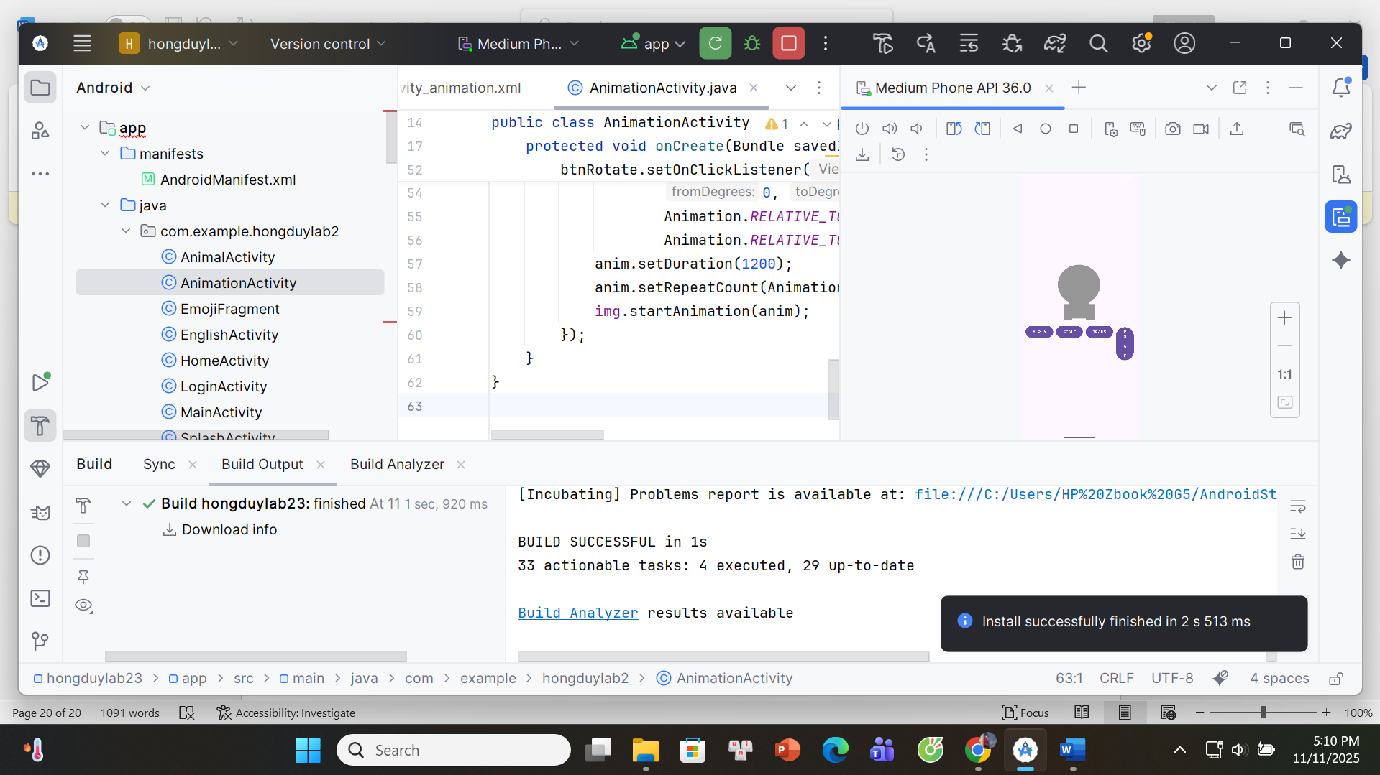

**activity_animation.xml**

<?xml version="1.0" encoding="utf-8"?>  
<LinearLayout xmlns:android="http://schemas.android.com/apk/res/android"  
 android:layout_width="match_parent"  
 android:layout_height="match_parent"  
 android:orientation="vertical"  
 android:gravity="center"  
 android:padding="20dp">  
  
 <ImageView  
 android:id="@+id/imgAnimal"  
 android:layout_width="200dp"  
 android:layout_height="200dp"  
 android:src="@drawable/elephant"  
 android:layout_marginBottom="40dp" />  
  
 <LinearLayout  
 android:layout_width="wrap_content"  
 android:layout_height="wrap_content"  
 android:orientation="horizontal">  
  
 <Button android:id="@+id/btnAlpha" android:text="ALPHA"  
 android:layout_width="wrap_content" android:layout_height="wrap_content"/>  
  
 <Button android:id="@+id/btnScale" android:text="SCALE"  
 android:layout_width="wrap_content" android:layout_height="wrap_content"  
 android:layout_marginStart="10dp"/>  
  
 <Button android:id="@+id/btnTrans" android:text="TRANS"  
 android:layout_width="wrap_content" android:layout_height="wrap_content"  
 android:layout_marginStart="10dp"/>  
  
 <Button android:id="@+id/btnRotate" android:text="ROTATE"  
 android:layout_width="wrap_content" android:layout_height="wrap_content"  
 android:layout_marginStart="10dp"/>  
 </LinearLayout>  
</LinearLayout>

**AnimationActivity.java**

package com.example.hongduylab2;  
  
import androidx.appcompat.app.AppCompatActivity;  
import android.os.Bundle;  
import android.view.animation.AlphaAnimation;  
import android.view.animation.RotateAnimation;  
import android.view.animation.ScaleAnimation;  
import android.view.animation.TranslateAnimation;  
import android.view.animation.Animation;  
import android.widget.Button;  
import android.widget.ImageView;  
  
public class AnimationActivity extends AppCompatActivity {  
  
 @Override  
 protected void onCreate(Bundle savedInstanceState) {  
 super.onCreate(savedInstanceState);  
 setContentView(R.layout.activity_animation);  
  
 ImageView img = findViewById(R.id.imgAnimal);  
 Button btnAlpha = findViewById(R.id.btnAlpha);  
 Button btnScale = findViewById(R.id.btnScale);  
 Button btnTrans = findViewById(R.id.btnTrans);  
 Button btnRotate = findViewById(R.id.btnRotate);  
  
 btnAlpha.setOnClickListener(v -> {  
 AlphaAnimation anim = new AlphaAnimation(0.1f, 1f);  
 anim.setDuration(1000);  
 anim.setRepeatCount(Animation.INFINITE);  
 img.startAnimation(anim);  
 });  
  
 btnScale.setOnClickListener(v -> {  
 ScaleAnimation anim = new ScaleAnimation(1, 1.5f, 1, 1.5f,  
 Animation.RELATIVE_TO_SELF, 0.5f,  
 Animation.RELATIVE_TO_SELF, 0.5f);  
 anim.setDuration(800);  
 anim.setRepeatCount(Animation.INFINITE);  
 img.startAnimation(anim);  
 });  
  
 btnTrans.setOnClickListener(v -> {  
 TranslateAnimation anim = new TranslateAnimation(0, 0, 0, 100);  
 anim.setDuration(900);  
 anim.setRepeatCount(Animation.INFINITE);  
 anim.setRepeatMode(Animation.REVERSE);  
 img.startAnimation(anim);  
 });  
  
 btnRotate.setOnClickListener(v -> {  
 RotateAnimation anim = new RotateAnimation(0, 360,  
 Animation.RELATIVE_TO_SELF, 0.5f,  
 Animation.RELATIVE_TO_SELF, 0.5f);  
 anim.setDuration(1200);  
 anim.setRepeatCount(Animation.INFINITE);  
 img.startAnimation(anim);  
 });  
 }  
}

**Thêm vào HomeActivity.java**

Button btnAnimation = findViewById(R.id.btnAnimation);  
btnAnimation.setOnClickListener(v -> {  
 startActivity(new Intent(HomeActivity.this, AnimationActivity.class));  
});

**Thêm vào AndroidManifest.xml**

<activity android:name=".AnimationActivity" android:exported="false"/>

# **LAB 3**

## **Máy đổi tiền**

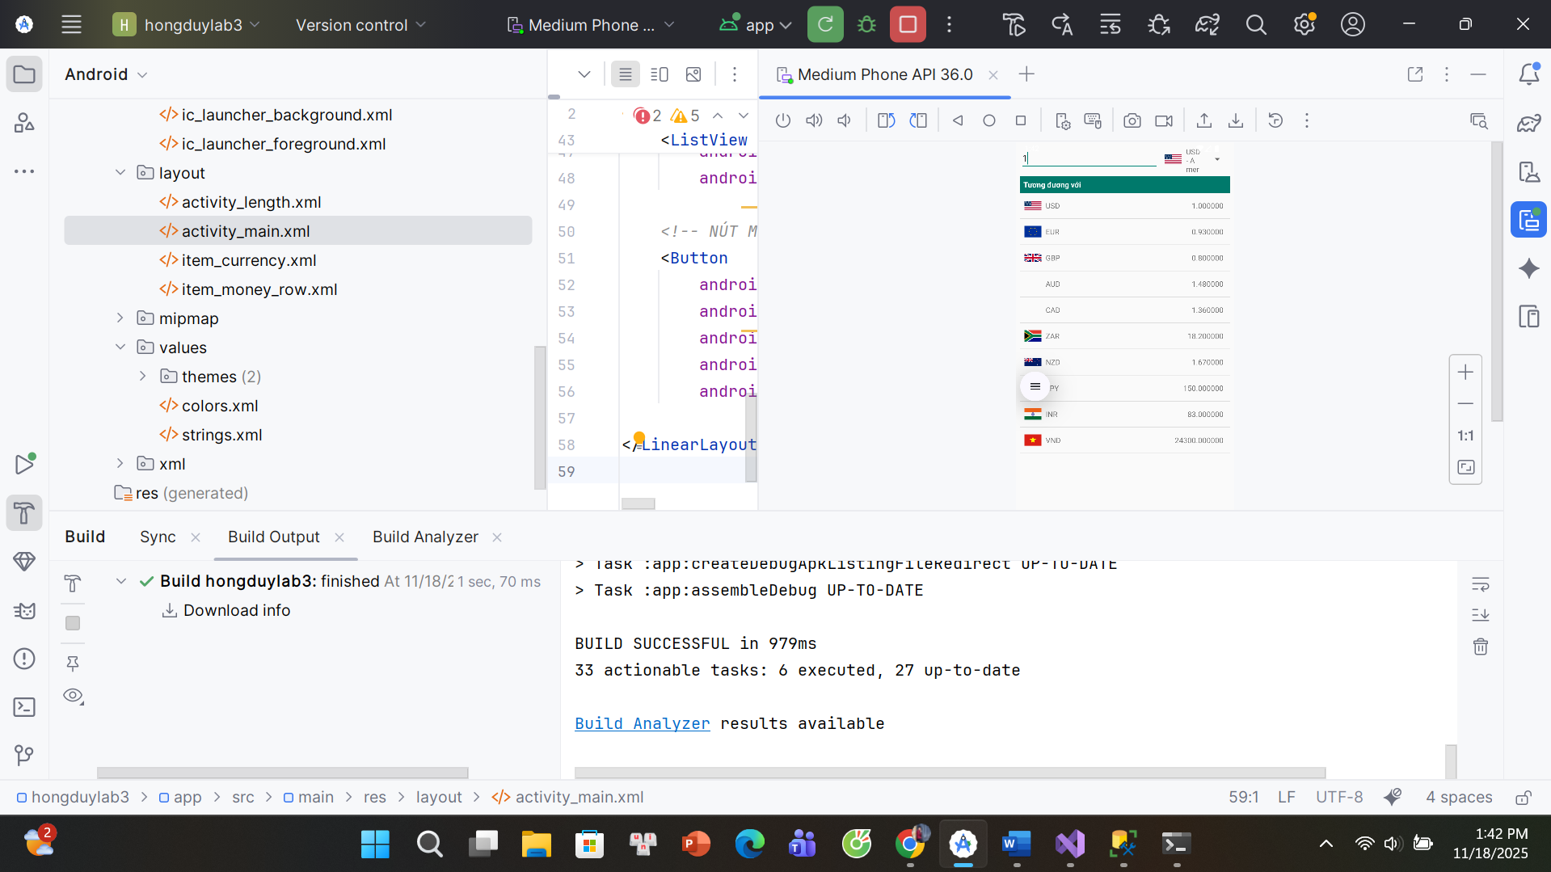

## **Đổi độ dài**

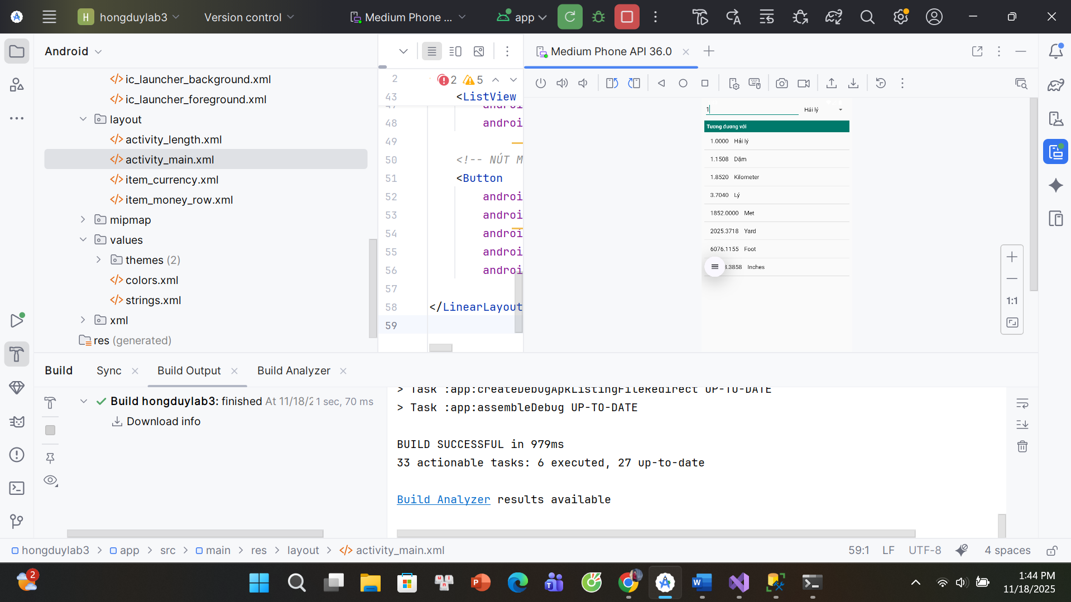

1. AndroidManifest.xml

*<?*xml version="1.0" encoding="utf-8"*?>*<manifest xmlns:android="http://schemas.android.com/apk/res/android"  
 package="com.example.hongduylab3">  
  
 <application  
 android:allowBackup="true"  
 android:icon="@mipmap/ic_launcher"  
 android:label="@string/app_name"  
 android:roundIcon="@mipmap/ic_launcher_round"  
 android:supportsRtl="true"  
 android:theme="@style/AppTheme">  
  
 *<!-- LAB 6 -->* <activity android:name=".Lab6Activity" />  
 <activity android:name=".LengthActivity" />  
  
 *<!-- LAB 7 -->* <activity android:name=".Lab7Activity" />  
 <activity android:name=".ColorActivity" />  
  
 *<!-- LAB 8 -->* <activity android:name=".Lab8Activity" />  
 <activity android:name=".Lab8ListActivity" />  
 <activity android:name=".Lab8GridActivity" />  
  
 *<!-- MENU LAB (MAIN) -->* <activity  
 android:name=".MainActivity"  
 android:exported="true">  
 <intent-filter>  
 <action android:name="android.intent.action.MAIN" />  
 <category android:name="android.intent.category.LAUNCHER" />  
 </intent-filter>  
 </activity>  
  
 </application>  
  
</manifest>

2. res/values/strings.xml/colors

*<?*xml version="1.0" encoding="utf-8"*?>*<resources>  
 <color name="black">#FF000000</color>  
 <color name="white">#FFFFFFFF</color>  
</resources>

*<?*xml version="1.0" encoding="utf-8"*?>*<resources>  
  
 *<!-- App & tác giả -->* <string name="app_name">Lab 6 &amp; Lab 7</string>  
 <string name="author">Phạm Hồng Duy</string>  
 <string name="computer">HP ZBook G5</string>  
  
 *<!-- MENU -->* <string name="menu_title">Chọn Lab</string>  
 <string name="btn_lab6">Lab 6 - Đổi tiền &amp; Đổi độ dài</string>  
 <string name="btn_lab7">Lab 7 - Custom Controls</string>  
  
 *<!-- Lab 6 -->* <string name="textbox_hint">Nhập số tiền</string>  
 <string name="btn_open_length">Mở chương trình đổi độ dài</string>  
 <string name="hint_length">Nhập độ dài</string>  
  
 *<!-- Tên các loại tiền tệ -->* <string name="usd_name">American Dollar</string>  
 <string name="eur_name">European Cash</string>  
 <string name="gbp_name">Great Britain</string>  
 <string name="aud_name">Australia Dollar</string>  
 <string name="cad_name">Canadian Dollar</string>  
 <string name="zar_name">South Africa Rand</string>  
 <string name="nzd_name">New Zealand Dollar</string>  
 <string name="vnd_name">Việt Nam Đồng</string>  
 <string name="inr_name">Indian Rupee</string>  
 <string name="jpy_name">Yên Nhật</string>  
  
 *<!-- Đơn vị viết tắt -->* <string name="usd_unit">USD</string>  
 <string name="eur_unit">EUR</string>  
 <string name="gbp_unit">GBP</string>  
 <string name="inr_unit">INR</string>  
 <string name="aud_unit">AUD</string>  
 <string name="cad_unit">CAD</string>  
 <string name="zar_unit">ZAR</string>  
 <string name="nzd_unit">NZD</string>  
 <string name="jpy_unit">JPY</string>  
 <string name="vnd_unit">VND</string>  
  
 *<!-- Lab 7 -->* <string name="btn_custom_1">Nút Custom 1</string>  
 <string name="btn_custom_2">Nút Custom 2</string>  
 <string name="btn_show_toast">Hiển thị Custom Toast</string>  
 <string name="btn_show_dialog">Hiển thị Custom Dialog</string>  
 <string name="btn_open_color">Mở bài 3 - RGB/CMY</string>  
  
 <string name="toast_message">Đây là Custom Toast của Lab 7</string>  
 <string name="dialog_title">Thông báo</string>  
 <string name="dialog_message">Đây là Custom Dialog trong Lab 7</string>  
 <string name="dialog_ok">Đồng ý</string>  
 <string name="dialog_cancel">Huỷ</string>  
  
 <string name="color_screen_title">Bài 3 - Chọn màu RGB và CMY</string>  
 <string name="label_red">Red</string>  
 <string name="label_green">Green</string>  
 <string name="label_blue">Blue</string>  
  
 <string name="label_cyan">Cyan</string>  
 <string name="label_magenta">Magenta</string>  
 <string name="label_yellow">Yellow</string>  
  
</resources>

3. res/layout/activity_main.xml

*<?*xml version="1.0" encoding="utf-8"*?>*<LinearLayout xmlns:android="http://schemas.android.com/apk/res/android"  
 android:layout_width="match_parent"  
 android:layout_height="match_parent"  
 android:orientation="vertical"  
 android:padding="24dp"  
 android:gravity="center"  
 android:background="#FFFFFF">  
  
 <TextView  
 android:id="@+id/tvMenuTitle"  
 android:layout_width="wrap_content"  
 android:layout_height="wrap_content"  
 android:text="Chọn Lab"  
 android:textSize="22sp"  
 android:textStyle="bold"  
 android:layout_marginBottom="30dp"/>  
  
 <Button  
 android:id="@+id/btnLab6"  
 android:layout_width="250dp"  
 android:layout_height="wrap_content"  
 android:text="LAB 6 - ĐỔI TIỀN &amp; ĐỔI ĐỘ DÀI"  
 android:layout_marginBottom="20dp"/>  
  
 <Button  
 android:id="@+id/btnLab7"  
 android:layout_width="250dp"  
 android:layout_height="wrap_content"  
 android:text="LAB 7 - CUSTOM CONTROLS"  
 android:layout_marginBottom="20dp"/>  
  
 <Button  
 android:id="@+id/btnLab8"  
 android:layout_width="250dp"  
 android:layout_height="wrap_content"  
 android:text="LAB 8 - LISTVIEW &amp; GRIDVIEW" />  
  
</LinearLayout>

4. res/layout/activity_length.xml

*<?*xml version="1.0" encoding="utf-8"*?>*<LinearLayout xmlns:android="http://schemas.android.com/apk/res/android"  
 android:orientation="vertical"  
 android:layout_width="match_parent"  
 android:layout_height="match_parent"  
 android:padding="8dp">  
  
 *<!-- Hàng nhập độ dài + chọn đơn vị -->* <LinearLayout  
 android:layout_width="match_parent"  
 android:layout_height="wrap_content"  
 android:orientation="horizontal">  
  
 <EditText  
 android:id="@+id/edtLength"  
 android:layout_width="0dp"  
 android:layout_height="wrap_content"  
 android:layout_weight="2"  
 android:inputType="numberDecimal"  
 android:hint="@string/hint_length" />  
  
 <Spinner  
 android:id="@+id/spUnit"  
 android:layout_width="0dp"  
 android:layout_height="wrap_content"  
 android:layout_weight="1"  
 android:layout_marginStart="4dp" />  
 </LinearLayout>  
  
 <TextView  
 android:id="@+id/tvHeader"  
 android:layout_width="match_parent"  
 android:layout_height="wrap_content"  
 android:text="Tương đương với"  
 android:textStyle="bold"  
 android:padding="6dp"  
 android:background="#00796B"  
 android:textColor="#FFFFFF"  
 android:layout_marginTop="8dp" />  
  
 <ListView  
 android:id="@+id/lvResult"  
 android:layout_width="match_parent"  
 android:layout_height="0dp"  
 android:layout_weight="1"  
 android:dividerHeight="1dp" />  
  
</LinearLayout>

5. res/layout/item_currency.xml

*<?*xml version="1.0" encoding="utf-8"*?>*<LinearLayout xmlns:android="http://schemas.android.com/apk/res/android"  
 android:orientation="horizontal"  
 android:layout_width="match_parent"  
 android:layout_height="48dp"  
 android:gravity="center_vertical"  
 android:paddingHorizontal="8dp">  
  
 <ImageView  
 android:id="@+id/img_flag"  
 android:layout_width="32dp"  
 android:layout_height="24dp"  
 android:adjustViewBounds="true" />  
  
 <TextView  
 android:id="@+id/tv_currency"  
 android:layout_width="wrap_content"  
 android:layout_height="wrap_content"  
 android:layout_marginStart="8dp"  
 android:textSize="14sp" />  
</LinearLayout>

6. res/layout/item_money_row.xml

*<?*xml version="1.0" encoding="utf-8"*?>*<LinearLayout xmlns:android="http://schemas.android.com/apk/res/android"  
 android:orientation="horizontal"  
 android:layout_width="match_parent"  
 android:layout_height="48dp"  
 android:gravity="center_vertical"  
 android:paddingHorizontal="8dp">  
  
 <ImageView  
 android:id="@+id/img_flag_row"  
 android:layout_width="32dp"  
 android:layout_height="24dp"  
 android:adjustViewBounds="true" />  
  
 <TextView  
 android:id="@+id/tv_code_row"  
 android:layout_width="wrap_content"  
 android:layout_height="wrap_content"  
 android:layout_marginStart="8dp"  
 android:textSize="14sp" />  
  
 <TextView  
 android:id="@+id/tv_value_row"  
 android:layout_width="0dp"  
 android:layout_height="wrap_content"  
 android:layout_weight="1"  
 android:gravity="end"  
 android:textSize="14sp"  
 android:layout_marginEnd="4dp" />  
  
</LinearLayout>

7. java/com/example/hongduylab3/MainActivity.java

package com.example.hongduylab3;  
  
import androidx.appcompat.app.AppCompatActivity;  
  
import android.content.Intent;  
import android.os.Bundle;  
import android.widget.Button;  
import android.widget.TextView;  
  
public class MainActivity extends AppCompatActivity {  
  
 Button btnLab6, btnLab7, btnLab8;  
 TextView tvMenuTitle;  
  
 @Override  
 protected void onCreate(Bundle savedInstanceState) {  
 super.onCreate(savedInstanceState);  
 setContentView(R.layout.*activity_main*);  
  
 tvMenuTitle = findViewById(R.id.*tvMenuTitle*);  
 btnLab6 = findViewById(R.id.*btnLab6*);  
 btnLab7 = findViewById(R.id.*btnLab7*);  
 btnLab8 = findViewById(R.id.*btnLab8*); *// <-- mới thêm* btnLab6.setOnClickListener(v -> {  
 startActivity(new Intent(MainActivity.this, Lab6Activity.class));  
 });  
  
 btnLab7.setOnClickListener(v -> {  
 startActivity(new Intent(MainActivity.this, Lab7Activity.class));  
 });  
  
 *// 👉 Nút Lab 8* btnLab8.setOnClickListener(v -> {  
 startActivity(new Intent(MainActivity.this, Lab8Activity.class));  
 });  
 }  
}

8. java/com/example/hongduylab3/LengthActivity.java

package com.example.hongduylab3;  
  
import androidx.appcompat.app.AppCompatActivity;  
  
import android.os.Bundle;  
import android.text.Editable;  
import android.text.TextWatcher;  
import android.widget.EditText;  
import android.widget.ListView;  
import android.widget.Spinner;  
import android.widget.ArrayAdapter;  
  
import java.util.ArrayList;  
import java.util.Locale;  
  
public class LengthActivity extends AppCompatActivity {  
  
 EditText edtLength;  
 Spinner spUnit;  
 ListView lvResult;  
  
 String[] unitNames = {  
 "Hải lý", "Dặm", "Kilometer", "Lý", "Met", "Yard", "Foot", "Inches"  
 };  
  
 *// 1 đơn vị tương ứng bao nhiêu mét* double[] toMeter = {  
 1852.0, *// Hải lý* 1609.344, *// Dặm* 1000.0, *// Km* 500.0, *// Lý* 1.0, *// Mét* 0.9144, *// Yard* 0.3048, *// Foot* 0.0254 *// Inches* };  
  
 ArrayList<String> resultList;  
 ArrayAdapter<String> listAdapter;  
  
 @Override  
 protected void onCreate(Bundle savedInstanceState) {  
 super.onCreate(savedInstanceState);  
 setContentView(R.layout.*activity_length*);  
  
 edtLength = findViewById(R.id.*edtLength*);  
 spUnit = findViewById(R.id.*spUnit*);  
 lvResult = findViewById(R.id.*lvResult*);  
  
 *// Adapter cho Spinner* ArrayAdapter<String> spinAdapter =  
 new ArrayAdapter<>(this,  
 android.R.layout.*simple_spinner_item*, unitNames);  
 spinAdapter.setDropDownViewResource(android.R.layout.*simple_spinner_dropdown_item*);  
 spUnit.setAdapter(spinAdapter);  
  
 *// Adapter cho ListView* resultList = new ArrayList<>();  
 listAdapter = new ArrayAdapter<>(this,  
 android.R.layout.*simple_list_item_1*, resultList);  
 lvResult.setAdapter(listAdapter);  
  
 *// Lắng nghe chọn đơn vị trong Spinner* spUnit.setOnItemSelectedListener(new android.widget.AdapterView.OnItemSelectedListener() {  
 @Override  
 public void onItemSelected(android.widget.AdapterView<?> parent,  
 android.view.View view,  
 int position,  
 long id) {  
 updateResult();  
 }  
  
 @Override  
 public void onNothingSelected(android.widget.AdapterView<?> parent) { }  
 });  
  
 *// Lắng nghe thay đổi text trong EditText* edtLength.addTextChangedListener(new TextWatcher() {  
 @Override public void beforeTextChanged(CharSequence s, int start, int count, int after) {}  
 @Override public void onTextChanged(CharSequence s, int start, int before, int count) {  
 updateResult();  
 }  
 @Override public void afterTextChanged(Editable s) {}  
 });  
 }  
  
 private void updateResult() {  
 String text = edtLength.getText().toString().trim();  
 resultList.clear();  
  
 if (text.isEmpty()) {  
 listAdapter.notifyDataSetChanged();  
 return;  
 }  
  
 double value;  
 try {  
 value = Double.*parseDouble*(text);  
 } catch (NumberFormatException e) {  
 listAdapter.notifyDataSetChanged();  
 return;  
 }  
  
 int fromIndex = spUnit.getSelectedItemPosition();  
 double inMeter = value * toMeter[fromIndex];  
  
 for (int i = 0; i < unitNames.length; i++) {  
 double converted = inMeter / toMeter[i];  
 String line = String.*format*(Locale.*US*, "%.4f %s", converted, unitNames[i]);  
 resultList.add(line);  
 }  
  
 listAdapter.notifyDataSetChanged();  
 }  
}

9. java/com/example/hongduylab3/CurrencySpinnerAdapter.java

package com.example.hongduylab3;  
  
import android.content.Context;  
import android.view.LayoutInflater;  
import android.view.View;  
import android.view.ViewGroup;  
import android.widget.ArrayAdapter;  
import android.widget.ImageView;  
import android.widget.TextView;  
  
import androidx.annotation.NonNull;  
import androidx.annotation.Nullable;  
  
public class CurrencySpinnerAdapter extends ArrayAdapter<String> {  
  
 private final Context context;  
 private final String[] units;  
 private final String[] names;  
 private final int[] flags;  
  
 public CurrencySpinnerAdapter(@NonNull Context context,  
 String[] units,  
 String[] names,  
 int[] flags) {  
 super(context, 0, units);  
 this.context = context;  
 this.units = units;  
 this.names = names;  
 this.flags = flags;  
 }  
  
 @NonNull  
 @Override  
 public View getView(int position, @Nullable View convertView,  
 @NonNull ViewGroup parent) {  
 return createItem(position, convertView, parent);  
 }  
  
 @Override  
 public View getDropDownView(int position, @Nullable View convertView,  
 @NonNull ViewGroup parent) {  
 return createItem(position, convertView, parent);  
 }  
  
 private View createItem(int position, View convertView, ViewGroup parent) {  
 View view = convertView;  
 if (view == null) {  
 view = LayoutInflater.*from*(context)  
 .inflate(R.layout.*item_currency*, parent, false);  
 }  
 ImageView imgFlag = view.findViewById(R.id.*img_flag*);  
 TextView tvCurrency = view.findViewById(R.id.*tv_currency*);  
  
 imgFlag.setImageResource(flags[position]);  
 String text = units[position] + " - " + names[position];  
 tvCurrency.setText(text);  
  
 return view;  
 }  
}

10. java/com/example/hongduylab3/MoneyListAdapter.java

package com.example.hongduylab3;  
  
import android.content.Context;  
import android.view.LayoutInflater;  
import android.view.View;  
import android.view.ViewGroup;  
import android.widget.BaseAdapter;  
import android.widget.ImageView;  
import android.widget.TextView;  
  
import java.util.Locale;  
  
public class MoneyListAdapter extends BaseAdapter {  
  
 private final Context context;  
 private final String[] units;  
 private final int[] flags;  
 private final double[] values;  
 private final LayoutInflater inflater;  
  
 public MoneyListAdapter(Context context,  
 String[] units,  
 int[] flags,  
 double[] values) {  
 this.context = context;  
 this.units = units;  
 this.flags = flags;  
 this.values = values;  
 this.inflater = LayoutInflater.*from*(context);  
 }  
  
 @Override  
 public int getCount() {  
 return units.length;  
 }  
  
 @Override  
 public Object getItem(int position) {  
 return values[position];  
 }  
  
 @Override  
 public long getItemId(int position) {  
 return position;  
 }  
  
 @Override  
 public View getView(int position, View convertView, ViewGroup parent) {  
 View view = convertView;  
 if (view == null) {  
 view = inflater.inflate(R.layout.*item_money_row*, parent, false);  
 }  
  
 ImageView imgFlag = view.findViewById(R.id.*img_flag_row*);  
 TextView tvCode = view.findViewById(R.id.*tv_code_row*);  
 TextView tvValue = view.findViewById(R.id.*tv_value_row*);  
  
 imgFlag.setImageResource(flags[position]);  
 tvCode.setText(units[position]);  
  
 String text = String.*format*(Locale.*US*, "%.6f", values[position]);  
 tvValue.setText(text);  
  
 return view;  
 }  
}

## **Custom Controls**

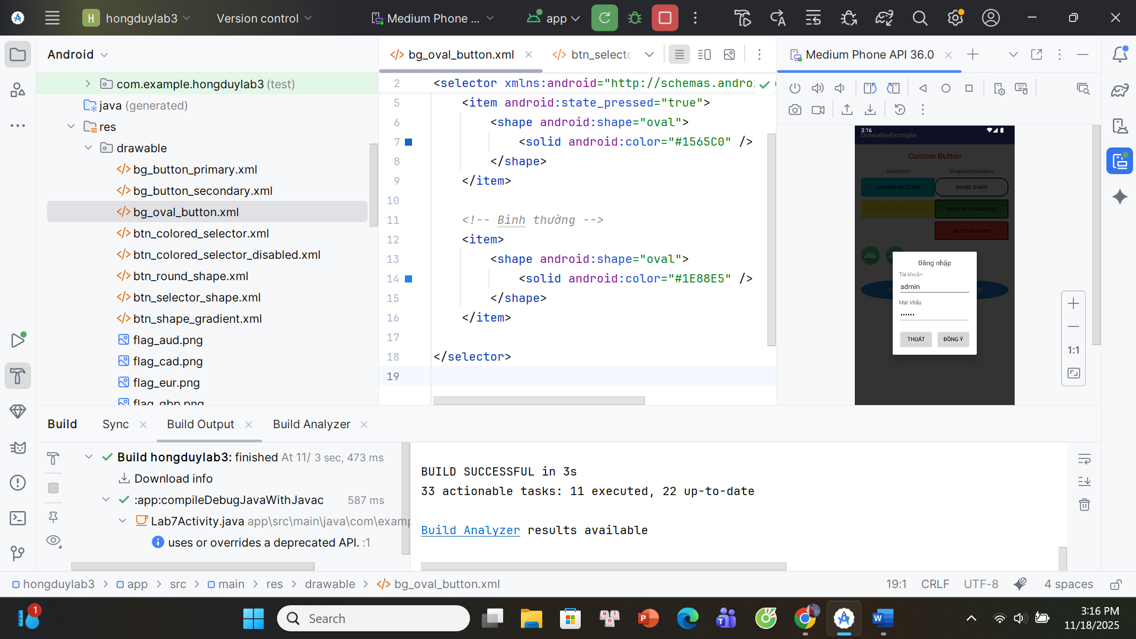

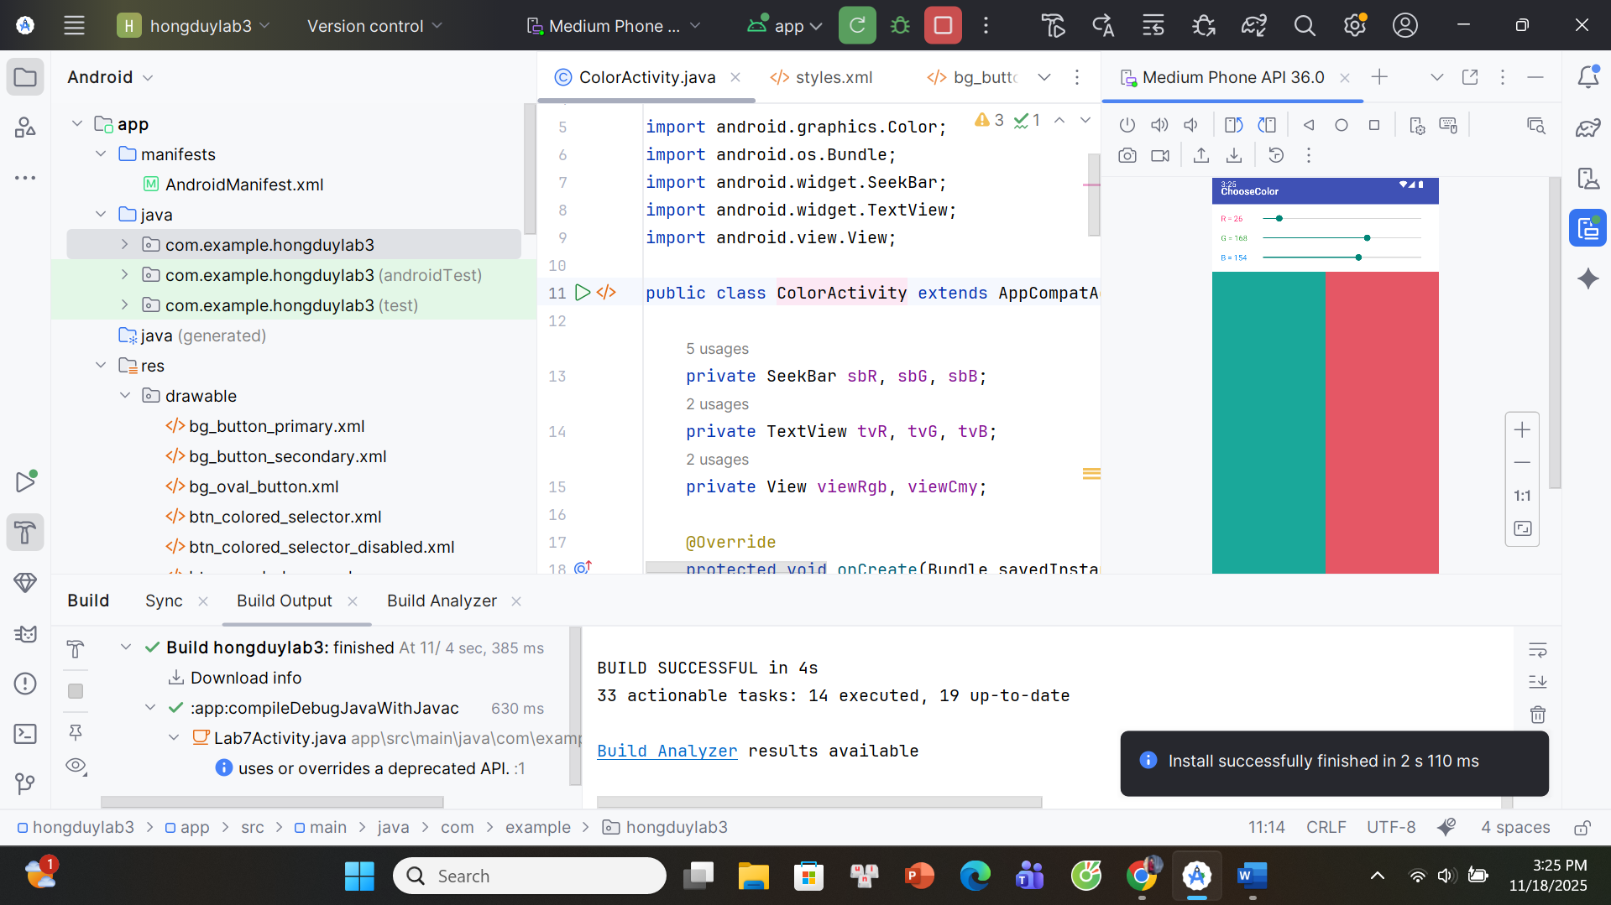

1-Lab7Activity.java

package com.example.hongduylab3;  
  
import androidx.appcompat.app.AppCompatActivity;  
  
import android.app.Dialog;  
import android.content.Intent;  
import android.os.Bundle;  
import android.view.Gravity;  
import android.view.LayoutInflater;  
import android.view.Window;  
import android.view.View;  
import android.widget.Button;  
import android.widget.EditText;  
import android.widget.Toast;  
  
public class Lab7Activity extends AppCompatActivity {  
  
 Button btnToast, btnDialog, btnOpenColor;  
  
 @Override  
 protected void onCreate(Bundle savedInstanceState) {  
 super.onCreate(savedInstanceState);  
 setContentView(R.layout.*activity_lab7*);  
  
 btnToast = findViewById(R.id.*btnToast*);  
 btnDialog = findViewById(R.id.*btnDialog*);  
 btnOpenColor = findViewById(R.id.*btnOpenColor*); *// nút mở ChooseColor  
  
 // Nút TOAST* btnToast.setOnClickListener(v -> showCustomToast());  
  
 *// Nút DIALOG* btnDialog.setOnClickListener(v -> showLoginDialog());  
  
 *// Nút CHOOSE COLOR* btnOpenColor.setOnClickListener(v -> {  
 Intent i = new Intent(Lab7Activity.this, ColorActivity.class);  
 startActivity(i);  
 });  
 }  
  
 *// ======== CUSTOM TOAST ========* private void showCustomToast() {  
 LayoutInflater inflater = getLayoutInflater();  
 View layout = inflater.inflate(R.layout.*toast_custom*, null);  
  
 Toast toast = new Toast(getApplicationContext());  
 toast.setDuration(Toast.*LENGTH_SHORT*);  
 toast.setView(layout);  
 toast.setGravity(Gravity.*CENTER_HORIZONTAL* | Gravity.*CENTER_VERTICAL*, 0, -50);  
 toast.show();  
 }  
  
 *// ======== CUSTOM DIALOG LOGIN ========* private void showLoginDialog() {  
 Dialog dialog = new Dialog(this);  
 dialog.requestWindowFeature(Window.*FEATURE_NO_TITLE*);  
 dialog.setContentView(R.layout.*dialog_login*);  
  
 EditText edtUser = dialog.findViewById(R.id.*edtUser*);  
 EditText edtPass = dialog.findViewById(R.id.*edtPass*);  
 Button btnOk = dialog.findViewById(R.id.*btnOk*);  
 Button btnCancel = dialog.findViewById(R.id.*btnCancel*);  
  
 edtUser.setText("admin");  
 edtPass.setText("123456");  
  
 btnCancel.setOnClickListener(v -> dialog.dismiss());  
  
 btnOk.setOnClickListener(v -> {  
 String u = edtUser.getText().toString().trim();  
 if ("admin".equals(u)) {  
 Toast.*makeText*(Lab7Activity.this,  
 "Đăng nhập: " + u, Toast.*LENGTH_SHORT*).show();  
 } else {  
 Toast.*makeText*(Lab7Activity.this,  
 "Sai tài khoản", Toast.*LENGTH_SHORT*).show();  
 }  
 dialog.dismiss();  
 });  
  
 dialog.show();  
 }  
}

2-ColorActivity.java

package com.example.hongduylab3;  
  
import androidx.appcompat.app.AppCompatActivity;  
  
import android.graphics.Color;  
import android.os.Bundle;  
import android.widget.SeekBar;  
import android.widget.TextView;  
import android.view.View;  
  
public class ColorActivity extends AppCompatActivity {  
  
 private SeekBar sbR, sbG, sbB;  
 private TextView tvR, tvG, tvB;  
 private View viewRgb, viewCmy;  
  
 @Override  
 protected void onCreate(Bundle savedInstanceState) {  
 super.onCreate(savedInstanceState);  
 setContentView(R.layout.*activity_color*);  
  
 sbR = findViewById(R.id.*sbR*);  
 sbG = findViewById(R.id.*sbG*);  
 sbB = findViewById(R.id.*sbB*);  
  
 tvR = findViewById(R.id.*tvR*);  
 tvG = findViewById(R.id.*tvG*);  
 tvB = findViewById(R.id.*tvB*);  
  
 viewRgb = findViewById(R.id.*viewRgb*);  
 viewCmy = findViewById(R.id.*viewCmy*);  
  
 sbR.setMax(255);  
 sbG.setMax(255);  
 sbB.setMax(255);  
  
 *// giá trị khởi tạo cho giống ví dụ* sbR.setProgress(26);  
 sbG.setProgress(168);  
 sbB.setProgress(16);  
  
 SeekBar.OnSeekBarChangeListener listener = new SeekBar.OnSeekBarChangeListener() {  
 @Override public void onProgressChanged(SeekBar seekBar, int progress, boolean fromUser) {  
 updateColor();  
 }  
 @Override public void onStartTrackingTouch(SeekBar seekBar) { }  
 @Override public void onStopTrackingTouch(SeekBar seekBar) { }  
 };  
  
 sbR.setOnSeekBarChangeListener(listener);  
 sbG.setOnSeekBarChangeListener(listener);  
 sbB.setOnSeekBarChangeListener(listener);  
  
 updateColor();  
 }  
  
 private void updateColor() {  
 int r = sbR.getProgress();  
 int g = sbG.getProgress();  
 int b = sbB.getProgress();  
  
 tvR.setText("R = " + r);  
 tvG.setText("G = " + g);  
 tvB.setText("B = " + b);  
  
 int rgb = Color.*rgb*(r, g, b);  
 viewRgb.setBackgroundColor(rgb);  
  
 *// CMY: c = 255 - r ...* int c = 255 - r;  
 int m = 255 - g;  
 int y = 255 - b;  
 int cmy = Color.*rgb*(c, m, y);  
 viewCmy.setBackgroundColor(cmy);  
 }  
}

3-activity_lab7.xml

*<?xml version="1.0" encoding="utf-8"?>  
<RelativeLayout xmlns:android="http://schemas.android.com/apk/res/android"  
 android:layout_width="match_parent"  
 android:layout_height="match_parent"  
 android:background="#FFFFFF">  
  
 <!-- Thanh tiêu đề xanh -->  
 <LinearLayout  
 android:id="@+id/layoutTitleBar"  
 android:layout_width="match_parent"  
 android:layout_height="48dp"  
 android:background="#3F51B5"  
 android:gravity="center_vertical">  
  
 <TextView  
 android:id="@+id/tvAppTitle"  
 android:layout_width="wrap_content"  
 android:layout_height="wrap_content"  
 android:layout_marginStart="16dp"  
 android:text="DrawableExample"  
 android:textColor="#FFFFFF"  
 android:textSize="18sp"  
 android:textStyle="bold" />  
 </LinearLayout>  
  
 <!-- Nội dung -->  
 <LinearLayout  
 android:orientation="vertical"  
 android:layout_width="match_parent"  
 android:layout_height="match_parent"  
 android:layout_below="@id/layoutTitleBar"  
 android:padding="16dp">  
  
 <!-- Hàng tiêu đề + nút COLOR góc phải -->  
 <LinearLayout  
 android:layout_width="match_parent"  
 android:layout_height="wrap_content"  
 android:orientation="horizontal"  
 android:gravity="center_vertical">  
  
 <TextView  
 android:layout_width="0dp"  
 android:layout_height="wrap_content"  
 android:layout_weight="1"  
 android:text="Custom Button"  
 android:textColor="#E53935"  
 android:textStyle="bold"  
 android:textSize="20sp"  
 android:gravity="center" />  
  
 <Button  
 android:id="@+id/btnOpenColor"  
 android:layout_width="wrap_content"  
 android:layout_height="wrap_content"  
 android:text="COLOR"  
 android:textAllCaps="true"  
 android:textSize="12sp"  
 android:background="@drawable/btn_round_shape"  
 android:layout_marginStart="8dp" />  
 </LinearLayout>  
  
 <!-- Hàng chữ Selectors / Shapes+Selectors -->  
 <LinearLayout  
 android:layout_width="match_parent"  
 android:layout_height="wrap_content"  
 android:orientation="horizontal"  
 android:layout_marginTop="16dp">  
  
 <TextView  
 android:layout_width="0dp"  
 android:layout_height="wrap_content"  
 android:layout_weight="1"  
 android:text="Selectors"  
 android:textStyle="bold"  
 android:textSize="14sp"  
 android:gravity="center" />  
  
 <TextView  
 android:layout_width="0dp"  
 android:layout_height="wrap_content"  
 android:layout_weight="1"  
 android:text="Shapes+Selectors"  
 android:textStyle="bold"  
 android:textSize="14sp"  
 android:gravity="center" />  
 </LinearLayout>  
  
 <!-- 2 cột nút nhỏ -->  
 <LinearLayout  
 android:layout_width="match_parent"  
 android:layout_height="wrap_content"  
 android:orientation="horizontal"  
 android:layout_marginTop="8dp">  
  
 <!-- Cột trái: Selectors -->  
 <LinearLayout  
 android:layout_width="0dp"  
 android:layout_height="wrap_content"  
 android:layout_weight="1"  
 android:orientation="vertical">  
  
 <Button  
 android:layout_width="match_parent"  
 android:layout_height="wrap_content"  
 android:text="COLORED SELECTOR"  
 android:textAllCaps="true"  
 android:textSize="12sp"  
 android:background="@drawable/btn_colored_selector" />  
  
 <Button  
 android:layout_width="match_parent"  
 android:layout_height="wrap_content"  
 android:text="COLOR SELECTOR  
DISABLED"  
 android:textAllCaps="true"  
 android:textSize="12sp"  
 android:background="@drawable/btn_colored_selector_disabled"  
 android:enabled="false"  
 android:layout_marginTop="8dp" />  
 </LinearLayout>  
  
 <!-- Cột phải: Shapes + Selectors -->  
 <LinearLayout  
 android:layout_width="0dp"  
 android:layout_height="wrap_content"  
 android:layout_weight="1"  
 android:orientation="vertical">  
  
 <Button  
 android:layout_width="match_parent"  
 android:layout_height="wrap_content"  
 android:text="ROUND SHAPE"  
 android:textAllCaps="true"  
 android:textSize="12sp"  
 android:background="@drawable/btn_round_shape" />  
  
 <Button  
 android:layout_width="match_parent"  
 android:layout_height="wrap_content"  
 android:text="SHAPE WITH GRADIENT"  
 android:textAllCaps="true"  
 android:textSize="12sp"  
 android:background="@drawable/btn_shape_gradient"  
 android:layout_marginTop="8dp" />  
  
 <Button  
 android:layout_width="match_parent"  
 android:layout_height="wrap_content"  
 android:text="SELECTOR SHAPE"  
 android:textAllCaps="true"  
 android:textSize="12sp"  
 android:background="@drawable/btn_selector_shape"  
 android:layout_marginTop="8dp" />  
 </LinearLayout>  
 </LinearLayout>  
  
 <!-- 2 emoji -->  
 <LinearLayout  
 android:layout_width="match_parent"  
 android:layout_height="wrap_content"  
 android:orientation="horizontal"  
 android:gravity="center_vertical"  
 android:layout_marginTop="16dp">  
  
 <ImageView  
 android:layout_width="48dp"  
 android:layout_height="48dp"  
 android:src="@mipmap/ic_launcher" />  
  
 <ImageView  
 android:layout_width="48dp"  
 android:layout_height="48dp"  
 android:src="@mipmap/ic_launcher"  
 android:layout_marginStart="16dp" />  
 </LinearLayout>  
  
 <!-- 2 nút TOAST / DIALOG hình oval -->  
 <LinearLayout  
 android:layout_width="match_parent"  
 android:layout_height="wrap_content"  
 android:orientation="horizontal"  
 android:gravity="center"  
 android:layout_marginTop="40dp">  
  
 <Button  
 android:id="@+id/btnToast"  
 android:layout_width="0dp"  
 android:layout_height="48dp"  
 android:layout_weight="1"  
 android:text="TOAST"  
 android:textAllCaps="true"  
 android:textColor="#FFFFFF"  
 android:background="@drawable/bg_oval_button"  
 android:layout_marginEnd="8dp" />  
  
 <Button  
 android:id="@+id/btnDialog"  
 android:layout_width="0dp"  
 android:layout_height="48dp"  
 android:layout_weight="1"  
 android:text="DIALOG"  
 android:textAllCaps="true"  
 android:textColor="#FFFFFF"  
 android:background="@drawable/bg_oval_button"  
 android:layout_marginStart="8dp" />  
 </LinearLayout>  
  
 <!-- Footer -->  
 <TextView  
 android:layout_width="match_parent"  
 android:layout_height="wrap_content"  
 android:text="Made by Phạm Hồng Duy"  
 android:textSize="12sp"  
 android:textColor="#3F51B5"  
 android:gravity="center"  
 android:layout_marginTop="16dp" />  
  
 </LinearLayout>  
  
</RelativeLayout>*

4-toast_custom.xml

*<?xml version="1.0" encoding="utf-8"?>  
<LinearLayout xmlns:android="http://schemas.android.com/apk/res/android"  
 android:orientation="horizontal"  
 android:layout_width="wrap_content"  
 android:layout_height="wrap_content"  
 android:background="#1565C0"  
 android:padding="8dp">  
  
 <ImageView  
 android:layout_width="24dp"  
 android:layout_height="24dp"  
 android:src="@mipmap/ic_launcher" />  
 <TextView  
 android:layout_width="wrap_content"  
 android:layout_height="wrap_content"  
 android:layout_marginStart="8dp"  
 android:text="Custom Toast, made by Phạm Hồng Duy"  
 android:textColor="#FFFFFF"  
 android:textSize="14sp" />  
</LinearLayout>*

5-activity_color.xml

*<?*xml version="1.0" encoding="utf-8"*?>*<LinearLayout xmlns:android="http://schemas.android.com/apk/res/android"  
 android:orientation="vertical"  
 android:layout_width="match_parent"  
 android:layout_height="match_parent"  
 android:background="#FFFFFF">  
 <LinearLayout  
 android:layout_width="match_parent"  
 android:layout_height="48dp"  
 android:background="#3F51B5"  
 android:gravity="center_vertical">  
 <TextView  
 android:layout_width="wrap_content"  
 android:layout_height="wrap_content"  
 android:layout_marginStart="16dp"  
 android:text="ChooseColor"  
 android:textColor="#FFFFFF"  
 android:textSize="18sp"  
 android:textStyle="bold" />  
 </LinearLayout>  
 <LinearLayout  
 android:layout_width="match_parent"  
 android:layout_height="wrap_content"  
 android:orientation="vertical"  
 android:padding="16dp">  
 <LinearLayout  
 android:layout_width="match_parent"  
 android:layout_height="wrap_content"  
 android:orientation="horizontal"  
 android:gravity="center_vertical">  
 <TextView  
 android:id="@+id/tvR"  
 android:layout_width="60dp"  
 android:layout_height="wrap_content"  
 android:text="R = 0"  
 android:textColor="#FF4081" />  
 <SeekBar  
 android:id="@+id/sbR"  
 android:layout_width="0dp"  
 android:layout_height="wrap_content"  
 android:layout_weight="1" />  
 </LinearLayout>  
 <LinearLayout  
 android:layout_width="match_parent"  
 android:layout_height="wrap_content"  
 android:orientation="horizontal"  
 android:gravity="center_vertical"  
 android:layout_marginTop="16dp">  
 <TextView  
 android:id="@+id/tvG"  
 android:layout_width="60dp"  
 android:layout_height="wrap_content"  
 android:text="G = 0"  
 android:textColor="#4CAF50" />  
 <SeekBar  
 android:id="@+id/sbG"  
 android:layout_width="0dp"  
 android:layout_height="wrap_content"  
 android:layout_weight="1" />  
 </LinearLayout>  
 <LinearLayout  
 android:layout_width="match_parent"  
 android:layout_height="wrap_content"  
 android:orientation="horizontal"  
 android:gravity="center_vertical"  
 android:layout_marginTop="16dp">  
 <TextView  
 android:id="@+id/tvB"  
 android:layout_width="60dp"  
 android:layout_height="wrap_content"  
 android:text="B = 0"  
 android:textColor="#2196F3" />  
 <SeekBar  
 android:id="@+id/sbB"  
 android:layout_width="0dp"  
 android:layout_height="wrap_content"  
 android:layout_weight="1" />  
 </LinearLayout>  
 </LinearLayout>  
 <LinearLayout  
 android:layout_width="match_parent"  
 android:layout_height="0dp"  
 android:layout_weight="1"  
 android:orientation="horizontal">  
 <View  
 android:id="@+id/viewRgb"  
 android:layout_width="0dp"  
 android:layout_height="match_parent"  
 android:layout_weight="1"  
 android:background="#00FF00" />  
 <View  
 android:id="@+id/viewCmy"  
 android:layout_width="0dp"  
 android:layout_height="match_parent"  
 android:layout_weight="1"  
 android:background="#FF00FF" />  
 </LinearLayout>  
</LinearLayout>

6-custom_button

*<?*xml version="1.0" encoding="utf-8"*?>*<selector xmlns:android="http://schemas.android.com/apk/res/android">  
 <item android:state_pressed="true">  
 <shape android:shape="rectangle">  
 <corners android:radius="24dp" />  
 <gradient  
 android:startColor="#1976D2"  
 android:endColor="#0D47A1"  
 android:angle="90" />  
 <padding  
 android:left="16dp"  
 android:top="10dp"  
 android:right="16dp"  
 android:bottom="10dp" />  
 </shape>  
 </item>  
 <item>  
 <shape android:shape="rectangle">  
 <corners android:radius="24dp" />  
 <gradient  
 android:startColor="#2196F3"  
 android:endColor="#1976D2"  
 android:angle="90" />  
 <padding  
 android:left="16dp"  
 android:top="10dp"  
 android:right="16dp"  
 android:bottom="10dp" />  
 </shape>  
 </item>  
</selector>

*<?*xml version="1.0" encoding="utf-8"*?>*<selector xmlns:android="http://schemas.android.com/apk/res/android">  
 <item android:state_pressed="true">  
 <shape android:shape="rectangle">  
 <corners android:radius="24dp" />  
 <solid android:color="#00796B" />  
 <padding  
 android:left="16dp"  
 android:top="10dp"  
 android:right="16dp"  
 android:bottom="10dp" />  
 </shape>  
 </item>  
  
 <item>  
 <shape android:shape="rectangle">  
 <corners android:radius="24dp" />  
 <solid android:color="#009688" />  
 <padding  
 android:left="16dp"  
 android:top="10dp"  
 android:right="16dp"  
 android:bottom="10dp" />  
 </shape>  
 </item>  
</selector>

*<?*xml version="1.0" encoding="utf-8"*?>*<selector xmlns:android="http://schemas.android.com/apk/res/android"><item android:state_pressed="true">  
 <shape android:shape="oval">  
 <solid android:color="#1565C0" />  
 </shape>  
 </item><item>  
 <shape android:shape="oval">  
 <solid android:color="#1E88E5" />  
 </shape>  
 </item>  
</selector>

*<?*xml version="1.0" encoding="utf-8"*?>*<selector xmlns:android="http://schemas.android.com/apk/res/android">  
 <item android:state_pressed="true">  
 <shape>  
 <corners android:radius="4dp" />  
 <solid android:color="#00796B" />  
 </shape>  
 </item>  
 <item>  
 <shape>  
 <corners android:radius="4dp" />  
 <solid android:color="#00BCD4" />  
 </shape>  
 </item>  
</selector>

*<?*xml version="1.0" encoding="utf-8"*?>*<selector xmlns:android="http://schemas.android.com/apk/res/android">  
 <item android:state_enabled="false">  
 <shape>  
 <corners android:radius="4dp" />  
 <solid android:color="#FFEB3B" />  
 </shape>  
 </item>  
 <item>  
 <shape>  
 <corners android:radius="4dp" />  
 <solid android:color="#FFC107" />  
 </shape>  
 </item>  
</selector>

*<?*xml version="1.0" encoding="utf-8"*?>*<shape xmlns:android="http://schemas.android.com/apk/res/android"  
 android:shape="rectangle">  
 <corners android:radius="20dp" />  
 <solid android:color="#FFFFFF" />  
 <stroke  
 android:width="2dp"  
 android:color="#000000" />  
</shape>

*<?*xml version="1.0" encoding="utf-8"*?>*<selector xmlns:android="http://schemas.android.com/apk/res/android"><item android:state_pressed="true">  
 <shape android:shape="rectangle">  
 <corners android:radius="4dp" />  
 <solid android:color="#D32F2F" />  
 <stroke  
 android:width="2dp"  
 android:color="#000000" />  
 </shape>  
 </item><item>  
 <shape android:shape="rectangle">  
 <corners android:radius="4dp" />  
 <solid android:color="#F44336" />  
 <stroke  
 android:width="2dp"  
 android:color="#000000" />  
 </shape>  
 </item>  
</selector>

*<?*xml version="1.0" encoding="utf-8"*?>*<shape xmlns:android="http://schemas.android.com/apk/res/android"  
 android:shape="rectangle">  
 <corners android:radius="4dp" />  
 <gradient  
 android:startColor="#4CAF50"  
 android:endColor="#2E7D32"  
 android:angle="90" />  
 <stroke  
 android:width="2dp"  
 android:color="#000000" />  
</shape>

## **List trong Android**

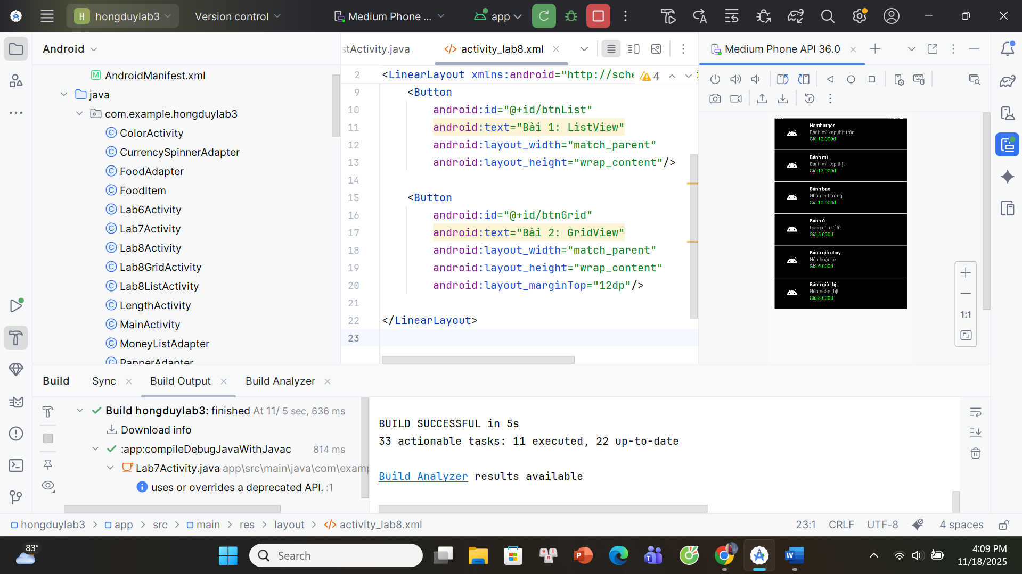

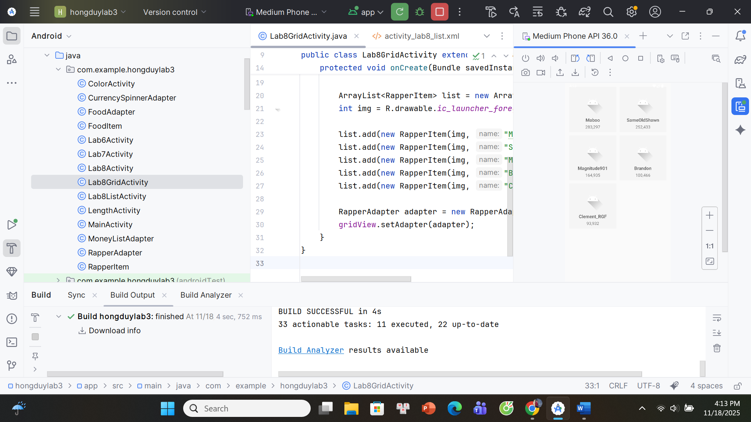

1-Lab8Activity.java

package com.example.hongduylab3;  
  
import androidx.appcompat.app.AppCompatActivity;  
  
import android.content.Intent;  
import android.os.Bundle;  
import android.view.View;  
  
public class Lab8Activity extends AppCompatActivity {  
  
 @Override  
 protected void onCreate(Bundle savedInstanceState) {  
 super.onCreate(savedInstanceState);  
 setContentView(R.layout.*activity_lab8*);  
  
 findViewById(R.id.*btnList*).setOnClickListener(new View.OnClickListener() {  
 @Override  
 public void onClick(View v) {  
 startActivity(new Intent(Lab8Activity.this, Lab8ListActivity.class));  
 }  
 });  
  
 findViewById(R.id.*btnGrid*).setOnClickListener(new View.OnClickListener() {  
 @Override  
 public void onClick(View v) {  
 startActivity(new Intent(Lab8Activity.this, Lab8GridActivity.class));  
 }  
 });  
 }  
}

2-Lab8ListActivity.java

package com.example.hongduylab3;  
  
import androidx.appcompat.app.AppCompatActivity;  
import android.os.Bundle;  
import android.widget.ListView;  
import java.util.ArrayList;  
  
public class Lab8ListActivity extends AppCompatActivity {  
  
 ListView lvFood;  
  
 @Override  
 protected void onCreate(Bundle savedInstanceState) {  
 super.onCreate(savedInstanceState);  
 setContentView(R.layout.*activity_lab8_list*);  
  
 lvFood = findViewById(R.id.*lvFood*);  
  
 ArrayList<FoodItem> list = new ArrayList<>();  
  
 int img = R.drawable.*ic_launcher_foreground*;  
  
 list.add(new FoodItem(img, "Hamburger", "Bánh mì kẹp thịt tròn", "Giá:12.000đ"));  
 list.add(new FoodItem(img, "Bánh mì", "Bánh mì kẹp thịt", "Giá:12.000đ"));  
 list.add(new FoodItem(img, "Bánh bao", "Nhân thịt trứng", "Giá:10.000đ"));  
 list.add(new FoodItem(img, "Bánh ú", "Dùng cho tế lễ", "Giá:5.000đ"));  
 list.add(new FoodItem(img, "Bánh giò chay", "Nếp hoặc tẻ", "Giá:6.000đ"));  
 list.add(new FoodItem(img, "Bánh giò thịt", "Nếp nhân thịt", "Giá:8.000đ"));  
  
 FoodAdapter adapter = new FoodAdapter(this, list);  
 lvFood.setAdapter(adapter);  
 }  
}

3-Lab8GridActivity.java

package com.example.hongduylab3;  
  
import androidx.appcompat.app.AppCompatActivity;  
import android.os.Bundle;  
import android.widget.GridView;  
  
import java.util.ArrayList;  
  
public class Lab8GridActivity extends AppCompatActivity {  
  
 GridView gridView;  
  
 @Override  
 protected void onCreate(Bundle savedInstanceState) {  
 super.onCreate(savedInstanceState);  
 setContentView(R.layout.*activity_lab8_grid*);  
  
 gridView = findViewById(R.id.*gridRapper*);  
  
 ArrayList<RapperItem> list = new ArrayList<>();  
 int img = R.drawable.*ic_launcher_foreground*;  
  
 list.add(new RapperItem(img, "Maboo", "283,297"));  
 list.add(new RapperItem(img, "SameOldShawn", "252,433"));  
 list.add(new RapperItem(img, "Magnitude901", "164,935"));  
 list.add(new RapperItem(img, "Brandon", "100,466"));  
 list.add(new RapperItem(img, "Clement_RGF", "93,932"));  
  
 RapperAdapter adapter = new RapperAdapter(this, list);  
 gridView.setAdapter(adapter);  
 }  
}

4-FoodAdapter

package com.example.hongduylab3;  
  
import android.content.Context;  
import android.view.*;  
import android.widget.*;  
  
import java.util.ArrayList;  
  
public class FoodAdapter extends BaseAdapter {  
  
 Context context;  
 ArrayList<FoodItem> data;  
  
 public FoodAdapter(Context ctx, ArrayList<FoodItem> list) {  
 context = ctx;  
 data = list;  
 }  
  
 @Override  
 public int getCount() { return data.size(); }  
  
 @Override  
 public Object getItem(int position) { return data.get(position); }  
  
 @Override  
 public long getItemId(int position) { return position; }  
  
 @Override  
 public View getView(int position, View convertView, ViewGroup parent) {  
  
 if (convertView == null) {  
 convertView = LayoutInflater.*from*(context)  
 .inflate(R.layout.*item_food*, parent, false);  
 }  
  
 FoodItem item = data.get(position);  
  
 ImageView img = convertView.findViewById(R.id.*imgFood*);  
 TextView tvName = convertView.findViewById(R.id.*tvName*);  
 TextView tvDesc = convertView.findViewById(R.id.*tvDesc*);  
 TextView tvPrice = convertView.findViewById(R.id.*tvPrice*);  
  
 img.setImageResource(item.imageRes);  
 tvName.setText(item.name);  
 tvDesc.setText(item.desc);  
 tvPrice.setText(item.priceText);  
  
 return convertView;  
 }  
}

5-FoodItem.java

package com.example.hongduylab3;  
  
public class FoodItem {  
 public int imageRes;  
 public String name, desc, priceText;  
  
 public FoodItem(int imageRes, String name, String desc, String priceText) {  
 this.imageRes = imageRes;  
 this.name = name;  
 this.desc = desc;  
 this.priceText = priceText;  
 }  
}

6-activity_lab8.xml

*<?*xml version="1.0" encoding="utf-8"*?>*<LinearLayout xmlns:android="http://schemas.android.com/apk/res/android"  
 android:orientation="vertical"  
 android:padding="20dp"  
 android:gravity="center"  
 android:layout_width="match_parent"  
 android:layout_height="match_parent">  
  
 <Button  
 android:id="@+id/btnList"  
 android:text="Bài 1: ListView"  
 android:layout_width="match_parent"  
 android:layout_height="wrap_content"/>  
  
 <Button  
 android:id="@+id/btnGrid"  
 android:text="Bài 2: GridView"  
 android:layout_width="match_parent"  
 android:layout_height="wrap_content"  
 android:layout_marginTop="12dp"/>  
  
</LinearLayout>

7-activity_lab8_list.xml

*<?*xml version="1.0" encoding="utf-8"*?>*<LinearLayout xmlns:android="http://schemas.android.com/apk/res/android"  
 android:orientation="vertical"  
 android:padding="16dp"  
 android:layout_width="match_parent"  
 android:layout_height="match_parent">  
  
 <ListView  
 android:id="@+id/lvFood"  
 android:layout_width="match_parent"  
 android:layout_height="match_parent" />  
  
</LinearLayout>

8-activity_lab8_grid.xml

*<?*xml version="1.0" encoding="utf-8"*?>*<LinearLayout xmlns:android="http://schemas.android.com/apk/res/android"  
 android:layout_width="match_parent"  
 android:layout_height="match_parent"  
 android:orientation="vertical"  
 android:padding="16dp">  
  
 <GridView  
 android:id="@+id/gridRapper"  
 android:layout_width="match_parent"  
 android:layout_height="match_parent"  
 android:numColumns="2"  
 android:verticalSpacing="12dp"  
 android:horizontalSpacing="12dp"  
 android:stretchMode="columnWidth" />  
</LinearLayout>

9-item_food.xml

*<?*xml version="1.0" encoding="utf-8"*?>*<RelativeLayout xmlns:android="http://schemas.android.com/apk/res/android"  
 android:padding="10dp"  
 android:layout_width="match_parent"  
 android:layout_height="90dp"  
 android:background="#000">  
  
 <ImageView  
 android:id="@+id/imgFood"  
 android:src="@drawable/ic_launcher_foreground"  
 android:layout_width="80dp"  
 android:layout_height="80dp" />  
  
 <TextView  
 android:id="@+id/tvName"  
 android:text="Tên món"  
 android:textColor="#FFF"  
 android:textStyle="bold"  
 android:layout_toRightOf="@id/imgFood"  
 android:layout_marginLeft="10dp"  
 android:layout_width="wrap_content"  
 android:layout_height="wrap_content"/>  
  
 <TextView  
 android:id="@+id/tvDesc"  
 android:text="Mô tả"  
 android:textColor="#AAA"  
 android:layout_below="@id/tvName"  
 android:layout_toRightOf="@id/imgFood"  
 android:layout_marginLeft="10dp"  
 android:layout_width="wrap_content"  
 android:layout_height="wrap_content"/>  
  
 <TextView  
 android:id="@+id/tvPrice"  
 android:text="Giá"  
 android:textColor="#00FF00"  
 android:layout_below="@id/tvDesc"  
 android:layout_toRightOf="@id/imgFood"  
 android:layout_marginLeft="10dp"  
 android:layout_width="wrap_content"  
 android:layout_height="wrap_content"/>  
  
</RelativeLayout>

10-item_rapper.xml

*<?*xml version="1.0" encoding="utf-8"*?>*<LinearLayout xmlns:android="http://schemas.android.com/apk/res/android"  
 android:orientation="horizontal"  
 android:padding="10dp"  
 android:background="#000"  
 android:layout_width="match_parent"  
 android:gravity="center_vertical"  
 android:layout_height="wrap_content">  
  
 <ImageView  
 android:id="@+id/imgRapper"  
 android:layout_width="60dp"  
 android:layout_height="60dp"  
 android:src="@drawable/ic_launcher_foreground" />  
  
 <LinearLayout  
 android:orientation="vertical"  
 android:layout_marginLeft="10dp"  
 android:layout_width="wrap_content"  
 android:layout_height="wrap_content">  
  
 <TextView  
 android:id="@+id/tvRapperName"  
 android:text="Name"  
 android:textColor="#9C27B0"  
 android:textStyle="bold"  
 android:textSize="17sp" />  
  
 <TextView  
 android:id="@+id/tvScore"  
 android:text="123,456"  
 android:textColor="#FFC107" />  
  
 </LinearLayout>  
  
</LinearLayout>

11-Lab8GridActivity.java

package com.example.hongduylab3;  
  
import androidx.appcompat.app.AppCompatActivity;  
import android.os.Bundle;  
import android.widget.GridView;  
  
import java.util.ArrayList;  
  
public class Lab8GridActivity extends AppCompatActivity {  
  
 GridView gridView;  
  
 @Override  
 protected void onCreate(Bundle savedInstanceState) {  
 super.onCreate(savedInstanceState);  
 setContentView(R.layout.*activity_lab8_grid*);  
  
 gridView = findViewById(R.id.*gridRapper*);  
  
 ArrayList<RapperItem> list = new ArrayList<>();  
 int img = R.drawable.*ic_launcher_foreground*;  
  
 list.add(new RapperItem(img, "Maboo", "283,297"));  
 list.add(new RapperItem(img, "SameOldShawn", "252,433"));  
 list.add(new RapperItem(img, "Magnitude901", "164,935"));  
 list.add(new RapperItem(img, "Brandon", "100,466"));  
 list.add(new RapperItem(img, "Clement_RGF", "93,932"));  
  
 RapperAdapter adapter = new RapperAdapter(this, list);  
 gridView.setAdapter(adapter);  
 }  
}

12-RapperAdapter.java

package com.example.hongduylab3;  
  
import android.content.Context;  
import android.view.View;  
import android.view.ViewGroup;  
import android.view.LayoutInflater;  
import android.widget.BaseAdapter;  
import android.widget.ImageView;  
import android.widget.TextView;  
  
import java.util.ArrayList;  
  
public class RapperAdapter extends BaseAdapter {  
  
 Context context;  
 ArrayList<RapperItem> list;  
  
 public RapperAdapter(Context c, ArrayList<RapperItem> l) {  
 context = c;  
 list = l;  
 }  
  
 @Override  
 public int getCount() { return list.size(); }  
  
 @Override  
 public Object getItem(int i) { return list.get(i); }  
  
 @Override  
 public long getItemId(int i) { return i; }  
  
 @Override  
 public View getView(int i, View view, ViewGroup parent) {  
  
 view = LayoutInflater.*from*(context).inflate(R.layout.*grid_item*, parent, false);  
  
 ImageView img = view.findViewById(R.id.*imgAvatar*);  
 TextView name = view.findViewById(R.id.*tvName*);  
 TextView score = view.findViewById(R.id.*tvScore*);  
  
 RapperItem item = list.get(i);  
  
 img.setImageResource(item.img);  
 name.setText(item.name);  
 score.setText(item.score);  
  
 return view;  
 }  
}

13-RapperItem.java

package com.example.hongduylab3;  
  
public class RapperItem {  
 int img;  
 String name, score;  
  
 public RapperItem(int img, String name, String score) {  
 this.img = img;  
 this.name = name;  
 this.score = score;  
 }  
}

# **LAB 4**

## **Truyện cười**

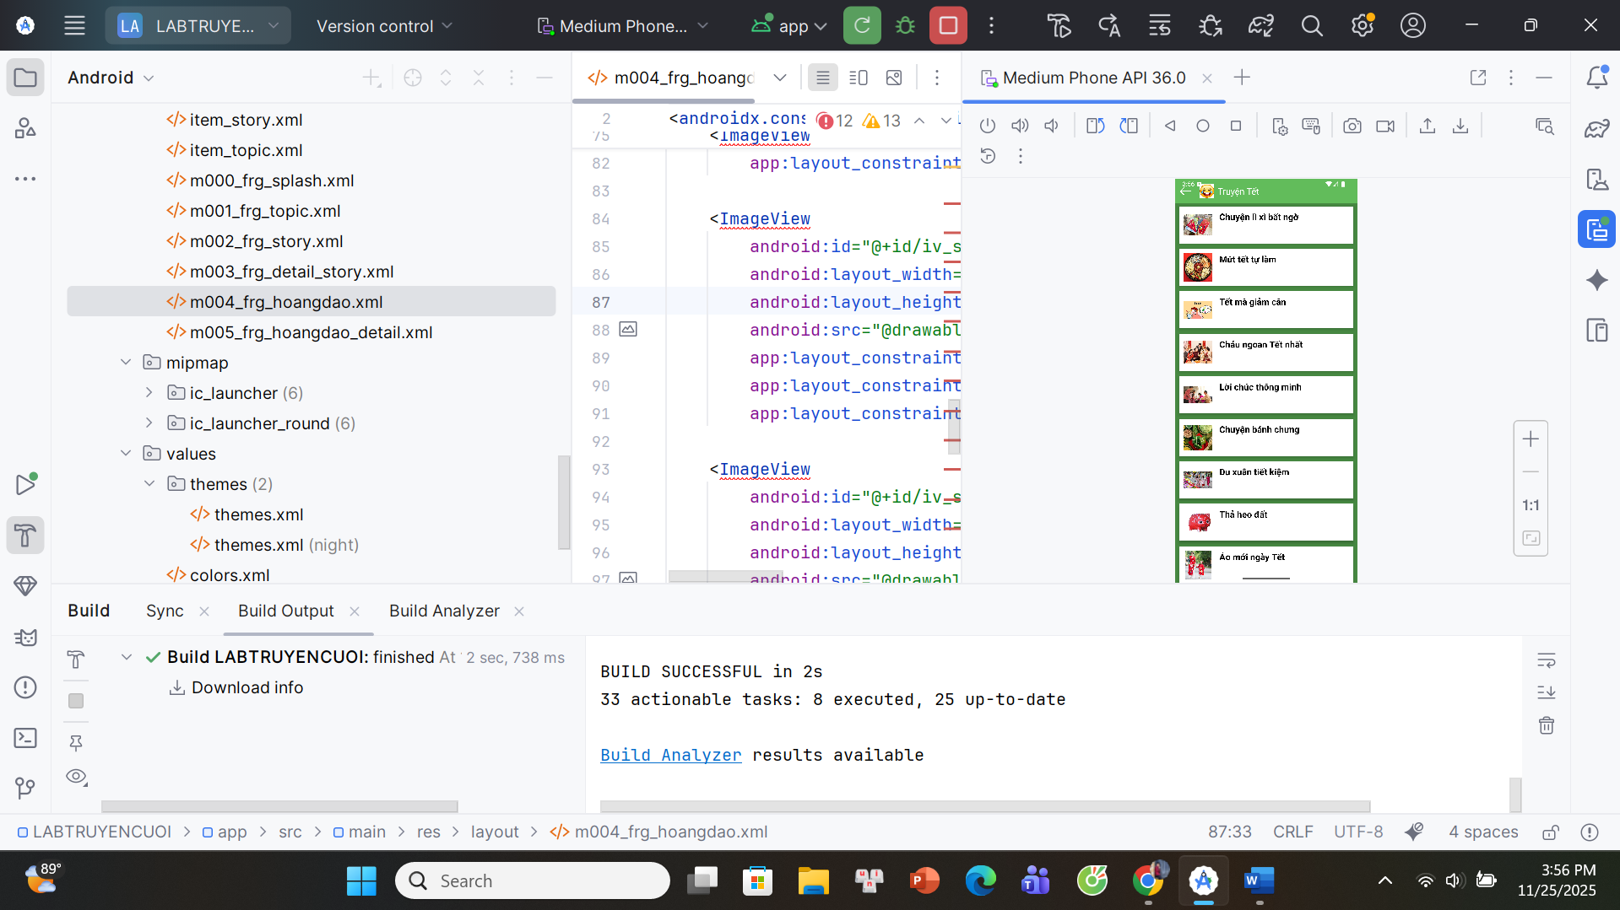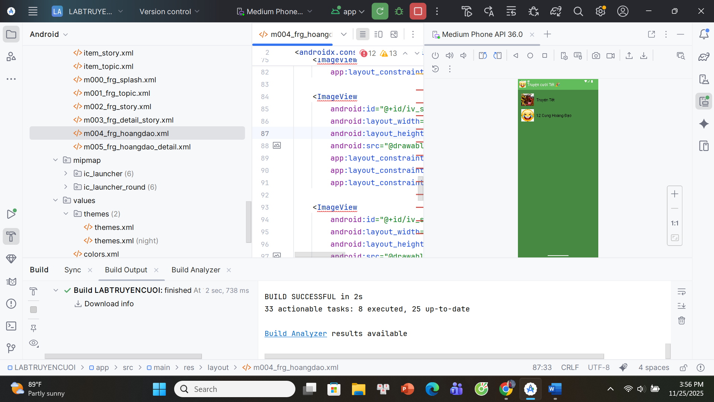

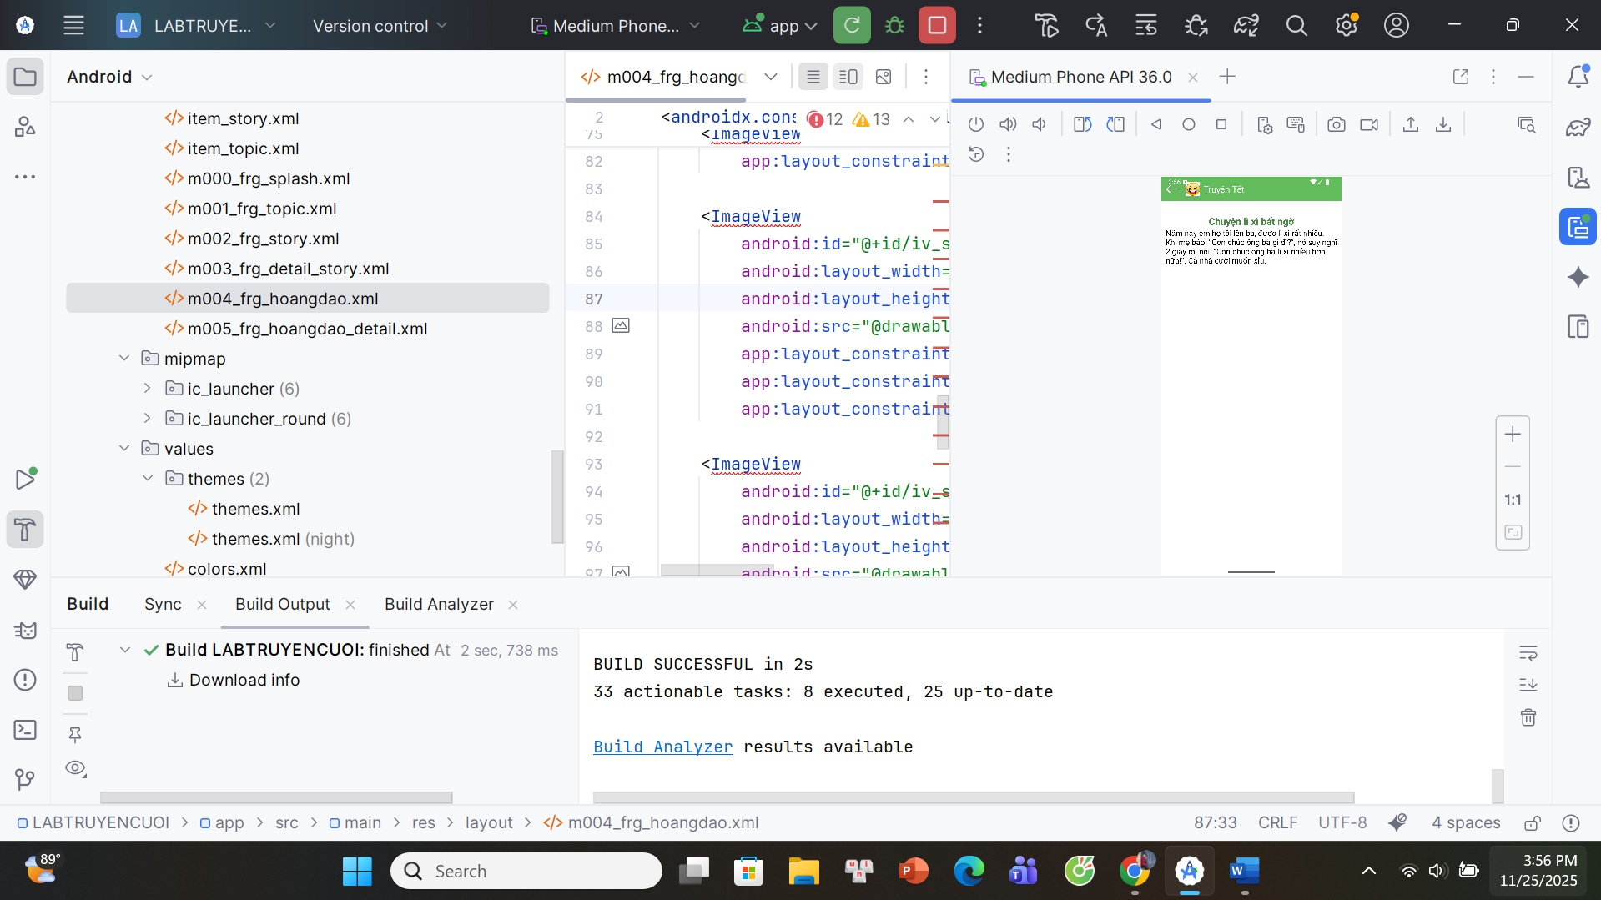

## **12 cung hoàng đạo**

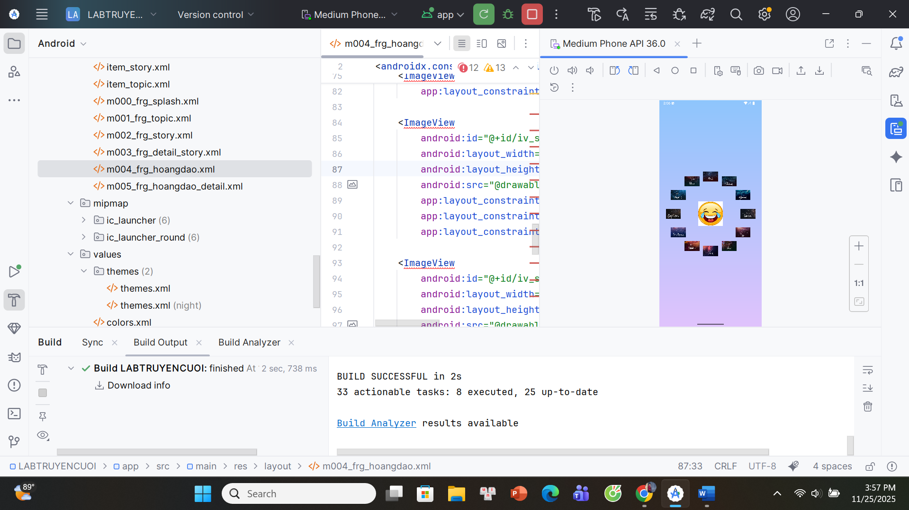

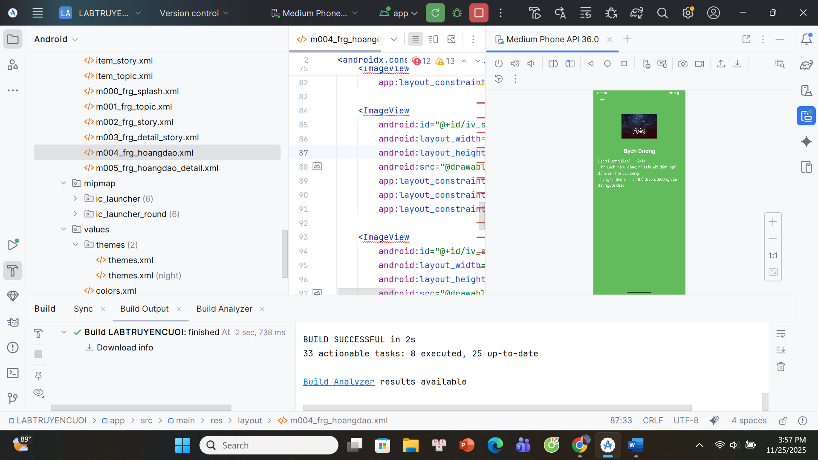

**AndroidManifest**

*<?*xml version="1.0" encoding="utf-8"*?>*<manifest xmlns:android="http://schemas.android.com/apk/res/android"  
 xmlns:tools="http://schemas.android.com/tools">  
  
 <application  
 android:allowBackup="true"  
 android:dataExtractionRules="@xml/data_extraction_rules"  
 android:fullBackupContent="@xml/backup_rules"  
 android:icon="@mipmap/ic_launcher"  
 android:label="@string/app_name"  
 android:roundIcon="@mipmap/ic_launcher_round"  
 android:supportsRtl="true"  
 android:theme="@style/Theme.TruyenCuoiTet">  
  
 <activity  
 android:name=".MainActivity"  
 android:exported="true">  
 <intent-filter>  
 <action android:name="android.intent.action.MAIN" />  
 <category android:name="android.intent.category.LAUNCHER" />  
 </intent-filter>  
 </activity>  
  
 </application>  
  
</manifest>

**DetaiStoryAdapter**

package com.example.labtruyencuoi;  
  
import android.content.Context;  
import android.view.LayoutInflater;  
import android.view.View;  
import android.view.ViewGroup;  
import android.widget.TextView;  
  
import androidx.viewpager.widget.PagerAdapter;  
  
import java.util.List;  
  
public class DetailStoryAdapter extends PagerAdapter {  
  
 private List<StoryEntity> list;  
 private Context mContext;  
  
 public DetailStoryAdapter(List<StoryEntity> list, Context mContext) {  
 this.list = list;  
 this.mContext = mContext;  
 }  
  
 @Override  
 public Object instantiateItem(ViewGroup container, int position) {  
 View v = LayoutInflater.*from*(mContext)  
 .inflate(R.layout.*item_detail_story*, container, false);  
  
 StoryEntity s = list.get(position);  
  
 *// ===== FIX LỖI getName() & getContent() =====* ((TextView) v.findViewById(R.id.*tv_name*)).setText(s.title);  
 ((TextView) v.findViewById(R.id.*tv_content*)).setText(s.content);  
  
 container.addView(v);  
 return v;  
 }  
  
 @Override  
 public int getCount() {  
 return list.size();  
 }  
  
 @Override  
 public boolean isViewFromObject(View v, Object o) {  
 return v == o;  
 }  
  
 @Override  
 public void destroyItem(ViewGroup container, int position, Object object) {  
 container.removeView((View) object);  
 }  
}

**M000SplashFrg**

package com.example.labtruyencuoi;  
  
import android.os.Bundle;  
import android.os.Handler;  
import androidx.fragment.app.Fragment;  
import android.view.LayoutInflater;  
import android.view.View;  
import android.view.ViewGroup;  
  
public class M000SplashFrg extends Fragment {  
  
 @Override  
 public View onCreateView(LayoutInflater inflater, ViewGroup container,  
 Bundle savedInstanceState) {  
  
 new Handler().postDelayed(() -> {  
 ((MainActivity)getActivity()).gotoM001Screen();  
 }, 2000);  
  
 return inflater.inflate(R.layout.*m000_frg_splash*, container, false);  
 }  
}

**M001TopicFrg**

package com.example.labtruyencuoi;  
  
import android.content.Context;  
import android.graphics.BitmapFactory;  
import android.os.Bundle;  
import androidx.fragment.app.Fragment;  
  
import android.view.LayoutInflater;  
import android.view.View;  
import android.view.ViewGroup;  
import android.widget.ImageView;  
import android.widget.LinearLayout;  
import android.widget.TextView;  
  
public class M001TopicFrg extends Fragment {  
  
 private Context mContext;  
  
 @Override  
 public void onAttach(Context context) {  
 super.onAttach(context);  
 mContext = context;  
 }  
  
 @Override  
 public View onCreateView(LayoutInflater inflater, ViewGroup container,  
 Bundle savedInstanceState) {  
  
 View v = inflater.inflate(R.layout.*m001_frg_topic*, container, false);  
  
 LinearLayout ln = v.findViewById(R.id.*ln_topic*);  
 ln.removeAllViews();  
  
 *// =========================  
 // 1) TOPIC TRUYỆN TẾT  
 // =========================* View topicTet = LayoutInflater.*from*(mContext).inflate(R.layout.*item_topic*, null);  
  
 ImageView ivTet = topicTet.findViewById(R.id.*iv_topic*);  
 TextView tvTet = topicTet.findViewById(R.id.*tv_topic*);  
  
 try {  
 ivTet.setImageBitmap(BitmapFactory.*decodeStream*(  
 mContext.getAssets().open("photo/tet.png")  
 ));  
 } catch (Exception ignored) {}  
  
 tvTet.setText("Truyện Tết");  
  
 topicTet.setOnClickListener(v2 ->  
 ((MainActivity) getActivity()).gotoM002Screen("tet")  
 );  
  
 ln.addView(topicTet);  
  
 *// =========================  
 // 2) TOPIC HOÀNG ĐẠO  
 // =========================* View topicHz = LayoutInflater.*from*(mContext).inflate(R.layout.*item_topic*, null);  
  
 ImageView ivHz = topicHz.findViewById(R.id.*iv_topic*);  
 TextView tvHz = topicHz.findViewById(R.id.*tv_topic*);  
  
 try {  
 ivHz.setImageBitmap(BitmapFactory.*decodeStream*(  
 mContext.getAssets().open("photo/chautructet.png") *// đổi ảnh tuỳ bạn* ));  
 } catch (Exception ignored) {}  
  
 tvHz.setText("12 Cung Hoàng Đạo");  
  
 topicHz.setOnClickListener(v2 ->  
 ((MainActivity) getActivity()).gotoM004Screen() *// HÀM NÀY BẠN TÍNH TẠO BÊN MAIN* );  
  
 ln.addView(topicHz);  
  
 return v;  
 }  
}

**M002StoryFrg**

package com.example.labtruyencuoi;  
  
import android.content.Context;  
import android.os.Bundle;  
  
import androidx.fragment.app.Fragment;  
import androidx.recyclerview.widget.LinearLayoutManager;  
import androidx.recyclerview.widget.RecyclerView;  
  
import android.view.LayoutInflater;  
import android.view.View;  
import android.view.ViewGroup;  
import android.widget.TextView;  
  
import java.io.BufferedReader;  
import java.io.InputStreamReader;  
import java.util.ArrayList;  
  
public class M002StoryFrg extends Fragment {  
  
 private Context mContext;  
 private String topicName;  
  
 public void setTopicName(String topicName) {  
 this.topicName = topicName;  
 }  
  
 @Override  
 public void onAttach(Context context) {  
 super.onAttach(context);  
 mContext = context;  
 }  
  
 @Override  
 public View onCreateView(LayoutInflater inflater, ViewGroup container,  
 Bundle savedInstanceState) {  
  
 View v = inflater.inflate(R.layout.*m002_frg_story*, container, false);  
  
 v.findViewById(R.id.*iv_back*).setVisibility(View.*VISIBLE*);  
 v.findViewById(R.id.*iv_back*).setOnClickListener(v1 ->  
 ((MainActivity)getActivity()).backToM001Screen()  
 );  
  
 ((TextView)v.findViewById(R.id.*tv_name*)).setText("Truyện Tết");  
  
 RecyclerView rv = v.findViewById(R.id.*rv_story*);  
 ArrayList<StoryEntity> list = readStory();  
  
 StoryAdapter adapter = new StoryAdapter(list, getActivity());  
 rv.setAdapter(adapter);  
 rv.setLayoutManager(new LinearLayoutManager(mContext));  
  
 return v;  
 }  
  
 private ArrayList<StoryEntity> readStory() {  
 ArrayList<StoryEntity> list = new ArrayList<>();  
  
 try {  
 BufferedReader r = new BufferedReader(new InputStreamReader(  
 mContext.getAssets().open("story/" + topicName + ".txt")  
 ));  
  
 String title = "";  
 StringBuilder content = new StringBuilder();  
 String line;  
  
 while ((line = r.readLine()) != null) {  
  
 if (line.trim().isEmpty()) continue;  
  
 *// Tiêu đề* title = line.trim();  
  
 *// Nội dung* content.setLength(0);  
 while ((line = r.readLine()) != null && !line.contains("','0');")) {  
 content.append(line).append("\n");  
 }  
  
 list.add(new StoryEntity(topicName, title, content.toString()));  
 }  
  
 r.close();  
  
 } catch (Exception e) {  
 e.printStackTrace();  
 }  
  
 return list;  
 }  
}

**M003DetailStoryFrg**  
package com.example.labtruyencuoi;  
  
import android.content.Context;  
import android.os.Bundle;  
import androidx.fragment.app.Fragment;  
import androidx.viewpager.widget.ViewPager;  
  
import android.view.LayoutInflater;  
import android.view.View;  
import android.view.ViewGroup;  
import android.widget.TextView;  
  
import java.util.ArrayList;  
  
public class M003DetailStoryFrg extends Fragment {  
  
 private ArrayList<StoryEntity> list;  
 private StoryEntity current;  
 private String topicName;  
 private Context mContext;  
  
 public void setData(String topicName, ArrayList<StoryEntity> list, StoryEntity current) {  
 this.topicName = topicName;  
 this.list = list;  
 this.current = current;  
 }  
  
 @Override  
 public void onAttach(Context context) {  
 super.onAttach(context);  
 mContext = context;  
 }  
  
 @Override  
 public View onCreateView(LayoutInflater inflater, ViewGroup container,  
 Bundle savedInstanceState) {  
  
 View v = inflater.inflate(R.layout.*m003_frg_detail_story*, container, false);  
  
 v.findViewById(R.id.*iv_back*).setVisibility(View.*VISIBLE*);  
 v.findViewById(R.id.*iv_back*).setOnClickListener(v1 ->  
 ((MainActivity)getActivity()).gotoM002Screen(topicName));  
  
 ((TextView)v.findViewById(R.id.*tv_name*)).setText("Truyện Tết");  
  
 ViewPager vp = v.findViewById(R.id.*vp_story*);  
 vp.setAdapter(new DetailStoryAdapter(list, mContext));  
 vp.setCurrentItem(list.indexOf(current));  
  
 return v;  
 }  
}

**M004HongDaoFrg**  
package com.example.labtruyencuoi;  
  
import android.graphics.drawable.GradientDrawable;  
import android.os.Bundle;  
import androidx.annotation.NonNull;  
import androidx.annotation.Nullable;  
import androidx.fragment.app.Fragment;  
  
import android.view.LayoutInflater;  
import android.view.View;  
import android.view.ViewGroup;  
import android.widget.ImageView;  
  
public class M004HoaNgDaoFrg extends Fragment {  
  
 private int[] imgs = {  
 R.drawable.*hd_aries*, R.drawable.*hd_taurus*, R.drawable.*hd_gemini*,  
 R.drawable.*hd_cancer*, R.drawable.*hd_leo*, R.drawable.*hd_virgo*,  
 R.drawable.*hd_libra*, R.drawable.*hd_scorpio*, R.drawable.*hd_sagittarius*,  
 R.drawable.*hd_capricorn*, R.drawable.*hd_aquarius*, R.drawable.*hd_pisces* };  
  
 private String[] titles = {  
 "Bạch Dương","Kim Ngưu","Song Tử","Cự Giải",  
 "Sư Tử","Xử Nữ","Thiên Bình","Bọ Cạp",  
 "Nhân Mã","Ma Kết","Bảo Bình","Song Ngư"  
 };  
  
 private String[] contents = {  
 "Bạch Dương (21/3 – 19/4)\nTính cách: năng động, nhiệt huyết, dám nghĩ dám làm, hơi bốc đồng.\nThông tin thêm: Thích thử thách, thường dẫn dắt người khác.",  
 "Kim Ngưu (20/4 – 20/5)\nTính cách: kiên định, thực tế, yêu sự ổn định, có gu thẩm mỹ.\nThông tin thêm: Thường rất nhẫn nại và trung thành.",  
 "Song Tử (21/5 – 20/6)\nTính cách: linh hoạt, nhanh nhẹn, thích giao tiếp, dễ thích nghi.\nThông tin thêm: Thường có hai mặt tính cách khác nhau.",  
 "Cự Giải (21/6 – 22/7)\nTính cách: tình cảm, nhạy cảm, gia đình là trên hết.\nThông tin thêm: Thường rất quan tâm người thân và bạn bè.",  
 "Sư Tử (23/7 – 22/8)\nTính cách: tự tin, quyết đoán, thích tỏa sáng, lãnh đạo.\nThông tin thêm: Thường hay tìm sự chú ý và được ngưỡng mộ.",  
 "Xử Nữ (23/8 – 22/9)\nTính cách: tỉ mỉ, cầu toàn, thông minh, thực tế.\nThông tin thêm: Thường giúp người khác và thích sạch sẽ gọn gàng.",  
 "Thiên Bình (23/9 – 22/10)\nTính cách: công bằng, hòa nhã, thích sự cân bằng và thẩm mỹ.\nThông tin thêm: Thường khó quyết định vì luôn muốn cân nhắc.",  
 "Bọ Cạp (23/10 – 21/11)\nTính cách: quyết liệt, bí ẩn, cuốn hút, sâu sắc.\nThông tin thêm: Thường có trực giác mạnh và cảm xúc mãnh liệt.",  
 "Nhân Mã (22/11 – 21/12)\nTính cách: yêu tự do, lạc quan, thích phiêu lưu.\nThông tin thêm: Thường hay đi du lịch và học hỏi trải nghiệm mới.",  
 "Ma Kết (22/12 – 19/1)\nTính cách: kỷ luật, kiên trì, tham vọng, thực tế.\nThông tin thêm: Thường chăm chỉ và có kế hoạch lâu dài.",  
 "Bảo Bình (20/1 – 18/2)\nTính cách: sáng tạo, độc lập, lý trí, thích khám phá.\nThông tin thêm: Thường có tư duy tiến bộ và tầm nhìn rộng.",  
 "Song Ngư (19/2 – 20/3)\nTính cách: mơ mộng, nhạy cảm, đồng cảm, sáng tạo.\nThông tin thêm: Thường giàu trí tưởng tượng và trực giác nhạy bén."  
 };  
  
 private int[] ids = {  
 R.id.*iv_aries*, R.id.*iv_taurus*, R.id.*iv_gemini*, R.id.*iv_cancer*,  
 R.id.*iv_leo*, R.id.*iv_virgo*, R.id.*iv_libra*, R.id.*iv_scorpio*,  
 R.id.*iv_sagittarius*, R.id.*iv_capricorn*, R.id.*iv_aquarius*, R.id.*iv_pisces* };  
  
 @Nullable  
 @Override  
 public View onCreateView(@NonNull LayoutInflater inflater,  
 @Nullable ViewGroup container,  
 @Nullable Bundle savedInstanceState) {  
  
 View v = inflater.inflate(R.layout.*m004_frg_hoangdao*, container, false);  
  
 *// Gradient background* GradientDrawable gd = new GradientDrawable(  
 GradientDrawable.Orientation.*TOP_BOTTOM*,  
 new int[]{0xFF8EC5FC, 0xFFE0C3FC}); *// pastel gradient* gd.setCornerRadius(0f);  
 v.setBackground(gd);  
  
 for(int i=0;i<ids.length;i++){  
 final int idx = i;  
 ImageView iv = v.findViewById(ids[i]);  
 if(iv!=null){  
 iv.setImageResource(imgs[i]);  
 iv.setOnClickListener(view -> {  
 if(getActivity() instanceof MainActivity){  
 ((MainActivity) getActivity())  
 .gotoHoangDaoDetail(imgs[idx], titles[idx], contents[idx]);  
 }  
 });  
 }  
 }  
  
 return v;  
 }  
}

**M005HoangDaoDetailFrg**

package com.example.labtruyencuoi;  
  
import android.os.Bundle;  
import androidx.fragment.app.Fragment;  
  
import android.view.LayoutInflater;  
import android.view.View;  
import android.view.ViewGroup;  
import android.widget.ImageView;  
import android.widget.TextView;  
  
public class M005HoangDaoDetailFrg extends Fragment {  
  
 private int imgRes;  
 private String title;  
 private String content;  
  
 @Override  
 public View onCreateView(LayoutInflater inflater, ViewGroup container,  
 Bundle savedInstanceState) {  
  
 View v = inflater.inflate(R.layout.*m005_frg_hoangdao_detail*, container, false);  
  
 *// Nhận dữ liệu từ M004* Bundle b = getArguments();  
 if (b != null) {  
 imgRes = b.getInt("img");  
 title = b.getString("title");  
 content = b.getString("content");  
 }  
  
 ImageView iv = v.findViewById(R.id.*iv_avatar*);  
 TextView tvTitle = v.findViewById(R.id.*tv_title*);  
 TextView tvContent = v.findViewById(R.id.*tv_content*);  
  
 iv.setImageResource(imgRes);  
 tvTitle.setText(title);  
 tvContent.setText(content);  
  
 v.findViewById(R.id.*iv_back*).setOnClickListener(v2 ->  
 getActivity().getSupportFragmentManager().popBackStack()  
 );  
  
 return v;  
 }  
}

**MainActivity**package com.example.labtruyencuoi;  
  
import androidx.appcompat.app.AppCompatActivity;  
import androidx.fragment.app.Fragment;  
import android.os.Bundle;  
  
public class MainActivity extends AppCompatActivity {  
  
 private String topicName;  
  
 @Override  
 protected void onCreate(Bundle savedInstanceState) {  
 super.onCreate(savedInstanceState);  
 setContentView(R.layout.*activity_main*);  
  
 showFrg(new M000SplashFrg());  
 }  
  
 private void showFrg(Fragment frg) {  
 getSupportFragmentManager().beginTransaction()  
 .replace(R.id.*container*, frg) *// sửa ln_main -> container* .addToBackStack(null)  
 .commit();  
 }  
  
 public void gotoM001Screen() {  
 showFrg(new M001TopicFrg());  
 }  
  
 public void gotoM002Screen(String topicName) {  
 this.topicName = topicName;  
  
 M002StoryFrg frg = new M002StoryFrg();  
 frg.setTopicName(topicName);  
  
 showFrg(frg);  
 }  
  
 public void gotoM003Screen(java.util.ArrayList<StoryEntity> list, StoryEntity story) {  
 M003DetailStoryFrg frg = new M003DetailStoryFrg();  
 frg.setData(topicName, list, story);  
 showFrg(frg);  
 }  
  
 public void backToM001Screen() {  
 gotoM001Screen();  
 }  
  
 *// =========================  
 // HOÀNG ĐẠO  
 // =========================* public void gotoM004Screen() {  
 showFrg(new M004HoaNgDaoFrg());  
 }  
  
 public void gotoHoangDaoDetail(int imgRes, String title, String content) {  
 Bundle b = new Bundle();  
 b.putInt("img", imgRes);  
 b.putString("title", title);  
 b.putString("content", content);  
  
 M005HoangDaoDetailFrg frg = new M005HoangDaoDetailFrg();  
 frg.setArguments(b);  
  
 showFrg(frg);  
 }  
}

**StoryAdapter**package com.example.labtruyencuoi;  
  
import android.content.Context;  
import android.view.LayoutInflater;  
import android.view.View;  
import android.view.ViewGroup;  
import android.widget.ImageView;  
import android.widget.TextView;  
  
import androidx.recyclerview.widget.RecyclerView;  
  
import java.util.ArrayList;  
  
public class StoryAdapter extends RecyclerView.Adapter<StoryAdapter.ViewHolder> {  
  
 private ArrayList<StoryEntity> list;  
 private Context mContext;  
  
 public StoryAdapter(ArrayList<StoryEntity> list, Context mContext) {  
 this.list = list;  
 this.mContext = mContext;  
 }  
  
 @Override  
 public ViewHolder onCreateViewHolder(ViewGroup parent, int viewType) {  
 View view = LayoutInflater.*from*(mContext)  
 .inflate(R.layout.*item_story*, parent, false);  
 return new ViewHolder(view);  
 }  
  
 @Override  
 public void onBindViewHolder(ViewHolder h, int pos) {  
 StoryEntity story = list.get(pos);  
  
 h.tvStory.setText(story.title);  
 h.ivIcon.setImageResource(getIconRes(story.title));  
  
 h.itemView.setOnClickListener(v -> {  
 ((MainActivity) mContext).gotoM003Screen(list, story);  
 });  
 }  
  
 @Override  
 public int getItemCount() {  
 return list.size();  
 }  
  
 public class ViewHolder extends RecyclerView.ViewHolder {  
 ImageView ivIcon;  
 TextView tvStory;  
  
 public ViewHolder(View itemView) {  
 super(itemView);  
  
 ivIcon = itemView.findViewById(R.id.*iv_icon*);  
 tvStory = itemView.findViewById(R.id.*tv_story*);  
 }  
 }  
  
 *// ============================  
 // ICON THEO TỪNG TIÊU ĐỀ  
 // ============================* private int getIconRes(String title) {  
 switch (title) {  
 case "Chuyện lì xì bất ngờ": return R.drawable.*lixi*;  
 case "Mứt tết tự làm": return R.drawable.*mutet*;  
 case "Tết mà giảm cân": return R.drawable.*giamcan*;  
 case "Cháu ngoan Tết nhất": return R.drawable.*chauchuctet*;  
 case "Lời chúc thông minh": return R.drawable.*chuctet*;  
 case "Chuyện bánh chưng": return R.drawable.*banhchung*;  
 case "Du xuân tiết kiệm": return R.drawable.*duxuan*;  
 case "Thả heo đất": return R.drawable.*heodat*;  
 case "Áo mới ngày Tết": return R.drawable.*aotet*;  
 case "Lì xì nhầm": return R.drawable.*lixinham*;  
 }  
 return R.drawable.*ic_face*; *// icon mặc định* }  
}

**StoryEntity**

package com.example.labtruyencuoi;  
  
public class StoryEntity {  
  
 public String topicName; *// Chủ đề (vd: "tet")* public String title; *// Tên truyện* public String content; *// Nội dung truyện* public StoryEntity(String topicName, String title, String content) {  
 this.topicName = topicName;  
 this.title = title;  
 this.content = content;  
 }  
}

**bg_circle_white**

*<?*xml version="1.0" encoding="utf-8"*?>*<shape xmlns:android="http://schemas.android.com/apk/res/android"  
 android:shape="oval">  
 <solid android:color="#FFFFFF"/>  
</shape>

**actionbar_home**

<LinearLayout xmlns:android="http://schemas.android.com/apk/res/android"  
 android:layout_width="match_parent"  
 android:layout_height="56dp"  
 android:background="@color/greenLight"  
 android:orientation="horizontal"  
 android:gravity="center_vertical">  
  
 <!-- Nút back -->  
 <ImageView  
 android:id="@+id/iv_back"  
 android:layout_width="48dp"  
 android:layout_height="48dp"  
 android:padding="10dp"  
 android:tint="@color/white"  
 android:src="@drawable/ic_back"  
 android:visibility="gone" />  
  
 <!-- ICON TẾT -->  
 <ImageView  
 android:id="@+id/iv_icon"  
 android:layout_width="32dp"  
 android:layout_height="32dp"  
 android:src="@drawable/ic_face"  
 android:layout_marginStart="8dp"  
 android:layout_marginEnd="8dp" />  
  
 <!-- TIÊU ĐỀ -->  
 <TextView  
 android:id="@+id/tv_name"  
 android:layout_width="wrap_content"  
 android:layout_height="match_parent"  
 android:text="Truyện cười Tết 🎉"  
 android:textColor="@color/white"  
 android:textSize="20sp"  
 android:gravity="center_vertical"/>  
</LinearLayout>

**activity_main**

<?xml version="1.0" encoding="utf-8"?>  
<LinearLayout xmlns:android="http://schemas.android.com/apk/res/android"  
 android:id="@+id/ln_main"  
 android:layout_width="match_parent"  
 android:layout_height="match_parent"  
 android:orientation="vertical">  
  
 <FrameLayout  
 android:id="@+id/container"  
 android:layout_width="match_parent"  
 android:layout_height="match_parent"/>  
</LinearLayout>

**item_detail_story**

<LinearLayout xmlns:android="http://schemas.android.com/apk/res/android"  
 android:background="@color/white"  
 android:orientation="vertical"  
 android:padding="10dp"  
 android:layout_width="match_parent"  
 android:layout_height="match_parent">  
  
 <TextView  
 android:id="@+id/tv_name"  
 android:layout_width="match_parent"  
 android:layout_height="wrap_content"  
 android:gravity="center"  
 android:textColor="@color/greenMid"  
 android:textSize="22sp"  
 android:textStyle="bold"  
 android:layout_marginTop="20dp"/>  
  
 <ScrollView  
 android:layout_width="match_parent"  
 android:layout_height="match_parent">  
  
 <TextView  
 android:id="@+id/tv_content"  
 android:layout_width="match_parent"  
 android:layout_height="wrap_content"  
 android:textSize="18sp"  
 android:textColor="@color/black"/>  
 </ScrollView>  
  
</LinearLayout>

**item_story**

<LinearLayout xmlns:android="http://schemas.android.com/apk/res/android"  
 android:layout_width="match_parent"  
 android:layout_height="wrap_content"  
 android:orientation="horizontal"  
 android:padding="10dp"  
 android:background="@color/white"  
 android:layout_marginHorizontal="10dp"  
 android:layout_marginVertical="6dp"  
 android:elevation="4dp"  
 android:paddingVertical="12dp">  
  
 <ImageView  
 android:id="@+id/iv_icon"  
 android:layout_width="64dp"  
 android:layout_height="64dp"  
 android:src="@drawable/ic_face"  
 android:layout_marginEnd="16dp" />  
  
 <TextView  
 android:id="@+id/tv_story"  
 android:layout_width="0dp"  
 android:layout_height="wrap_content"  
 android:layout_weight="1"  
 android:text="Tên truyện"  
 android:textSize="20sp"  
 android:textStyle="bold"  
 android:textColor="@color/black"/>  
</LinearLayout>

**item_topic**<LinearLayout xmlns:android="http://schemas.android.com/apk/res/android"  
 android:layout_width="match_parent"  
 android:layout_height="72dp"  
 android:orientation="horizontal"  
 android:gravity="center_vertical"  
 android:padding="8dp">  
  
 <ImageView  
 android:id="@+id/iv_topic"  
 android:layout_width="64dp"  
 android:layout_height="64dp"  
 android:scaleType="centerCrop"  
 android:src="@drawable/ic_face" />  
  
 <TextView  
 android:id="@+id/tv_topic"  
 android:layout_width="wrap_content"  
 android:layout_height="wrap_content"  
 android:layout_marginStart="12dp"  
 android:text="Tên truyện"  
 android:textColor="@color/black"  
 android:textSize="20sp" />  
  
</LinearLayout>

**m000_frg_splash**

<FrameLayout xmlns:android="http://schemas.android.com/apk/res/android"  
 android:layout_width="match_parent"  
 android:layout_height="match_parent"  
 android:background="@color/greenMid">  
  
 <ImageView  
 android:layout_width="230dp"  
 android:layout_height="120dp"  
 android:layout_gravity="center"  
 android:src="@drawable/ic_splash"/>  
</FrameLayout>

**m001_frg_topic**

<LinearLayout xmlns:android="http://schemas.android.com/apk/res/android"  
 android:orientation="vertical"  
 android:background="@color/greenMid"  
 android:layout_width="match_parent"  
 android:layout_height="match_parent">  
  
 <include layout="@layout/actionbar_home"/>  
  
 <ScrollView  
 android:layout_width="match_parent"  
 android:layout_height="match_parent">  
  
 <LinearLayout  
 android:id="@+id/ln_topic"  
 android:orientation="vertical"  
 android:layout_width="match_parent"  
 android:padding="10dp"  
 android:layout_height="wrap_content"/>  
 </ScrollView>  
  
</LinearLayout>

**m002_frg_story**

<LinearLayout xmlns:android="http://schemas.android.com/apk/res/android"  
 android:background="@color/greenMid"  
 android:orientation="vertical"  
 android:layout_width="match_parent"  
 android:layout_height="match_parent">  
  
 <include layout="@layout/actionbar_home"/>  
  
 <androidx.recyclerview.widget.RecyclerView  
 android:id="@+id/rv_story"  
 android:layout_width="match_parent"  
 android:layout_height="match_parent"/>  
</LinearLayout>

**m003_frg_detail_story**

<LinearLayout xmlns:android="http://schemas.android.com/apk/res/android"  
 android:orientation="vertical"  
 android:background="@color/white"  
 android:layout_width="match_parent"  
 android:layout_height="match_parent">  
  
 <include layout="@layout/actionbar_home"/>  
  
 <androidx.viewpager.widget.ViewPager  
 android:id="@+id/vp_story"  
 android:layout_width="match_parent"  
 android:layout_height="match_parent"/>  
</LinearLayout>

**m004_frg_hoangdao**

<?xml version="1.0" encoding="utf-8"?>  
<androidx.constraintlayout.widget.ConstraintLayout  
 xmlns:android="http://schemas.android.com/apk/res/android"  
 xmlns:app="http://schemas.android.com/apk/res-auto"  
 android:layout_width="match_parent"  
 android:layout_height="match_parent"  
 android:padding="16dp">  
  
 <!-- Tạo vòng tròn trung tâm -->  
 <ImageView  
 android:id="@+id/iv_center"  
 android:layout_width="60dp"  
 android:layout_height="60dp"  
 android:src="@drawable/ic_face"  
 app:layout_constraintBottom_toBottomOf="parent"  
 app:layout_constraintTop_toTopOf="parent"  
 app:layout_constraintStart_toStartOf="parent"  
 app:layout_constraintEnd_toEndOf="parent"/>  
  
 <!-- Dùng CircleConstraint để đặt các cung -->  
 <ImageView  
 android:id="@+id/iv_aries"  
 android:layout_width="60dp"  
 android:layout_height="60dp"  
 android:src="@drawable/hd_aries"  
 app:layout_constraintCircle="@id/iv_center"  
 app:layout_constraintCircleRadius="150dp"  
 app:layout_constraintCircleAngle="0"/>  
  
 <ImageView  
 android:id="@+id/iv_taurus"  
 android:layout_width="60dp"  
 android:layout_height="60dp"  
 android:src="@drawable/hd_taurus"  
 app:layout_constraintCircle="@id/iv_center"  
 app:layout_constraintCircleRadius="150dp"  
 app:layout_constraintCircleAngle="30"/>  
  
 <ImageView  
 android:id="@+id/iv_gemini"  
 android:layout_width="60dp"  
 android:layout_height="60dp"  
 android:src="@drawable/hd_gemini"  
 app:layout_constraintCircle="@id/iv_center"  
 app:layout_constraintCircleRadius="150dp"  
 app:layout_constraintCircleAngle="60"/>  
  
 <ImageView  
 android:id="@+id/iv_cancer"  
 android:layout_width="60dp"  
 android:layout_height="60dp"  
 android:src="@drawable/hd_cancer"  
 app:layout_constraintCircle="@id/iv_center"  
 app:layout_constraintCircleRadius="150dp"  
 app:layout_constraintCircleAngle="90"/>  
  
 <ImageView  
 android:id="@+id/iv_leo"  
 android:layout_width="60dp"  
 android:layout_height="60dp"  
 android:src="@drawable/hd_leo"  
 app:layout_constraintCircle="@id/iv_center"  
 app:layout_constraintCircleRadius="150dp"  
 app:layout_constraintCircleAngle="120"/>  
  
 <ImageView  
 android:id="@+id/iv_virgo"  
 android:layout_width="60dp"  
 android:layout_height="60dp"  
 android:src="@drawable/hd_virgo"  
 app:layout_constraintCircle="@id/iv_center"  
 app:layout_constraintCircleRadius="150dp"  
 app:layout_constraintCircleAngle="150"/>  
  
 <ImageView  
 android:id="@+id/iv_libra"  
 android:layout_width="60dp"  
 android:layout_height="60dp"  
 android:src="@drawable/hd_libra"  
 app:layout_constraintCircle="@id/iv_center"  
 app:layout_constraintCircleRadius="150dp"  
 app:layout_constraintCircleAngle="180"/>  
  
 <ImageView  
 android:id="@+id/iv_scorpio"  
 android:layout_width="60dp"  
 android:layout_height="60dp"  
 android:src="@drawable/hd_scorpio"  
 app:layout_constraintCircle="@id/iv_center"  
 app:layout_constraintCircleRadius="150dp"  
 app:layout_constraintCircleAngle="210"/>  
  
 <ImageView  
 android:id="@+id/iv_sagittarius"  
 android:layout_width="60dp"  
 android:layout_height="60dp"  
 android:src="@drawable/hd_sagittarius"  
 app:layout_constraintCircle="@id/iv_center"  
 app:layout_constraintCircleRadius="150dp"  
 app:layout_constraintCircleAngle="240"/>  
  
 <ImageView  
 android:id="@+id/iv_capricorn"  
 android:layout_width="60dp"  
 android:layout_height="60dp"  
 android:src="@drawable/hd_capricorn"  
 app:layout_constraintCircle="@id/iv_center"  
 app:layout_constraintCircleRadius="150dp"  
 app:layout_constraintCircleAngle="270"/>  
  
 <ImageView  
 android:id="@+id/iv_aquarius"  
 android:layout_width="60dp"  
 android:layout_height="60dp"  
 android:src="@drawable/hd_aquarius"  
 app:layout_constraintCircle="@id/iv_center"  
 app:layout_constraintCircleRadius="150dp"  
 app:layout_constraintCircleAngle="300"/>  
  
 <ImageView  
 android:id="@+id/iv_pisces"  
 android:layout_width="60dp"  
 android:layout_height="60dp"  
 android:src="@drawable/hd_pisces"  
 app:layout_constraintCircle="@id/iv_center"  
 app:layout_constraintCircleRadius="150dp"  
 app:layout_constraintCircleAngle="330"/>  
  
</androidx.constraintlayout.widget.ConstraintLayout>

# **LAB 5**

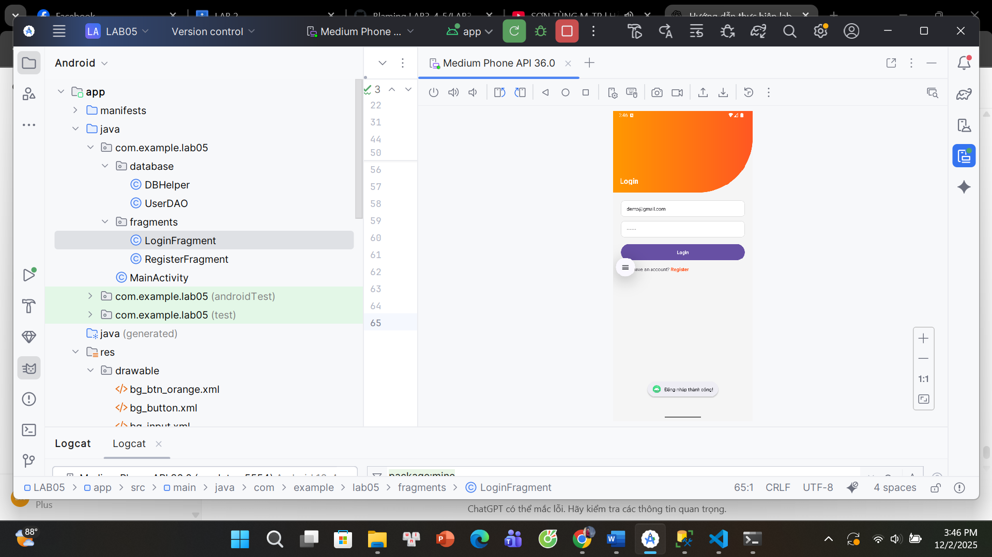

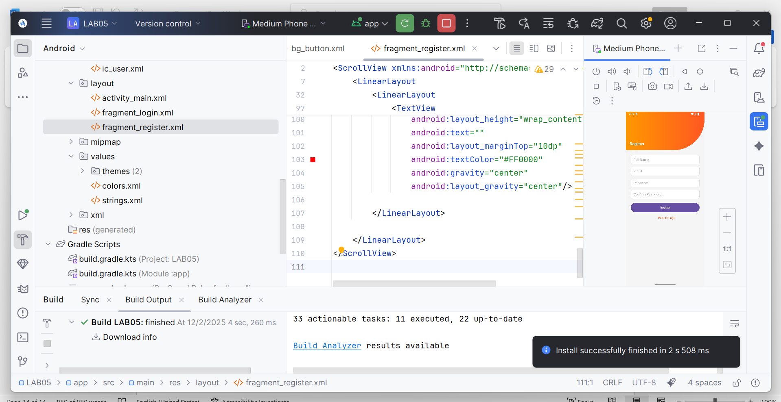

**DB Helper**

package com.example.lab05.database;  
import java.sql.Connection;  
import java.sql.DriverManager;  
public class DBHelper {  
 private static final String *IP* = "192.168.192.185";  
 private static final String *PORT* = "1433";  
 private static final String *DB* = "Lab05";  
 private static final String *USER* = "sa";  
 private static final String *PASS* = "110604";  
 public static Connection connect() {  
 Connection conn = null;  
 try {  
 Class.*forName*("net.sourceforge.jtds.jdbc.Driver");  
 String url = "jdbc:jtds:sqlserver://"  
 + *IP* + ":" + *PORT* + ";databaseName=" + *DB* + ";user=" + *USER* + ";password=" + *PASS* + ";";  
 conn = DriverManager.*getConnection*(url);  
 System.*out*.println("SQL CONNECTED !!!");  
 } catch (Exception e) {  
 e.printStackTrace();  
 }  
 return conn;  
 }  
}

**UserDAO**

package com.example.lab05.database;  
import android.util.Log;  
import java.sql.Connection;  
import java.sql.PreparedStatement;  
import java.sql.ResultSet;  
public class UserDAO {public boolean login(String email, String password) {  
 Connection conn = null;  
 try {  
 conn = DBHelper.*connect*();  
 if (conn == null) {  
 Log.*e*("SQL", "Connection NULL (login)");  
 return false;  
 }  
 String sql = "SELECT * FROM Users WHERE email=? AND password=?";  
 PreparedStatement stm = conn.prepareStatement(sql);  
 stm.setString(1, email.trim());  
 stm.setString(2, password.trim());  
 ResultSet rs = stm.executeQuery();  
 boolean ok = rs.next();  
 rs.close();  
 stm.close();  
 conn.close();  
 return ok;  
 } catch (Exception e) {  
 e.printStackTrace();  
 return false;  
 }  
 }  
public boolean register(String email, String password, String name) {  
 Connection conn = null;  
 try {  
 conn = DBHelper.*connect*();  
 if (conn == null) {  
 Log.*e*("SQL", "Connection NULL (register)");  
 return false;  
 }String check = "SELECT * FROM Users WHERE email=?";  
 PreparedStatement cstm = conn.prepareStatement(check);  
 cstm.setString(1, email);  
 ResultSet rs = cstm.executeQuery();  
 if (rs.next()) {  
 rs.close();  
 cstm.close();  
 conn.close();  
 return false; *// email tồn tại* }  
 *// thêm mới* String sql = "INSERT INTO Users(email, password, name) VALUES(?, ?, ?)";  
 PreparedStatement stm = conn.prepareStatement(sql);  
 stm.setString(1, email.trim());  
 stm.setString(2, password.trim());  
 stm.setString(3, name.trim());  
 int rows = stm.executeUpdate();  
 stm.close();  
 conn.close();  
 return rows > 0;  
 } catch (Exception e) {  
 e.printStackTrace();  
 return false;  
 }  
 }  
}

**LoginFragment**

package com.example.lab05.fragments;  
  
import android.os.Bundle;  
import android.view.LayoutInflater;  
import android.view.View;  
import android.view.ViewGroup;  
import android.widget.EditText;  
import android.widget.Button;  
import android.widget.Toast;  
import androidx.fragment.app.Fragment;  
import com.example.lab05.R;  
import com.example.lab05.database.UserDAO;  
public class LoginFragment extends Fragment {  
  
 EditText edtEmail, edtPass;  
 Button btnLogin;  
 @Override  
 public View onCreateView(LayoutInflater inflater, ViewGroup container,  
 Bundle savedInstanceState) {  
 View view = inflater.inflate(R.layout.*fragment_login*, container, false);  
 edtEmail = view.findViewById(R.id.*edtEmail*);  
 edtPass = view.findViewById(R.id.*edtPass*);  
 btnLogin = view.findViewById(R.id.*btnLogin*);  
 btnLogin.setOnClickListener(v -> {  
 String email = edtEmail.getText().toString().trim();  
 String pass = edtPass.getText().toString().trim();  
 if (email.isEmpty() || pass.isEmpty()) {  
 Toast.*makeText*(getContext(), "Không để trống!", Toast.*LENGTH_SHORT*).show();  
 return;  
 }  
 new Thread(() -> {  
 UserDAO dao = new UserDAO();  
 boolean ok = dao.login(email, pass);  
 requireActivity().runOnUiThread(() -> {  
 if (ok) {  
 Toast.*makeText*(getContext(), "Đăng nhập thành công!", Toast.*LENGTH_SHORT*).show();  
 } else {  
 Toast.*makeText*(getContext(), "Sai thông tin!", Toast.*LENGTH_SHORT*).show();  
 }  
 });  
 }).start();  
 });  
 return view;  
 }  
}

**RegisterFragment**

package com.example.lab05.fragments;  
import android.os.Bundle;  
import android.view.LayoutInflater;  
import android.view.View;  
import android.view.ViewGroup;  
import android.widget.EditText;  
import android.widget.Button;  
import android.widget.TextView;  
import android.widget.Toast;  
import androidx.fragment.app.Fragment;  
import com.example.lab05.R;  
import com.example.lab05.database.UserDAO;  
public class RegisterFragment extends Fragment {  
 EditText edtName, edtEmail, edtPass, edtRepass;  
 Button btnRegister;  
 TextView btnBack;  
 @Override  
 public View onCreateView(LayoutInflater inflater, ViewGroup container,  
 Bundle savedInstanceState) {  
  
 View view = inflater.inflate(R.layout.*fragment_register*, container, false);  
  
 edtName = view.findViewById(R.id.*edtName*);  
 edtEmail = view.findViewById(R.id.*edtEmail*);  
 edtPass = view.findViewById(R.id.*edtPass*);  
 edtRepass = view.findViewById(R.id.*edtRepass*);  
 btnRegister = view.findViewById(R.id.*btnRegister*);  
 btnBack = view.findViewById(R.id.*txtBackLogin*);  
 btnRegister.setOnClickListener(v -> {  
 String name = edtName.getText().toString();  
 String email = edtEmail.getText().toString();  
 String pass = edtPass.getText().toString();  
 String repass = edtRepass.getText().toString();  
 if (!pass.equals(repass)) {  
 Toast.*makeText*(getContext(), "Mật khẩu không trùng!", Toast.*LENGTH_SHORT*).show();  
 return;  
 }  
 UserDAO dao = new UserDAO();  
 boolean ok = dao.register(email, pass, name);  
 if (ok) {  
 Toast.*makeText*(getContext(), "Tạo tài khoản thành công!", Toast.*LENGTH_SHORT*).show();  
 } else {  
 Toast.*makeText*(getContext(), "Email đã tồn tại!", Toast.*LENGTH_SHORT*).show();  
 }  
 });  
 btnBack.setOnClickListener(v ->  
 requireActivity().getSupportFragmentManager()  
 .beginTransaction()  
 .replace(R.id.*frameLayout*, new LoginFragment())  
 .commit()  
 );  
 return view;  
 }  
}

**bg_btn_orange**

*<?*xml version="1.0" encoding="utf-8"*?>*<shape xmlns:android="http://schemas.android.com/apk/res/android">  
 <gradient  
 android:startColor="#FF8008"  
 android:endColor="#FF5722"  
 android:angle="0" />  
 <corners android:radius="25dp"/>  
</shape>

**bg_button**

<shape xmlns:android="http://schemas.android.com/apk/res/android">  
 <gradient  
 android:startColor="#FF9800"  
 android:endColor="#FF5722"  
 android:angle="0"/>  
 <corners android:radius="30dp"/>  
</shape>

**Bg_input**

<shape xmlns:android="http://schemas.android.com/apk/res/android">  
 <gradient  
 android:startColor="#FF9800"  
 android:endColor="#FF5722"  
 android:angle="0"/>  
 <corners android:radius="30dp"/>  
</shape>

**Bg_login**

<layer-list xmlns:android="http://schemas.android.com/apk/res/android">  
 <item android:drawable="@drawable/bg_rect" />  
 <item android:bottom="3dp">  
 <shape>  
 <corners android:radius="20dp"/>  
 <gradient  
 android:angle="180"  
 android:startColor="@color/orangeMid"  
 android:endColor="@color/orange"/>  
 </shape>  
 </item>  
</layer-list>

**Bg_rect**

*<?*xml version="1.0" encoding="utf-8"*?>*<shape xmlns:android="http://schemas.android.com/apk/res/android"  
 android:shape="rectangle">  
 <solid android:color="#F57C00"/> *<!-- màu cam đậm -->* <corners android:radius="0dp"/>  
</shape>

**Bg_top**

<shape xmlns:android="http://schemas.android.com/apk/res/android">  
 <gradient  
 android:startColor="#FF9800"  
 android:endColor="#FF5722"  
 android:angle="0"/>  
 <corners android:bottomRightRadius="160dp"/>  
</shape>

**Ic_user**

<vector xmlns:android="http://schemas.android.com/apk/res/android"  
 android:width="24dp"  
 android:height="24dp"  
 android:viewportWidth="24"  
 android:viewportHeight="24">  
 <path  
 android:fillColor="#808080"  
 android:pathData="M12,12c2.21,0 4,-1.79 4,-4s-1.79,-4 -4,-4 -4,1.79 -4,4 1.79,4 4,4zM12,14c-2.67,0 -8,1.34 -8,4v2h16v-2c0,-2.66 -5.33,-4 -8,-4z"/>  
</vector>

**Activity_main**

*<?*xml version="1.0" encoding="utf-8"*?>*<FrameLayout xmlns:android="http://schemas.android.com/apk/res/android"  
 android:id="@+id/frameLayout"  
 android:layout_width="match_parent"  
 android:layout_height="match_parent" />

**Fragment_login**

*<?*xml version="1.0" encoding="utf-8"*?>*<LinearLayout xmlns:android="http://schemas.android.com/apk/res/android"  
 android:layout_width="match_parent"  
 android:layout_height="match_parent"  
 android:orientation="vertical"  
 android:background="#F5F5F5">  
 <LinearLayout  
 android:layout_width="match_parent"  
 android:layout_height="240dp"  
 android:background="@drawable/bg_top"  
 android:gravity="bottom"  
 android:padding="20dp">  
 <TextView  
 android:id="@+id/txtTitle"  
 android:layout_width="wrap_content"  
 android:layout_height="wrap_content"  
 android:text="Login"  
 android:textSize="22sp"  
 android:textColor="#FFFFFF"  
 android:textStyle="bold" />  
 </LinearLayout>  
 <LinearLayout  
 android:layout_width="match_parent"  
 android:layout_height="wrap_content"  
 android:orientation="vertical"  
 android:padding="24dp">  
 <EditText  
 android:id="@+id/edtEmail"  
 android:layout_width="match_parent"  
 android:layout_height="48dp"  
 android:background="@drawable/bg_input"  
 android:hint="Email"  
 android:paddingLeft="16dp"  
 android:textSize="14sp" />  
 <EditText  
 android:id="@+id/edtPass"  
 android:layout_width="match_parent"  
 android:layout_height="48dp"  
 android:background="@drawable/bg_input"  
 android:hint="Password"  
 android:paddingLeft="16dp"  
 android:layout_marginTop="12dp"  
 android:inputType="textPassword"  
 android:textSize="14sp" />  
 <Button  
 android:id="@+id/btnLogin"  
 android:layout_width="match_parent"  
 android:layout_height="48dp"  
 android:layout_marginTop="20dp"  
 android:background="@drawable/bg_button"  
 android:text="Login"  
 android:textColor="#FFFFFF"  
 android:textStyle="bold" />  
 <LinearLayout  
 android:layout_width="wrap_content"  
 android:layout_height="wrap_content"  
 android:orientation="horizontal"  
 android:layout_marginTop="16dp">  
 <TextView  
 android:layout_width="wrap_content"  
 android:layout_height="wrap_content"  
 android:text="Don't have an account? " />  
  
 <TextView  
 android:id="@+id/txtRegister"  
 android:layout_width="wrap_content"  
 android:layout_height="wrap_content"  
 android:text="Register"  
 android:textColor="#FF5722"  
 android:textStyle="bold"/>  
 </LinearLayout>  
 </LinearLayout>  
</LinearLayout>

**Fragment_register**

*<?*xml version="1.0" encoding="utf-8"*?>*<LinearLayout xmlns:android="http://schemas.android.com/apk/res/android"  
 android:orientation="vertical"  
 android:layout_width="match_parent"  
 android:layout_height="match_parent"  
 android:background="#F5F5F5">  
 <LinearLayout  
 android:layout_width="match_parent"  
 android:layout_height="260dp"  
 android:background="@drawable/bg_top"  
 android:gravity="end|bottom"  
 android:padding="20dp">  
 <TextView  
 android:text="Register"  
 android:textColor="#FFFFFF"  
 android:textSize="18sp"/>  
 </LinearLayout>  
 <LinearLayout  
 android:layout_width="match_parent"  
 android:layout_height="wrap_content"  
 android:orientation="vertical"  
 android:padding="25dp">  
 <EditText  
 android:id="@+id/edtName"  
 android:hint="Full Name"  
 android:background="@drawable/bg_input"  
 android:padding="12dp"  
 android:layout_width="match_parent"  
 android:layout_height="50dp"/>  
 <EditText  
 android:id="@+id/edtEmail"  
 android:hint="Email"  
 android:background="@drawable/bg_input"  
 android:layout_width="match_parent"  
 android:padding="12dp"  
 android:layout_height="50dp"  
 android:layout_marginTop="12dp"/>  
 <EditText  
 android:id="@+id/edtPass"  
 android:hint="Password"  
 android:inputType="textPassword"  
 android:background="@drawable/bg_input"  
 android:layout_width="match_parent"  
 android:padding="12dp"  
 android:layout_height="50dp"  
 android:layout_marginTop="12dp"/>  
 <EditText  
 android:id="@+id/edtRepass"  
 android:hint="Confirm Password"  
 android:inputType="textPassword"  
 android:background="@drawable/bg_input"  
 android:layout_width="match_parent"  
 android:padding="12dp"  
 android:layout_height="50dp"  
 android:layout_marginTop="12dp"/>  
 <Button  
 android:id="@+id/btnRegister"  
 android:text="Register"  
 android:textColor="#FFF"  
 android:layout_width="match_parent"  
 android:layout_height="50dp"  
 android:background="@drawable/bg_button"  
 android:layout_marginTop="20dp"/>  
 <TextView  
 android:id="@+id/txtBackLogin"  
 android:text="← Back to Login"  
 android:textColor="#FF5500"  
 android:textSize="13sp"  
 android:layout_gravity="center"  
 android:layout_marginTop="20dp"/>  
 </LinearLayout>  
</LinearLayout>

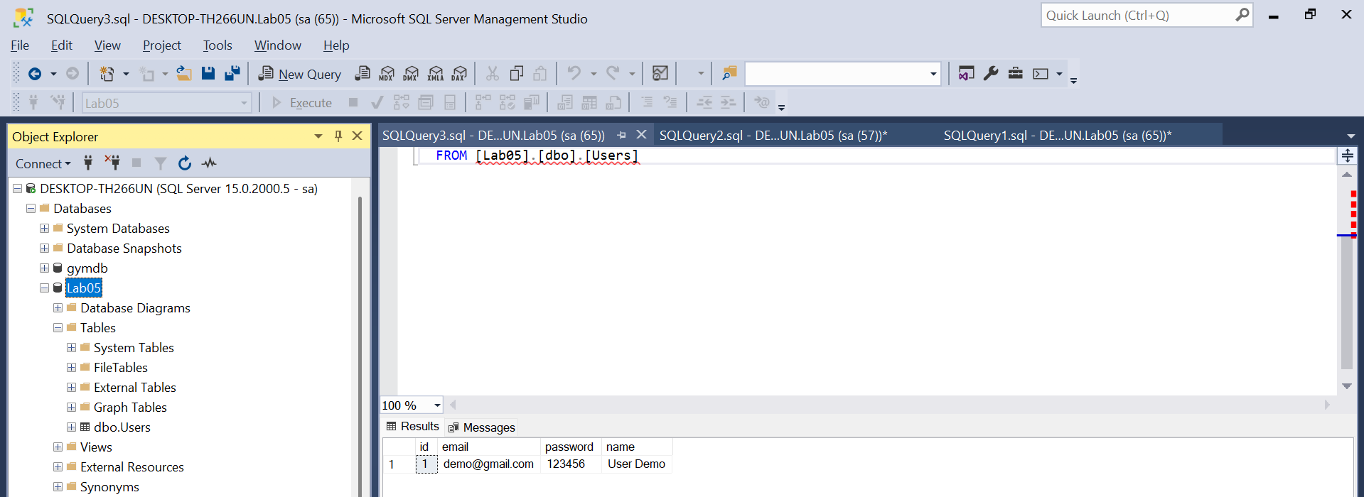

**Colors.xml**

<resources>  
 <color name="white">#FFFFFF</color>  
 <color name="black">#000000</color>  
 <color name="gray">#EFEFEF</color>  
 <color name="orange">#FB8C00</color>  
 <color name="orangeMid">#F4511E</color>  
</resources>